|  |
| --- |
| **KESHAV MEMORIAL INSTITUTE OF TECHNOLOGY**  **(AN AUTONOMOUS INSTITUTION)**  **Accredited by NBA & NAAC, Approved by AICTE, Affiliated to JNTUH,**  **Narayanguda, Hyderabad – 500029**      **DEPARTMENT OF COMPUTER SCIENCE AND ENGINEERING**  **LAB RECORD**  **SOFTWARE ENGINEERING LAB**  **B.Tech. III YEAR I SEM (RKR21)**  **ACADEMIC YEAR 2024-25** |

**KESHAV MEMORIAL INSTITUTE OF TECHNOLOGY**

**AN AUTONOMOUS**

**(**

**INSTITUTE**

)

**Accredited**

**by**

**NBA**

**&**

**NAAC,**

**Approved**

**by**

**AICTE,**

**Affiliated**

**to**

**JNTUH,**

**Hyderabad**

**Certificate**

This

is

to

certify

that

following

is

a

Bonafide

Record

of

the

workbook

task

done

by

bearing

Roll

No

of

Branch

of

year

B.Tech

Course

in

the

Subject

during the

Academic

year

&

under

our

supervision.

Number

of

week

tasks

completed:

Signature

of

Staff

Member

Incharge

Signature

of

Head

of

the

Dept.

Signature

of

Internal

Examiner

Signature

of

External

Examiner



|  |  |  |  |  |  |  |  |  |
| --- | --- | --- | --- | --- | --- | --- | --- | --- |
| **KESHAV MEMORIAL INSTITUTE OF TECHNOLOGY**  **(AN AUTONOMOUS INSTITUTE**)  **Accredited by NBA & NAAC, Approved by AICTE, Affiliated to JNTUH, Hyderabad**    **Daily Laboratory Assessment Sheet**  Name of the Lab: Name of the Student:  Class: HT. No: | | | | | | | | |
|  | **S.No.** | **Name of the Experiment** | **Date** | **Observation**  **Marks (3M)** | **Record**  **Marks**  **(4M)** | **Viva Voice**  **Marks (3M)** | **Total**  **Marks**  **(10M)** | **Signature of Faculty** |
|  |  |  |  |  |  |  |  |
|  |  |  |  |  |  |  |  |
|  |  |  |  |  |  |  |  |
|  |  |  |  |  |  |  |  |
|  |  |  |  |  |  |  |  |
|  |  |  |  |  |  |  |  |
|  |  |  |  |  |  |  |  |
|  |  |  |  |  |  |  |  |
|  |  |  |  |  |  |  |  |
|  |  |  |  |  |  |  |  |
|  |  |  |  |  |  |  |  |
|  |  |  |  |  |  |  |  |
|  |  |  |  |  |  |  |  |
|  |  |  |  |  |  |  |  |
|  |  |  |  |  |  |  |  |
|  |  |  |  |  |  |  |  |
|  | | | | | | | |

|  |  |  |  |  |  |  |  |  |
| --- | --- | --- | --- | --- | --- | --- | --- | --- |
|  | | | | | | | | |
|  | **S.No.** | **Name of the Experiment** | **Date** | **Observation Marks (3M)** | **Record**  **Marks**  **(4M)** | **Viva Voice Marks (3M)** | **Total**  **Marks**  **(10M)** | **Signature of Faculty** |
|  |  |  |  |  |  |  |  |
|  |  |  |  |  |  |  |  |
|  |  |  |  |  |  |  |  |
|  |  |  |  |  |  |  |  |
|  |  |  |  |  |  |  |  |
|  | **TOTAL** |  |  |  |  |  |  |
|  | | | | | | | |

|  |  |  |  |
| --- | --- | --- | --- |
| **INDEX** | | | |
|  | **S.NO** | **CONTENTS** | **PAGE NO** |
| I | Vision/Mission /PEOs/POs/PSOs |  |
| II | Syllabus |  |
| III | Course outcomes, C0-PO Mapping |  |
| **Exp No:** | **List of Experiments** |  |
| 1 | INSTALLATION OF STARUML, GIT BASH AND GITHUB ACCOUNT CREATION |  |
| 2 | IEEE – SRS (SOFTWARE REQUIREMENTS SPECIFICATION) WITH UML DIAGRAMS |  |
| 3 | INSTALLATION OF ECLIPSE, MAVEN, JDK, TOMCAT, CONFIGURING TOMCAT TO ECLIPSE |  |
| 4 | 1. BASIC GIT COMMANDS - VERSION, CONFIG, INIT, STATUS, ADD, COMMIT, DIFF, HELP 2. GIT COMMANDS: WORKING WITH LOCAL AND REMOTE REPOSITORIES -   BRANCHES, CHECKOUT, MERGE, REVERT, LOG   1. GIT COMMANDS: WORKING WITH REMOTE REPOSITORIES - REMOTE, CLONE, PULL, PUSH, FORK |  |
| 5 | 1. CREATING MAVEN JAVA PROJECT USING ECLIPSE AND PUSH INTO TO GITHUB. 2. CREATING MAVEN WEB PROJECT USING ECLIPSE AND PUSH INTO TO GITHUB. 3. INSTALLATION OF JENKINS. |  |
| 6 | 1. BUILDING THE CI/CD FREESTYLE PIPELINE USING JENKINS FOR MAVEN JAVA PROJECT 2. BUILDING THE CI/CD FREESTYLE PIPELINE USING JENKINS FOR MAVEN WEB PROJECT WITH POLL SCM 3. BUILDING THE CI/CD SCRIPTED PIPELINE USING JENKINS FOR MAVEN   JAVA PROJECT WITH POLL SCM |  |
| 7 | 1. INSTALLATION OF DOCKER, MINIKUBE, ACCOUNT IN DOCKERHUB 2. DOCKER CLI COMMANDS 3. MODIFYAND PUSH DOCKER IMAGE 4. CREATE AND PUSH DOCKER FILE IMAGE 5. RUNNING MULTIPLE CONTAINERS USING DOCKER COMPOSE 6. DEPLOYING AND SCALING APPLICATIONS USING MINIKUBE 7. DEPLOYING AND MANAGING MONITORING SYSTEMS USING NAGIOS IN   DOCKER |  |
|  | | | |

|  |  |  |  |
| --- | --- | --- | --- |
|  | |  |  |
|  | **Exp No:** | **List of Experiments** | **PAGE NO** |
| 8 | 1. AWS ACADEMY LEARNING ACCOUNT CREATION 2. PROJECT DEPLOYMENT IN THE AWS CLOUD USING EC2 INSTANCE 3. MAVEN WEB PROJECT DEPLOYMENT IN THE AWS CLOUD USING EC2   INSTANCE |  |
|  | | | |

**KESHAV MEMORIAL INSTITUTE OF TECHNOLOGY**

engineers.

•

•

•

•

•

•

•



**(AN AUTONOMOUS INSTITUTE)**

**Accredited by NBA & NAAC, Approved by AICTE, Affiliated to JNTUH,**

# Narayanguda, Hyderabad – 500029 Department of Computer Science & Engineering

**Vision of the Institution:**

To be the fountain head of latest technologies, producing highly skilled, globally competent

**Mission of the Institution:**

To provide a learning environment that inculcates problem solving skills, professional, ethical responsibilities, lifelong learning through multi modal platforms and prepare students to become successful professionals.

To establish Industry Institute Interaction to make students ready for the industry.

To provide exposure to students on latest hardware and software tools.

To promote research-based projects/activities in the emerging areas of technology convergence.

To encourage and enable students to not merely seek jobs from the industry but also to create new enterprises

To induce a spirit of nationalism which will enable the student to develop, understand India’s challenges and to encourage them to develop effective solutions.

To support the faculty to accelerate their learning curve to deliver excellent service to students

# KESHAV MEMORIAL INSTITUTE OF TECHNOLOGY

•

•

•

•

•

•



## (AN AUTONOMOUS INSTITUTE)

**Accredited by NBA & NAAC, Approved by AICTE, Affiliated to JNTUH,**

**Narayanguda, Hyderabad – 500029**

## Department of Computer Science & Engineering

**Vision of the Department**:

To be among the region's premier teaching and research Computer Science and Engineering departments producing globally competent and socially responsible graduates in the most conducive academic environment.

**Mission of the Department**:

To provide faculty with state-of-the-art facilities for continuous professional development and research, both in foundational aspects and of relevance to emerging computing trends.

To impart skills that transform students to develop technical solutions for societal needs and inculcate entrepreneurial talents.

To inculcate an ability in students to pursue the advancement of knowledge in various specializations of Computer Science and Engineering and make them industry-ready.

To engage in collaborative research with academia and industry and generate adequate resources for research activities for seamless transfer of knowledge resulting in sponsored projects and consultancy.

To cultivate responsibility through sharing of knowledge and innovative computing solutions that benefits the society-at-large.

To collaborate with academia, industry and community to set high standards in academic excellence and in fulfilling societal responsibilities.

**KESHAV MEMORIAL INSTITUTE OF TECHNOLOGY**

## (AN AUTONOMOUS INSTITUTE)

**Accredited by NBA & NAAC, Approved by AICTE, Affiliated to JNTUH,**

**Narayanguda, Hyderabad – 500029**

## Department of Computer Science & Engineering

**PROGRAM OUTCOMES (POs)**

**PO1: Engineering Knowledge**: Apply the knowledge of mathematics, science, engineering fundamentals, and an engineering specialization to the solution of complex engineering problems. **PO2: Problem Analysis**: Identify, formulate, review research literature, and analyze complex engineering problems reaching substantiated conclusions using first principles of mathematics, natural sciences, and engineering sciences.



**PO3: Design/Development of Solutions**: Design solutions for complex engineering problems and design system components or processes that meet the specified needs with appropriate consideration for the public health and safety, and the cultural, societal, and environmental considerations.

**PO4: Conduct Investigations of Complex Problems**: Use research-based knowledge and research methods including design of experiments, analysis and interpretation of data, and synthesis of the information to provide valid conclusions.

**PO5: Modern Tool Usage**: Create, select, and apply appropriate techniques, resources, and modern engineering and IT tools including prediction and modelling to complex engineering activities with an understanding of the limitations.

**PO6: The Engineer and Society**: Apply reasoning informed by the contextual knowledge to assess societal, health, safety, legal and cultural issues and the consequent responsibilities relevant to the professional engineering practice.

**PO7: Environment and Sustainability**: Understand the impact of the professional engineering solutions in societal and environmental contexts, and demonstrate the knowledge of, and need for sustainable development.

**PO8: Ethics**: Apply ethical principles and commit to professional ethics and responsibilities and norms of the engineering practice.

**PO9: Individual and Team Work**: Function effectively as an individual, and as a member or leader in diverse teams, and in multidisciplinary settings.

**PO10: Communication**: Communicate effectively on complex engineering activities with the engineering community and with society at large, such as, being able to comprehend and write effective reports and design documentation, make effective presentations, and give and receive clear instructions.

**PO11: Project Management and Finance**: Demonstrate knowledge and understanding of the engineering and management principles and apply these to one’s own work, as a member and leader in a team, to manage projects and in multidisciplinary environments.

**PO12: Life-long Learning**: Recognize the need for, and have the preparation and ability to engage in independent and life-long learning in the broadest context of technological change.

# KESHAV MEMORIAL INSTITUTE OF TECHNOLOGY



## (AN AUTONOMOUS INSTITUTE)

**Accredited by NBA & NAAC, Approved by AICTE, Affiliated to JNTUH,**

**Narayanguda, Hyderabad – 500029**

**Department of Computer Science & Engineering**

## PROGRAM SPECIFIC OUTCOMES (PSOs)

**PSO1**: An ability to analyze the common business functions to design and develop appropriate Computer Science solutions for social upliftment.

**PSO2**: Shall have expertise on the evolving technologies like Python, Machine Learning, Deep Learning, Internet of Things (IOT), Data Science, Full stack development, Social Networks, Cyber Security, Big Data, Mobile Apps, CRM, ERP etc.

# KESHAV MEMORIAL INSTITUTE OF TECHNOLOGY



## (AN AUTONOMOUS INSTITUTE)

**Accredited by NBA & NAAC, Approved by AICTE, Affiliated to JNTUH,**

**Narayanguda, Hyderabad – 500029**

**Department of Computer Science & Engineering**

## PROGRAM EDUCATIONAL OBJECTIVES (PEOs)

**PEO1:** Graduates will endeavor to excel in their chosen careers as professionals, researchers and entrepreneurs on a global platform.

**PEO2:** Graduates will demonstrate the ability to solve challenges in the fields of Engineering and Technology simultaneously catering to societal needs.

**PEO3:** Graduates will strive to improve their learning curve by practicing Continuing Professional Development (CPD).

**PEO4:** Graduates will, at all times, adopt a professional demeanor by communicating effectively, working collaboratively, and maintaining the ethics & core values as befitting their education in interdisciplinary and emerging fields.

## KESHAV MEMORIAL INSTITUTE OF TECHNOLOGY

**(AN AUTONOMOUS INSTITUTE**)

**Accredited by NBA & NAAC, Approved by AICTE, Affiliated to JNTUH, Hyderabad**

**B. Tech. in COMPUTER SCIENCE AND ENGINEERING**

**III Year I Semester Syllabus (RKR21)**

**SOFTWARE ENGINEERING LAB (21CC505PC)**

**Common to CSE, IT, CSE (AI&ML) and CSE (DS)**

**L T P C**

**0 0 3 1.5**

**Pre-requisites/ Co-requisites:**

1. 21CC502PC – Software Engineering Course
2. 21CS401PC- Java Programming Course

**Course Objectives: The course will help to**

1. Formulate problem statements and Software Requirement Specifications by comprehensively grasping project requirements.
2. Demonstrate proficiency in designing, developing, and testing diverse project modules.
3. Utilize Git Framework and GitHub while implementing Continuous Integration/Continuous Deployment (CI/CD) pipelines through Jenkins.
4. Implement project deployment using Docker and Kubernetes.
5. Acquire knowledge in AWS cloud infrastructure.

**Course Outcomes: After learning the concepts of this course, the student is able to**

1. Transform end-user needs into system and software requirements through a structured process.
2. Depict the system's high-level design using CASE tools based on the software requirements.
3. Employ Jenkins CI/CD for project building purposes.
4. Implement project deployment utilizing Docker and Kubernetes.
5. Create a project within the AWS Cloud environment.

**Software to be used:** The students must use JDK 11/17/21 Version, STAR UML, GIT Bash, Jenkins, Dockers Desktop, Mini KUBE, Eclipse, Tomcat, and Visual Studio Editor.

**List of Experiments:**

Do the following exercises for any one project given in the list of sample projects or any other projects?

1. Development of problem statement.
2. Preparation of Software Requirement Specification Document, Design Documents and Testing Phase related documents.
3. Study and usage of any Design phase CASE tool
4. Creating the project and committing using Git and GitHub
5. Creating Maven Java and Maven Web project using Eclipse and Push them to GitHub.
6. Building the CI/CD pipeline using Jenkins for the project in the previous experiment.
7. Local Deployment of project using Docker, Kubernetes and Monitoring using Nagios tool.
8. Cloud Deployment of a project in the AWS Cloud using EC2 instance.

|  |
| --- |
| **Sample Projects:**   1. Book Bank 2. Online course reservation system 3. E-ticketing 4. Recruitment system 5. Hospital Management system 6. Online Banking System   **TEXT BOOKS:**   1. Software Engineering, A practitioner’s Approach- Roger S. Pressman, 6th edition, Mc Graw Hill International Edition, 2015. 2. Software Engineering- Sommerville, 7th edition, Pearson Education, 2017. 3. The unified modeling language user guide Grady Brooch, James Rumbaugh, Ivar Jacobson, Pearson Education, 2016. 4. The DevOps Handbook: How to Create World-Class Agility, Reliability, and Security in Technology Organizations, 2015.   **REFERENCE BOOKS:**   1. https://kubernetes.io/docs/tutorials/hello-minikube/ 2. https://minikube.sigs.k8s.io/docs/start/ 3. https://[www.jenkins.io/doc/](http://www.jenkins.io/doc/) 4. https://docs.aws.amazon.com/AWSEC2/latest/UserGuide/concepts.html 5. Introducing Maven by, Balaji Varanasi and Sudha Belida, APRESS publications.   8 |

|  |  |  |  |  |  |  |  |  |  |  |  |  |  |  |  |  |  |  |  |  |  |  |  |  |  |  |  |  |  |  |  |  |  |  |  |  |  |  |  |  |  |  |  |  |  |  |  |  |  |  |  |  |  |  |  |  |  |  |  |  |  |  |  |  |  |  |  |  |  |  |  |  |  |  |  |  |  |  |  |  |  |  |  |  |  |  |  |  |  |  |  |  |  |  |  |  |  |  |  |  |  |  |
| --- | --- | --- | --- | --- | --- | --- | --- | --- | --- | --- | --- | --- | --- | --- | --- | --- | --- | --- | --- | --- | --- | --- | --- | --- | --- | --- | --- | --- | --- | --- | --- | --- | --- | --- | --- | --- | --- | --- | --- | --- | --- | --- | --- | --- | --- | --- | --- | --- | --- | --- | --- | --- | --- | --- | --- | --- | --- | --- | --- | --- | --- | --- | --- | --- | --- | --- | --- | --- | --- | --- | --- | --- | --- | --- | --- | --- | --- | --- | --- | --- | --- | --- | --- | --- | --- | --- | --- | --- | --- | --- | --- | --- | --- | --- | --- | --- | --- | --- | --- | --- | --- | --- |
| **KESHAV MEMORIAL INSTITUTE OF TECHNOLOGY**  **(AN AUTONOMOUS INSTITUTE)**  **Accredited by NBA & NAAC, Approved by AICTE, Affiliated to JNTUH,**  **Narayanguda, Hyderabad – 500029**  **Department of Computer Science & Engineering**  **Course Outcomes and CO-PO-PSO Mapping**  **Course Outcomes:**  After learning the contents of this course, the student is able to   |  |  | | --- | --- | | **CO1** | Transform end-user needs into system and software requirements through a structured process. | | **CO2** | Depict the system's high-level design using CASE tools based on the software requirements. | | **CO3** | Employ Jenkins CI/CD for project building purposes. | | **CO4** | Implement project deployment utilizing Docker and Kubernetes. | | **CO5** | Create a project within the AWS Cloud environment. |   **CO-PO-PSO MAPPING:**   |  |  |  |  |  |  |  |  |  |  |  |  |  |  |  |  | | --- | --- | --- | --- | --- | --- | --- | --- | --- | --- | --- | --- | --- | --- | --- | --- | |  | **CO** | **PO1** | **PO2** | **PO3** | **PO4** | **PO5** | **PO6** | **PO7** | **PO8** | **PO9** | **PO10** | **PO11** | **PO12** | **PSO-1** | **PSO-2** | | **Software**  **Engineering**  **Lab** | **CO1** | 3 | 3 | 3 | 2 |  |  |  |  |  | 2 |  |  | 2 | 1 | | **CO2** | 2 | 3 | 3 | 3 | 3 |  |  |  |  | 2 |  |  | 2 | 1 | | **CO3** |  |  |  |  | 3 |  |  |  | 2 | 2 | 2 |  | 1 | 2 | | **CO4** |  |  |  | 3 | 3 | 2 | 2 |  | 2 | 2 | 2 | 2 | 2 | 3 | | **CO5** | 3 |  |  |  | 3 | 2 | 2 |  |  |  | 3 | 3 | 3 | 3 |   9 |

# EXPERIMENT-1

**INSTALLATION OF GITBASH, STARUML AND GITHUB ACCOUNT CREATION:**

* **GITBASH:** It is an application uses Git commands on computer

* Search for Git Bash in google and select the official website

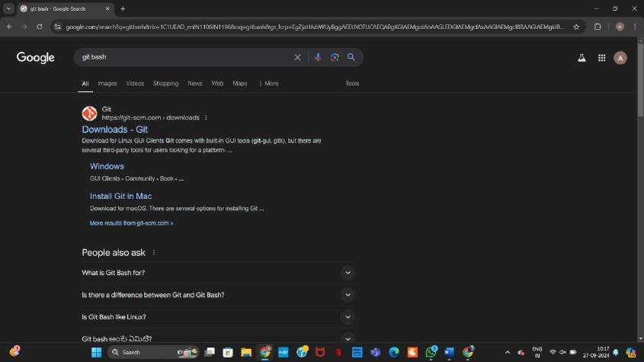

* Now open the site and select the download option for respective operating system

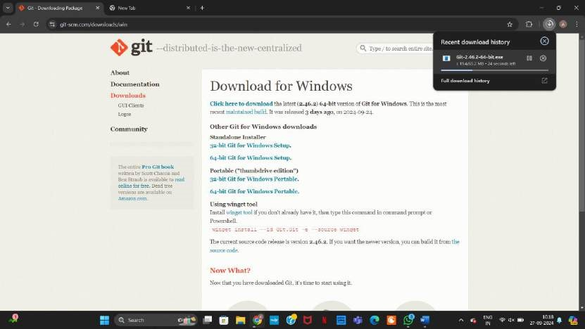

* Now start downloading by opening the downloaded file

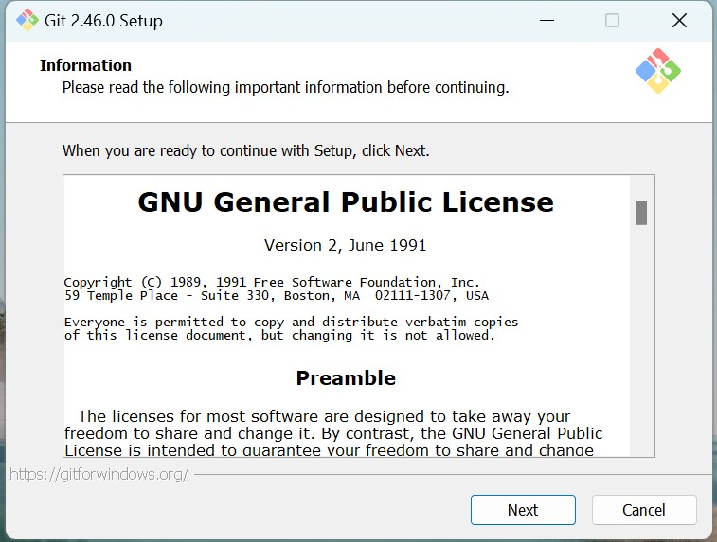

* Click next

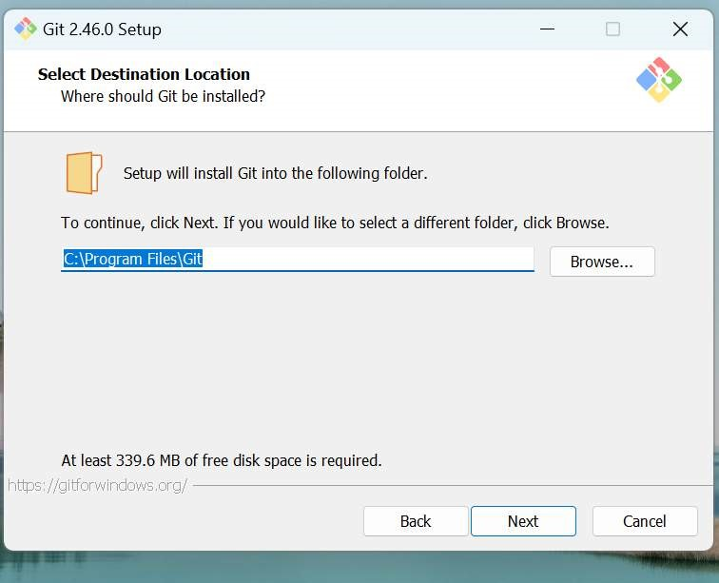

* After selecting path click next

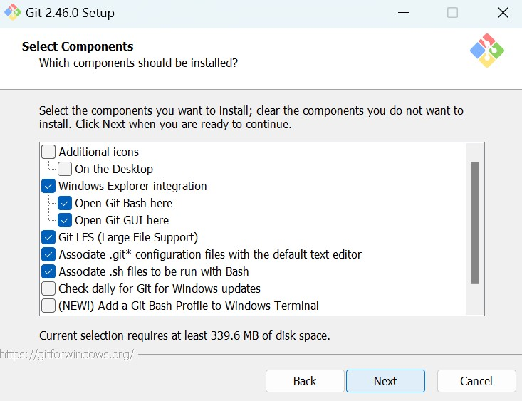

* Click next

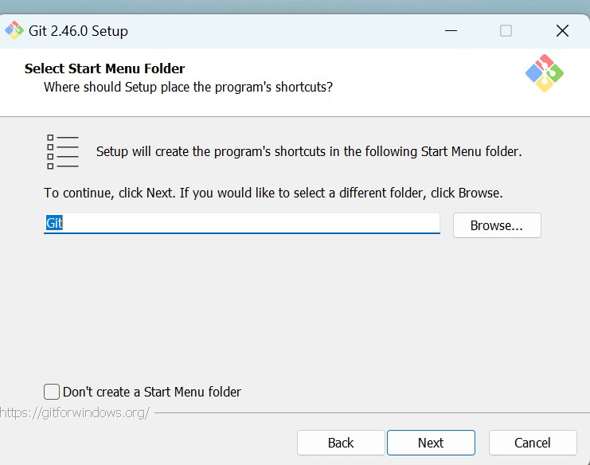

* Click next

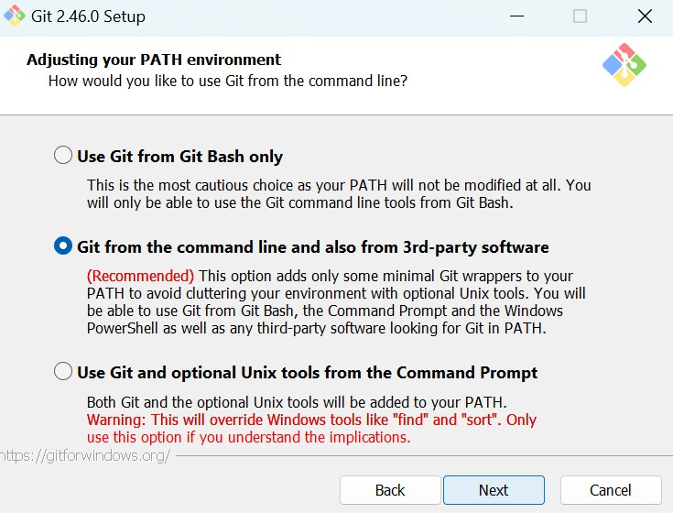

* Click next

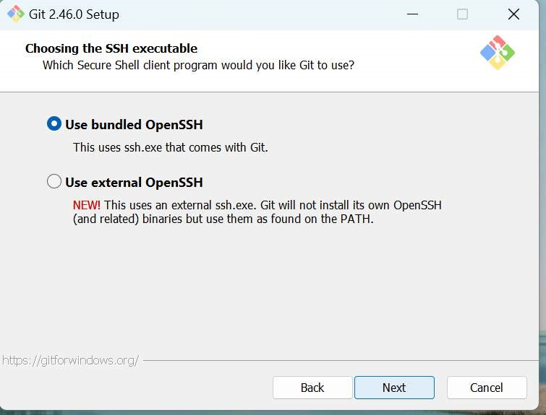

* Click next

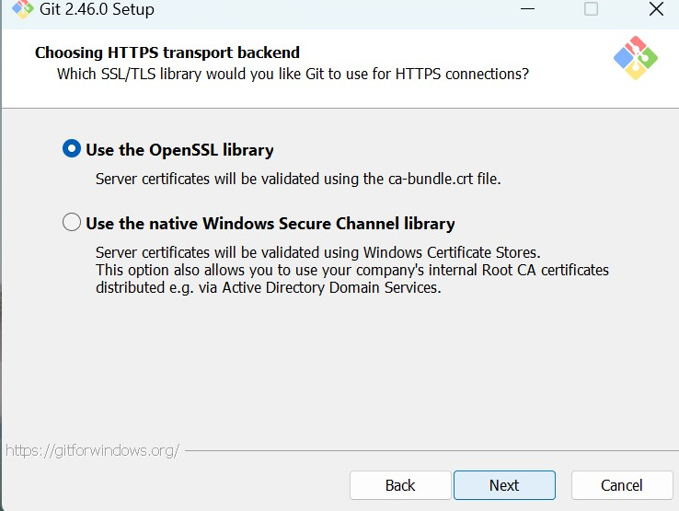

* Click next

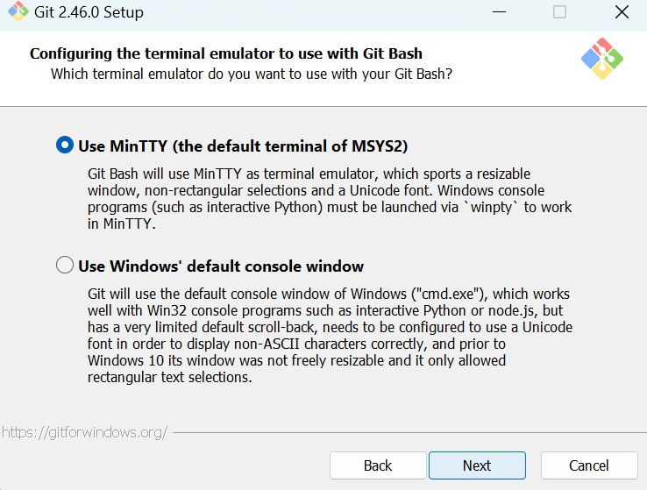

* Click next

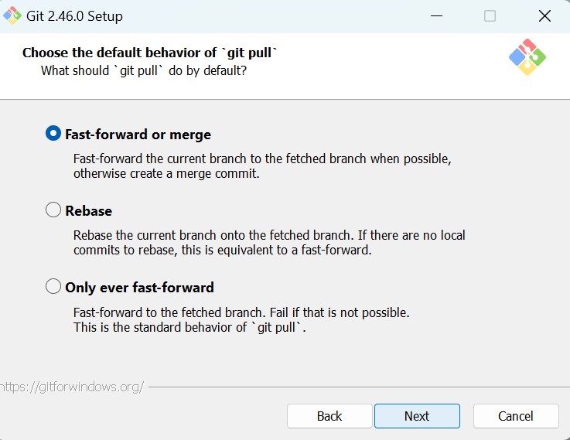

* Click next

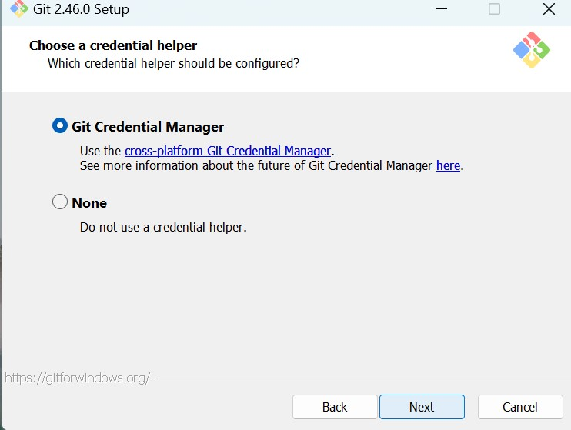

* Click next

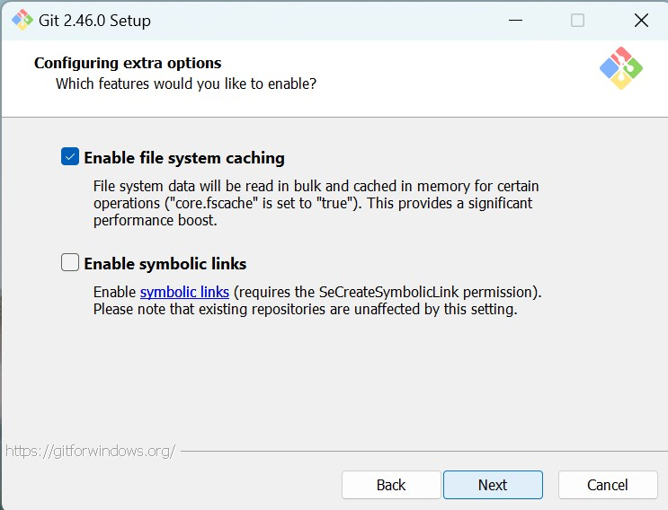

* Click next

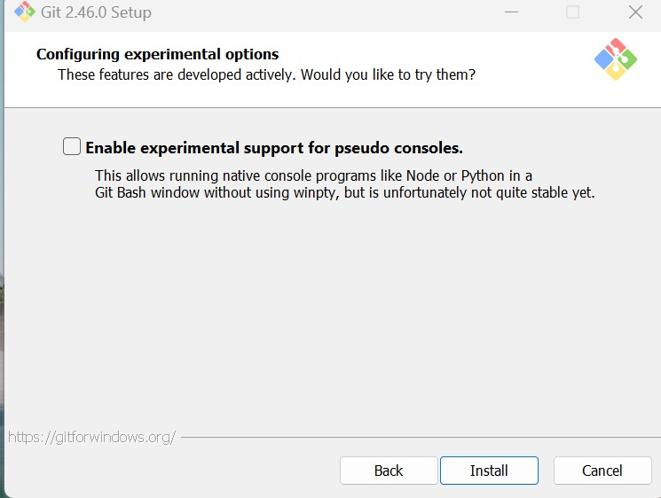

* Click install

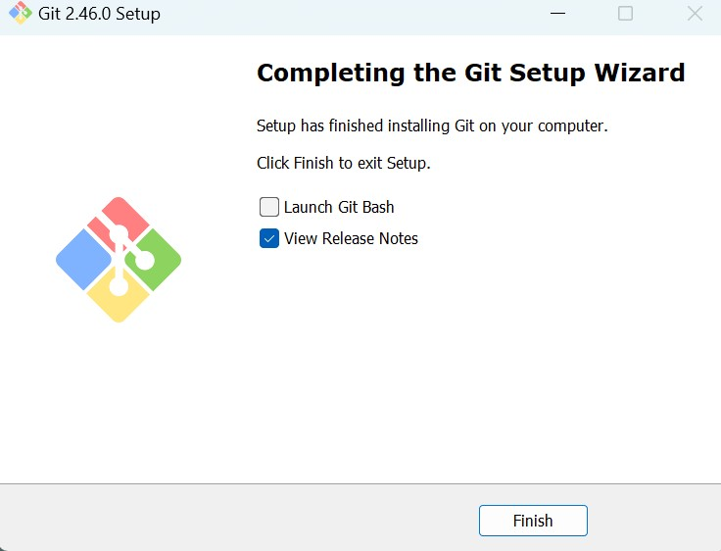

* Remove the marked option and click Finish

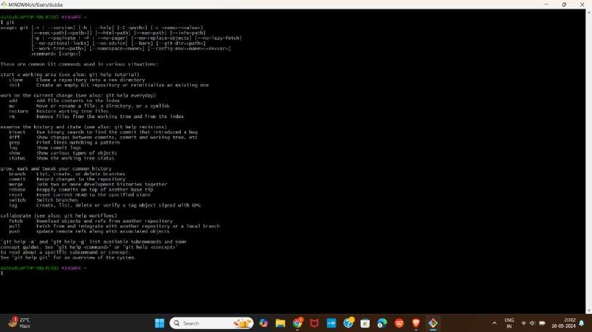

* Git Bash interface after installation

* **StarUML:** It is a software tool used to create diagrams that helps in designing and understanding complex systems
* Search for StarUML in google and select the official site

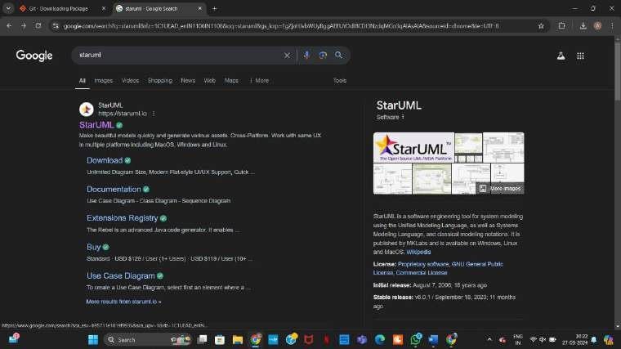

* Select the download option for respective operating systems

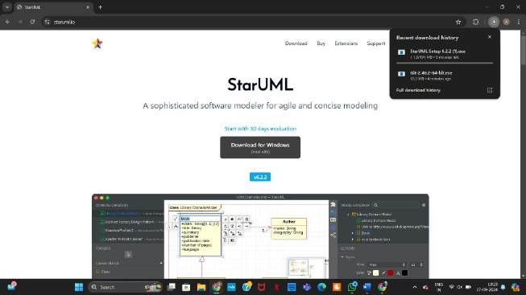

* Open windows and check for installation of StarUML

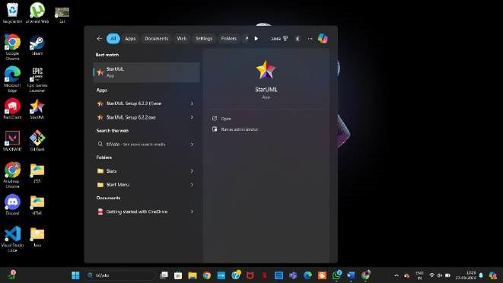

* StarUML interface

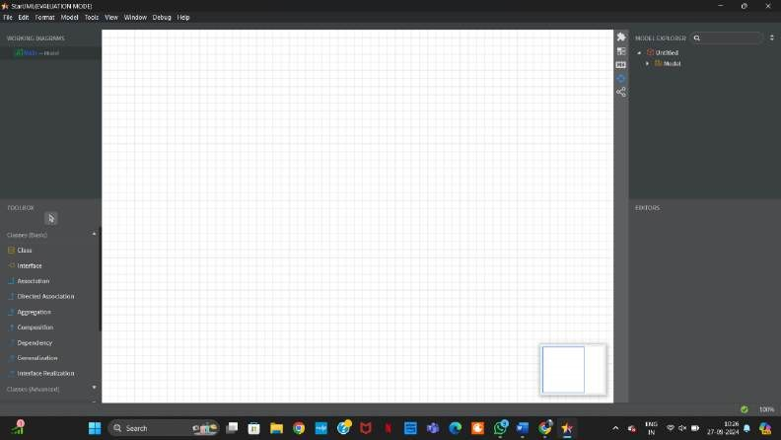

* **GitHub:** It is a website where people stores and shares others code.
* Sign in of GitHub

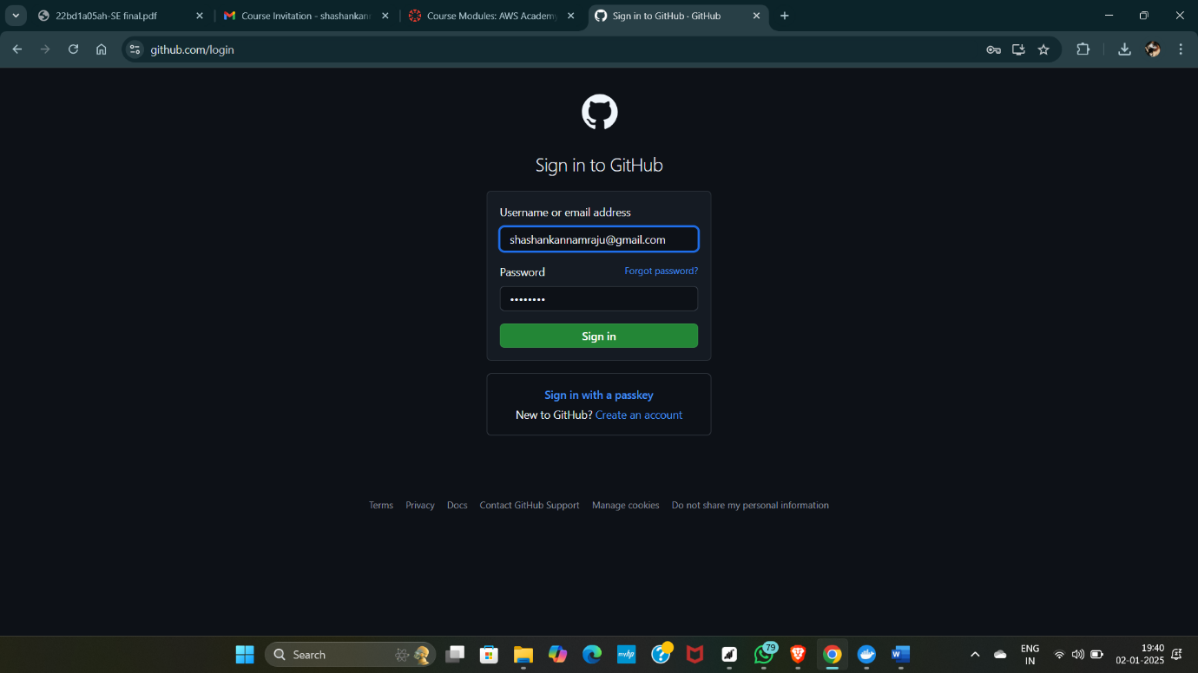

* GitHub dashboard after account creation

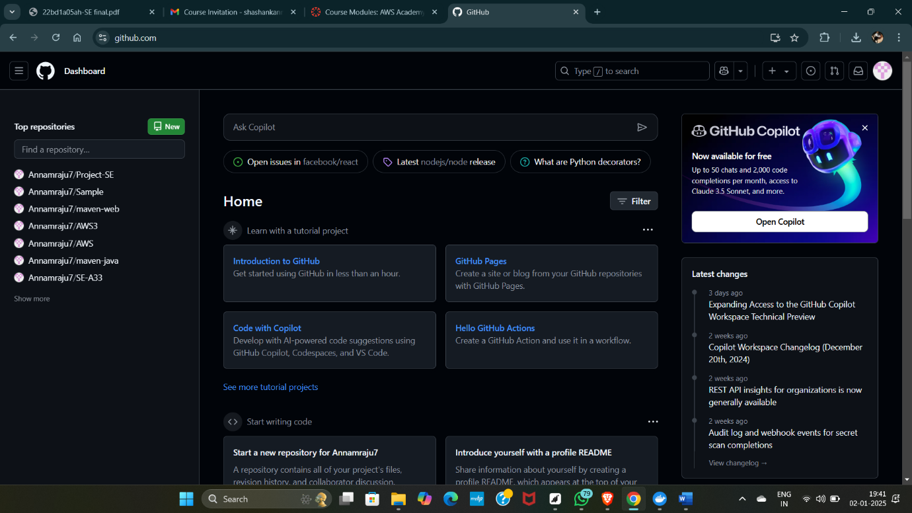

## E-TICKETING

1. D.KOUSHIK - 22BD1A05AH
2. A.RAJU - 22BD1A05A2
3. A.HAVAS - 22BD1A05A1
4. A.SHASHANK - 22BD1A05A4
5. D.CHERUTHAN - 22BD1A05AE

**Problem statement:**

Many e-ticketing platforms struggle with providing users flexibility in managing their tickets and transferring them to others when needed. Customers often face difficulties in handling multiple tickets during the purchase process, leading to a cumbersome experience. Additionally, when plans change, users are typically forced to sell their tickets through unofficial channels or face the loss of value, as most platforms do not offer seamless transfer options. This lack of features creates inefficiencies and frustration for both customers and event organizers.

To solve this, we propose developing an e-ticketing web application named **E-Tickets** with two main features: a **Ticket Cart** and a **Ticket Transfer** system. The Ticket Cart will allow users to select, review, and manage multiple tickets before completing the purchase, improving ease of use and flexibility. The Ticket Transfer feature will enable users to securely transfer purchased tickets to others with minimal hassle, maintaining transparency and trust throughout the process. Together, these features will significantly enhance the ticketing experience, offering both convenience and security for users.

**Software Requirement Specification**

For

**E-TICKETING**

## Version 1.1

Prepared by:

1. D.KOUSHIK - 22BD1A05AH
2. A. HAVAS - 22BD1A05A1
3. A. RAJU - 22BD1A05A2
4. A. SHASHANK - 22BD1A05A4
5. D. CHERUTHAN - 22BD1A05AE

**Keshav Memorial Institute of Technology**

**23-09-2024**

## Table of Contents

**1.Introduction...............................................................................................**

1.1 Purpose..................................................................................................................... 1.2 DocumentConventions.............................................................................................

1.3 Intended Audience and Reading Suggestions..........................................................

1.4 Product Scope..........................................................................................................

1.5 References...............................................................................................................

### 2.Overall Description

2.1 Product Perspective………………………………………………………………....

2.2 Product Functions…………………………………………………………………...

2.3 User Classes and Characteristic…………...………………………………………

2.4 Operating Environment………..………………………………….………………...

2.5 Design and Implementation Constraints………………………………………........

2.6 Assumptions and Dependencies…………………..………………………………...

### 3. External Interface Requirements

3.1 User Interface…………………………………………………………

3.2 Hardware Interface……………………………………………………

3.2 Software Interface……………………………………………………

3.2 Communications Interface……………………………………………………

### 4. System Features

4.1 System Feature 1

4.2 System Feature 2

### 5. Other Nonfunctional Requirements

5.1 Performance Requirements………………………………………………………

5.2 Safety Requirements……………………………………………………

5.3 Security Requirements……………………………………………………

5.4 Software Quality Attributes……………………………………………………

5.5 Business Rules……………………………………………………

**6. Other Requirements**

**Appendix A: Glossary**

**Appendix B: Analysis Models**

**Appendix C: To Be Determined List**

### Revision History

|  |  |  |  |
| --- | --- | --- | --- |
| **Name** | **Date** | **Reason for changes** | **Version** |
| Week-1 |  | SRS creation | 1.0 |
| Week-2 |  | SDLC,UML,Use-Case  Diagram and Template | 2.0 |
| Week-3 |  | Class diagram | 3.0 |

## 1. Introduction

The Software Requirements Specification (SRS) outlines the agreement between the customer and developer regarding the software product's features and functionality. This document serves to clearly capture and define the customer's requirements, providing a reference for all stages of the software development process.

**1.1 Purpose:**

An e-ticketing platform streamlines the ticketing process by allowing users to book and purchase tickets online for events, or services. It enhances convenience, eliminates the need for physical tickets, and reduces operational costs for businesses by automating the ticket issuance and management process. Additionally, e-ticketing platforms offer real-time availability updates, secure payment options, and can help prevent fraud through digital verification. This makes the system efficient, eco-friendly, and accessible to users from anywhere at any time.

**1.2 Document Convention:**

**Heading:**

Font-Size: 16

Font-Style: Bold

Font: Times New Roman  **Subheading:**

Font-Size:14

Font-Style: Bold

Font: Times New Roman **Content:**

Font-Size: 12

Font: Times New Roman

**1.3 Intended Audience and Reading Suggestions:**

This document serves as a prototype for the E-Ticketing Platform and will be valuable to various stakeholders in different ways. Developers will use it to design and implement the platform, following the outlined functional and non-functional requirements. Project Managers will rely on this document to oversee the project’s progress, manage costs, and ensure timely completion. Advertisers will find it useful for crafting marketing strategies and promotions that effectively showcase the platform's unique features and competitive advantages. Users will benefit from understanding the platform’s functionalities, assessing whether it meets their needs, and providing feedback or requesting changes as necessary. Testers will utilize the document to ensure that the platform meets all specified criteria and performs as expected. Overall, the document provides essential guidance for each group involved in the development, deployment, and promotion of the E-ticketing system.

**1.4 Product scope:**

The product scope for an e-ticketing web application involves the development of a user-friendly platform that facilitates the purchase, management, and distribution of electronic tickets for events such as concerts, sports, movies, or travel. The system will provide seamless functionality for various user roles, including buyers, event organizers, and administrators, with secure authentication and personalized dashboards. Users will be able to browse events, select seats (if applicable), and complete transactions through a streamlined checkout process that integrates multiple payment options. Event organizers will have tools to create, manage, and promote events while tracking ticket sales and customer data. The platform will also feature mobile responsiveness, ensuring a smooth experience across devices. The solution aims to enhance efficiency, reduce paper usage, and provide real-time ticket availability, along with robust security features for fraud prevention and data protection.

**1.5 References:**

We took references from different websites like scribd, coursehero , studocu etc. <https://www.scribd.com/document/585359643/e-ticketing-management-system-srs>. <https://www.scribd.com/document/618052735/SE-Project-E-Ticketing>.

**2. Overall Description:**

### 2.1 Product Perspective

The E-Tickets platform is designed as a comprehensive e-ticketing solution that improves upon existing ticketing systems by offering users a seamless and efficient way to purchase tickets for events, or services. E-Tickets combines convenience with security and ease of use, allowing users to browse, book, and pay for tickets entirely online. The platform includes three key roles: event organizers, customers, and administrators. Event organizers can manage their events and ticket sales, while customers can easily purchase tickets and check real-time availability. Administrators oversee the platform to ensure smooth operation, manage user accounts, and handle disputes.

E-Tickets will introduce innovative features, such as ticket transfer functionality that allows users to securely transfer their purchased tickets to friends or family members. It is mobile-friendly, ensuring users have access to their tickets and event information on the go, and provides a secure payment gateway for transactions.

### 2.2 Product Functions

#### 2.2.1 Administrator

* Admins will manage user accounts, approve or reject event organizers, and ensure compliance with platform policies.
* Admins will be able to insert, update, and delete events and tickets, monitor tickets, and resolve disputes.
* They will maintain event categories, manage promotional campaigns, and communicate important announcements, such as discounts and offers, to users.

#### 2.2.2 Event Organizers

* Event organizers will be able to create and manage events, set ticket prices, and define seating arrangements (where applicable).
* They can view and manage ticket sales, track revenue, and interact with customers regarding event inquiries.
* Organizers will be given tools to create event-specific promotions and discounts.

#### 2.2.3 Customers/Users

* Customers will browse events, purchase tickets, and manage their bookings through a user-friendly interface.
* They will have the ability to review event details, check seating availability, and use advanced search filters (event type, location, price).
* Customers can securely store and access their e-tickets, and transfer tickets to others if needed.
* They will also be able to leave feedback on events and organizers, helping to build community trust.

### 2.3 User Characteristics

The platform targets several types of users, including customers, event organizers, and administrators.

* **Customers**: Users of various technological backgrounds who are looking to book tickets for events and services.
* **Event Organizers**: Individuals or companies responsible for setting up events. They are expected to have moderate technical skills and the ability to manage online dashboards.
* **Administrators**: Trained personnel who ensure the smooth operation of the platform, handle user queries, and resolve technical or operational issues. They must be well-versed in the backend functionality and security protocols.

### 2.4 Operating Environment

The E-Tickets platform will function on modern web browsers such as Chrome, Firefox, Safari, and Edge. It will support mobile devices, tablets, and desktops, ensuring compatibility across various screen sizes and operating systems (Windows, macOS, Linux, iOS, Android). The platform will rely on cloud-hosted databases and scalable infrastructure, ensuring availability and quick response times even during high-demand periods.

### 2.5 Design and Implementation Constraints

* The platform will be accessible via the internet and will require a stable internet connection.
* The system will need to handle real-time ticket availability updates and process payments securely via a reliable payment gateway.
* E-Tickets will operate 24/7, ensuring users can access the platform anytime, anywhere.

### 2.6 Assumptions and Dependencies

* E-Tickets will integrate with third-party payment gateways for secure transactions and offer multiple payment options.
* The platform will utilize cloud infrastructure to ensure scalability and reliability during high-traffic periods.
* It assumes that users will have access to an internet connection and devices capable of browsing and processing transactions online.
* The system's success depends on user adoption, availability of events, and the ability to provide a seamless and secure user experience across all devices.

## 3. External Interface Requirements

### 3.1 User Interface

The user interface (UI) of the E-Tickets platform will offer a clean and intuitive design, ensuring a smooth user experience for customers, event organizers, and administrators. Below are the key characteristics:

3.1.1. **Screen Layout and Design**:

All pages will follow a uniform layout with consistent navigation menus at the top with the user profile option on top right, and a content area in the center displaying event details, tickets, or user account information.

3.1.2. **Standard Elements**:

* **Navigation bar** with standard options like Home, My Tickets, and Support, available on every screen.
* **Buttons**: “Book Now,” “Cancel,” “My Tickets”, “Profile” will appear on the screens.

3.1.3. **Error Handling**:

* **Error message formatting**: bold red text below the relevant input field.

3.1.4. **Sample Screens**:

* **Event List**: Displays all upcoming events with filters for category, date, and location.
* **Event Detail**: Includes event information, available tickets, and seat selection (if applicable).
* **Profile Management**: Users can update personal information and view past ticket purchases.
* **Login/Signup Screen**: Fields for email, password, and buttons for social login options.
* **Ticket Booking Screen:** Display of available options (e.g., destination, time, date) with filtering options.
* **Payment Screen**: Secure fields for entering payment information, with security details clearly displayed.

### 3.2 Hardware Interface

For the E-Ticketing project, the software interfaces with various hardware components and supported devices as follows:

**3.2.1 Supported Device Types:**

The software will support desktop and mobile devices, including smartphones and tablets, ensuring cross-platform compatibility. The user interface will be responsive to different screen sizes, ensuring optimal user experience on all supported devices.

### 3.3 Software Interface

The E-Tickets will interact with several software interfaces to ensure seamless functionality and user experience. These include a web-based front-end for users to browse events, select tickets, and make payments, which will be built using technologies such as HTML, CSS . The back-end (will consists of Node Js and express Js) will integrate with a secure payment gateway API (such as Stripe or Razorpay) for processing transactions, and a database management system (MongoDB) to store user information, ticket details, and transaction records. Additionally, the system may interface with third-party APIs for event information, seat management, or ticket validation, ensuring real-time updates and smooth coordination across platforms.

### 3.4 Communication Interface

The E-Tickets will require several communication interfaces to facilitate smooth data exchange between the system, users, and third-party services. The website will use HTTPS for secure data transmission between the client and the server, ensuring encryption of sensitive information such as login credentials and payment details. The system will integrate with email services via SMTP to send ticket confirmations, notifications, and updates to users.

## 4. System Features

### 5.1 System Feature 1(Ticket Cart)

#### 4.1.1 Description and Priority

The Ticket Cart feature allows users to select multiple event tickets and save them in a cart for future purchase. The feature supports ticket selection, quantity adjustments, and viewing the total price.

#### 4.1.2 Stimulus/Response Sequences

**User Action:** User selects an event ticket and adds it to the cart or removes a ticket form cart

**System Response:** The ticket is added to the cart or removed from the cart, and the system updates the cart with the current total price.

#### 4.1.3 Functional Requirements

REQ-1: The system must allow users to add multiple tickets to a cart.

REQ-2: The system must allow users to view the total number of tickets and the total price in the cart.

REQ-3: The system must update the cart in real-time as the user adjusts ticket quantities or removes tickets.

REQ-4: The system must allow users to remove individual tickets from the cart.

### 5.2 System Feature 2(Ticket Transfer)

#### 4.2.1 Description and Priority

The Ticket Transfer feature allows users to transfer purchased tickets to another individual via email or through a direct user-to-user transfer system within the platform.

#### 4.2.2 Stimulus/Response Sequences

**User Action**: The user selects a purchased ticket for transfer.

**System Response**: The system prompts the user to enter the recipient's email or username. Upon confirmation, the system verifies the transfer details, updates the ticket ownership, and notifies both the sender and recipient via email.

#### 4.2.3 Functional Requirements

REQ-1: The system must allow users to transfer a ticket to another user via email or direct transfer.

REQ-2: The system must verify that the recipient’s email address or username is valid before completing the transfer.

REQ-3: The system must notify the recipient of the ticket transfer via email.

REQ-4: The system must update ticket ownership in the database after a successful transfer.

REQ-5: The system must notify both the sender and recipient of the success or failure of the transfer.

## 5.Other Nonfunctional Requirements

### 5.1 Performance Requirements

For the E-Tickets, the performance requirements ensure smooth operation and a positive user experience:

**Response Time**: The platform should respond within less time for common operations such as browsing events, purchasing tickets, or transferring tickets.

**Load Time**: All pages should load within less time on standard internet connections (3G and higher).

**Ticket Generation**: The system must generate and deliver e-tickets as fast as possible on successful payment.

**Payment Processing**: Transactions should be completed securely and respond on success confirmation.

**Data Sync**: Real-time ticket availability and status must be synchronized across all devices without delay.

These performance requirements are necessary to maintain user satisfaction, ensure smooth operation, and handle the expected scale of use.

### 5.2 Safety Requirements

**Data Integrity**: The platform should ensure no data loss or corruption during purchases or transfers.

**Backup**: Automatic backups should be in place to prevent data loss in case of failure.

**User Protection**: Prevent errors such as accidental double purchases or wrong transfers.

### 5.3 Security Requirements

**Authentication**: All users must log in securely with strong passwords. Two-factor authentication should be used for sensitive actions (e.g., ticket transfers).

**Role-based Access**: Users (customers, event organizers, administrators) must only access features relevant to their role.

### 5.4 Software Quality Attributes

**Usability**: The platform should be simple and intuitive to use for both customers and event organizers.

**Reliability**: The system should function without errors, ensuring correct processing of transactions.

**Maintainability**: The platform should be easy to update and improve over time.

**Compatibility**: The system should work well on both web and mobile devices.

### 5.5 Business Rules

**User Roles**: Users of the system will include customers, event organizers, and administrators. Customers can purchase, transfer, and refund tickets; event organizers can create and manage events; administrators can approve events and manage user accounts.

**Ticket Transfers**: Only valid, confirmed tickets may be transferred to another user. Once a ticket is transferred, ownership is fully shifted, and the original owner loses access to the ticket.

### Use Case Diagram

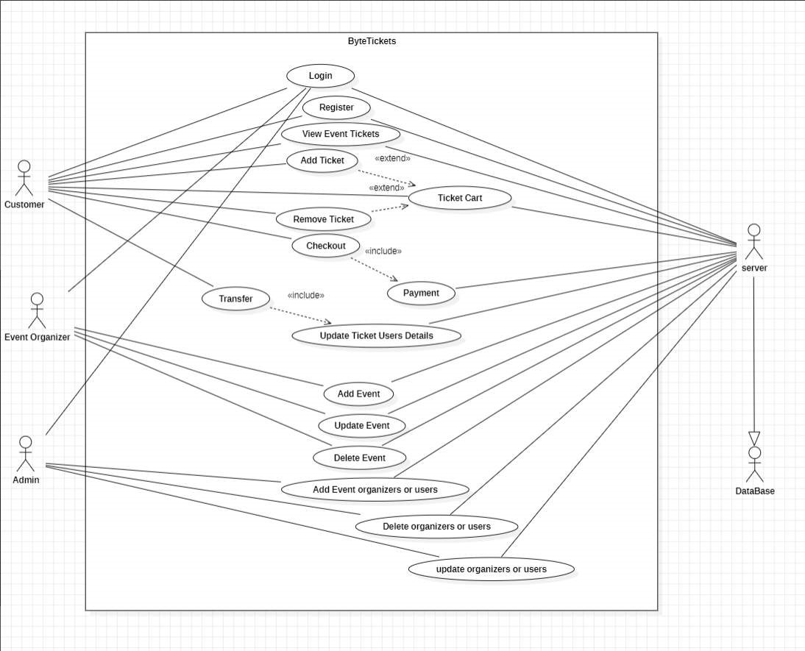

### Sequence Diagram

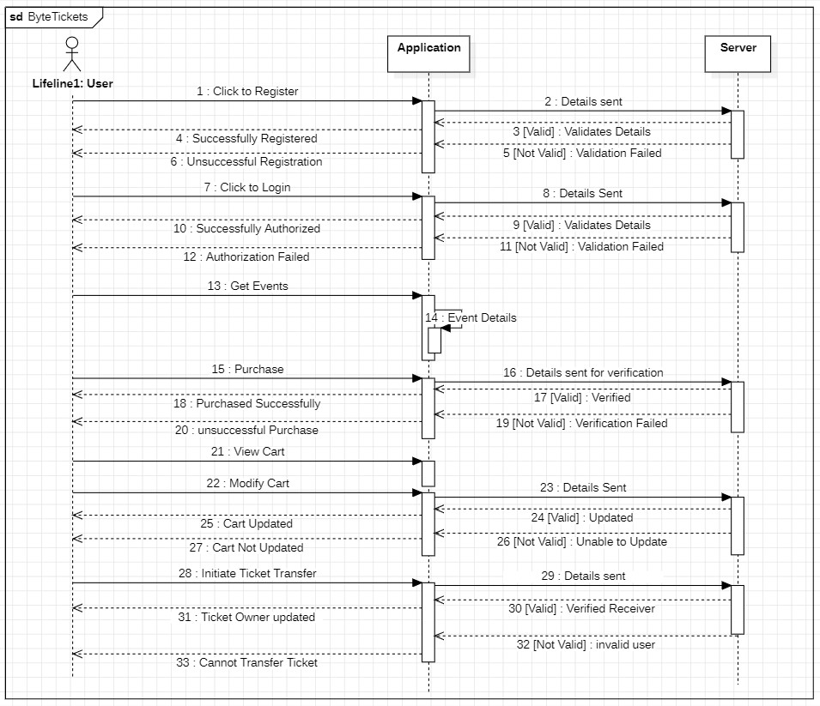

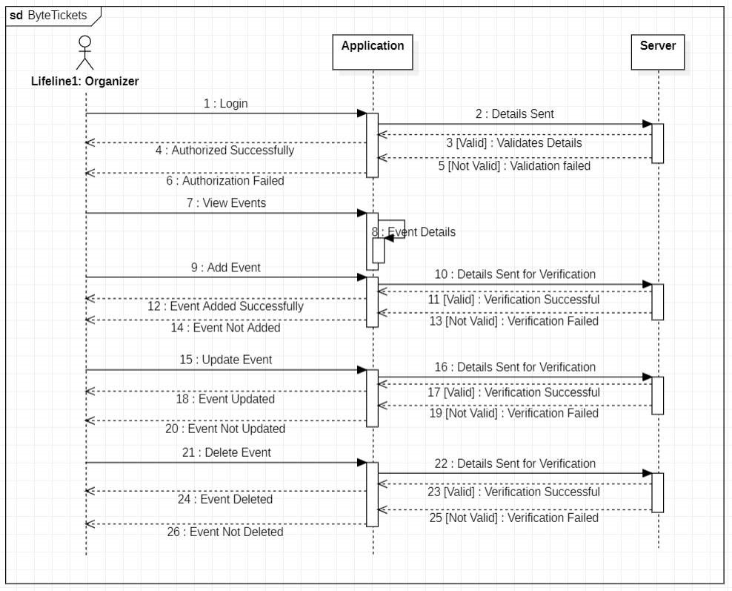

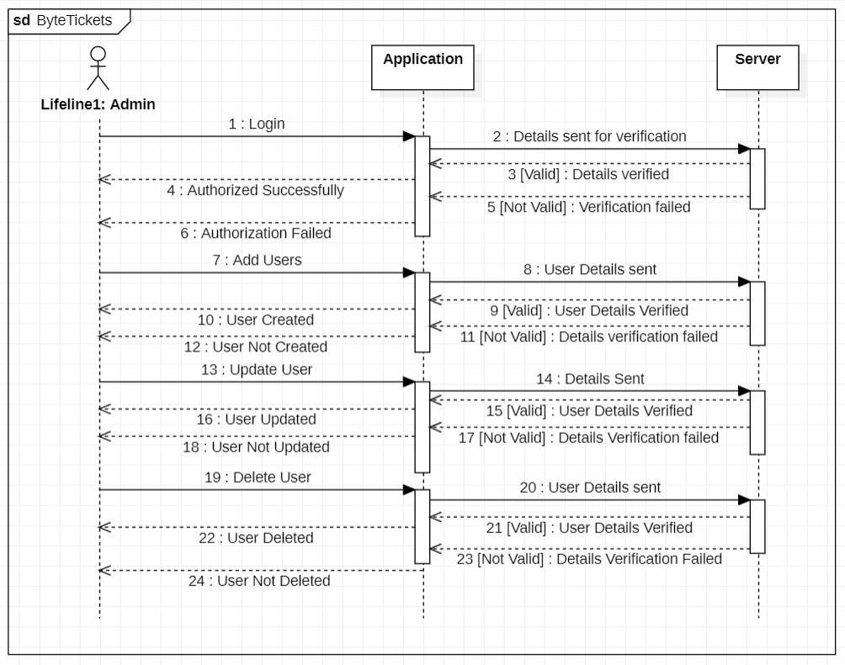

### Class Diagram

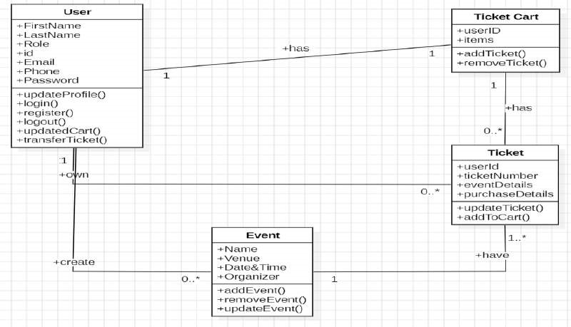

### Component Diagram

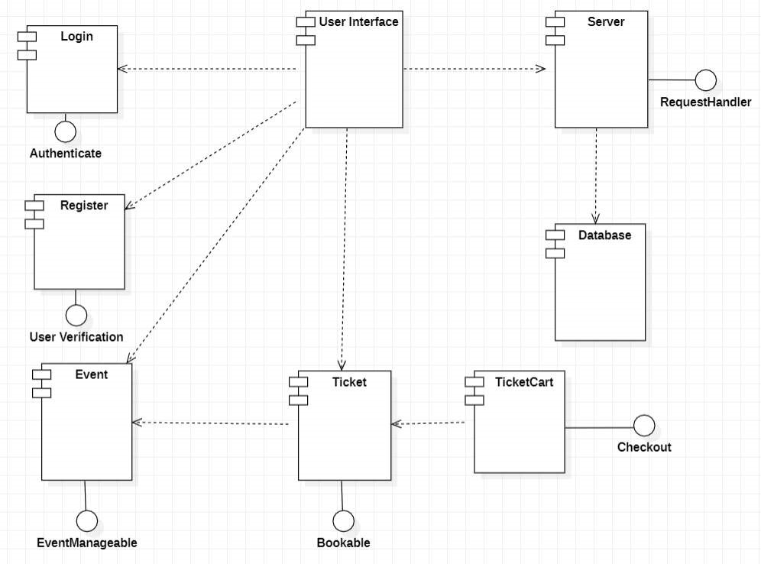

## Experiment-3

**INSTALLATION OF ECLIPSE, MAVEN, JDK, TOMCAT, CONFIGURING TOMCAT TO ECLIPSE**

Maven Installation:

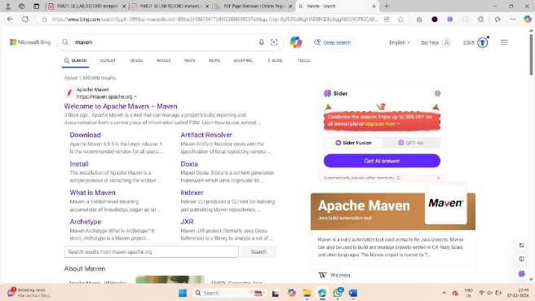

1.Type maven download in google.com

### Visit [https://maven.apache.org/,](https://maven.apache.org/) navigate to download page and install the software

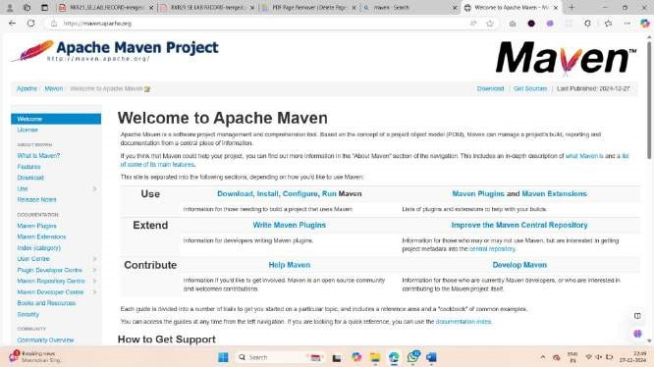

2.Download the binary zip archive from the maven website.

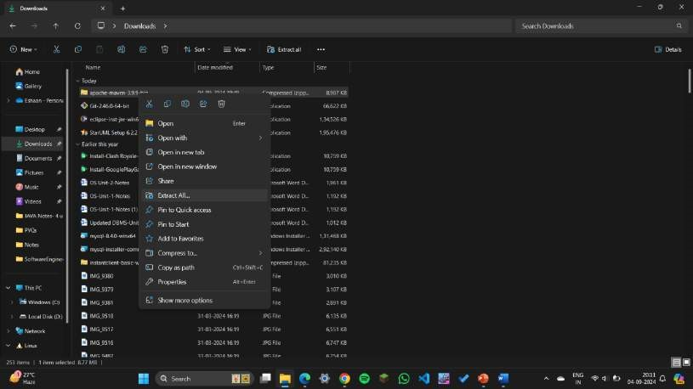

3.After installation, right click on the zip file and click extract all.

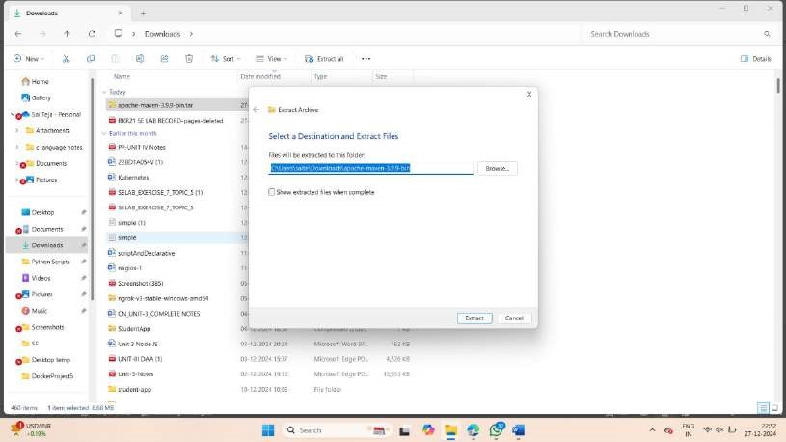

4.Specify the path as mentioned above.

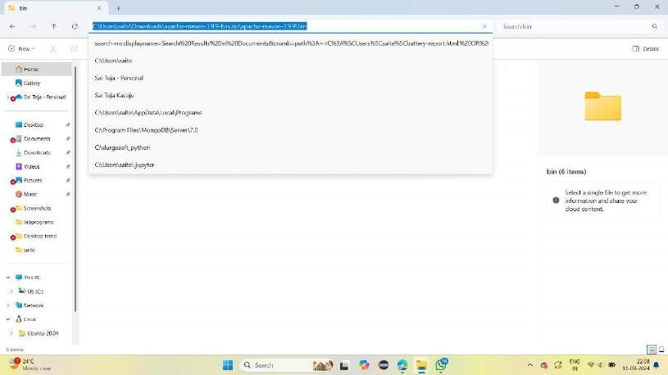

5.Copy the path of the maven file you installed.

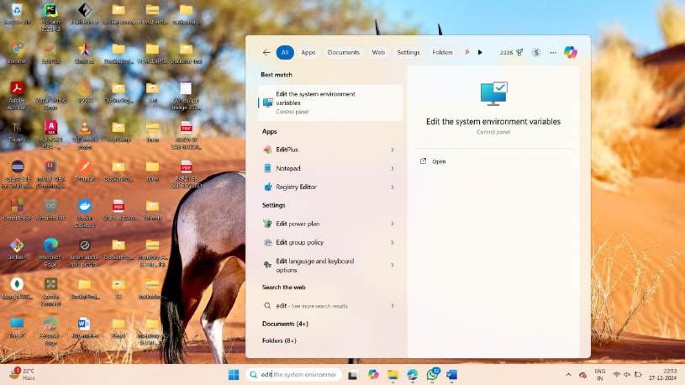

6.Click windows and type edit the system environment variables.

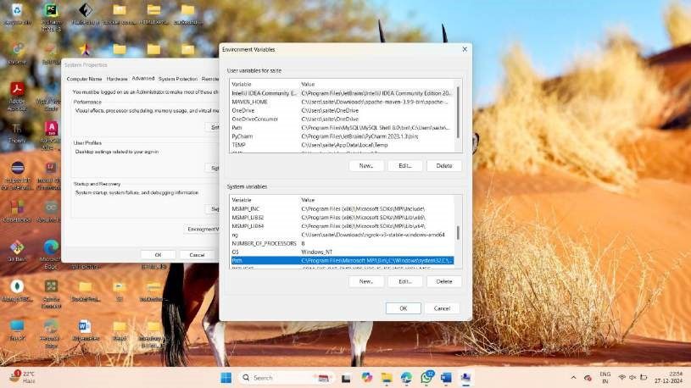

7.Click on environment variables.

8.Click on Path and click new and paste the path you copied before from step 5.

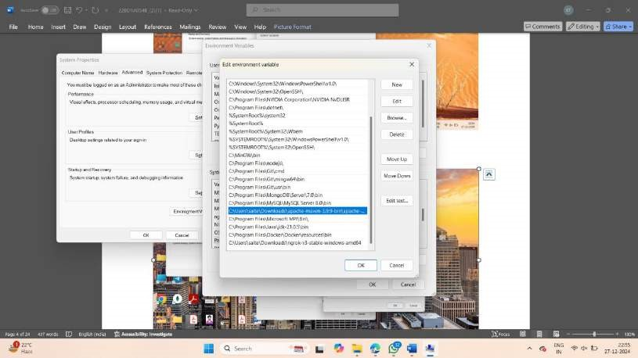

9.Click on OK.

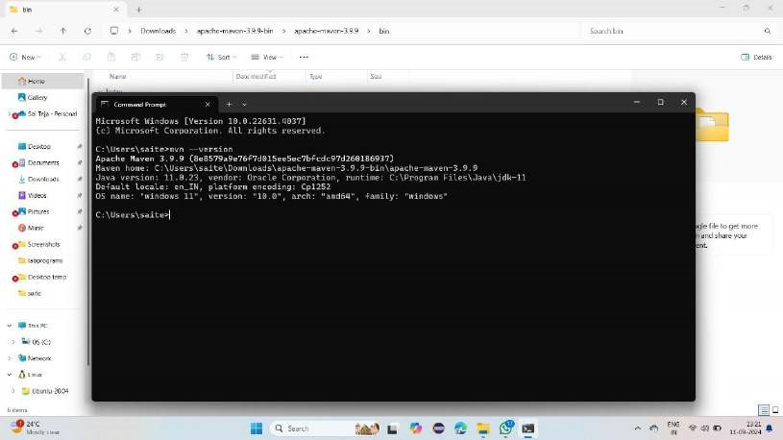

12. Open terminal

13.Type mvn –version and it will display the version of your installed maven software.

ECLIPSE Installation:

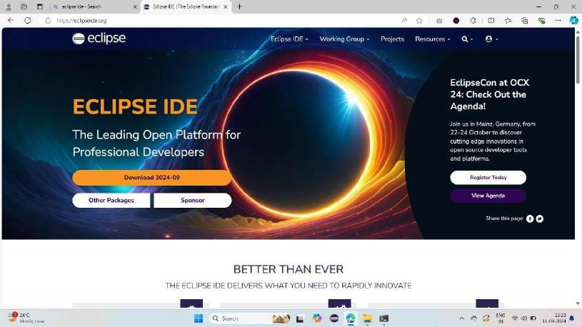

1.Type download eclipse from google.com 2.Click on eclipse downloads.

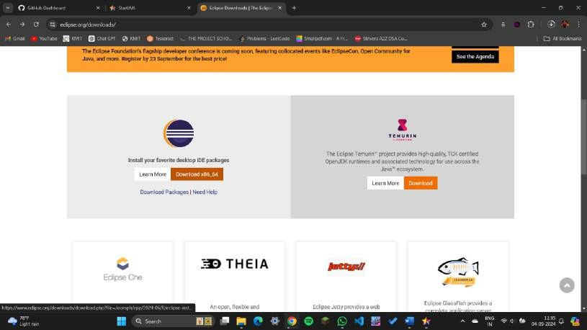

3.Click on download x86_64.

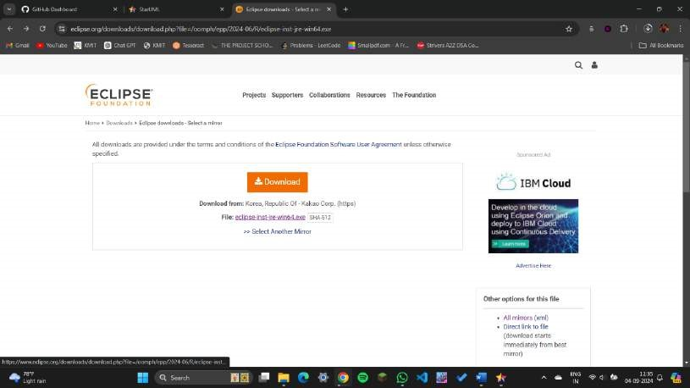

4.Click download.

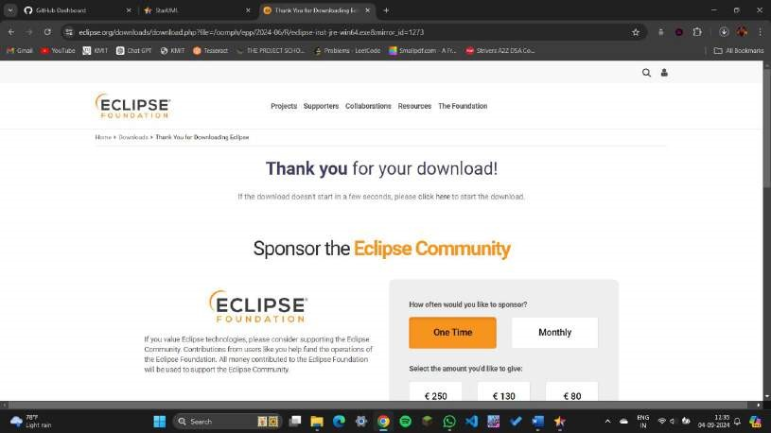

5.After installation, this will get displayed.

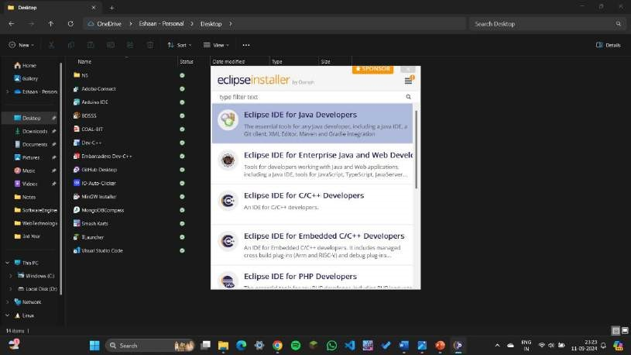

6.Open Eclipse and click Eclipse IDE for Java Developers

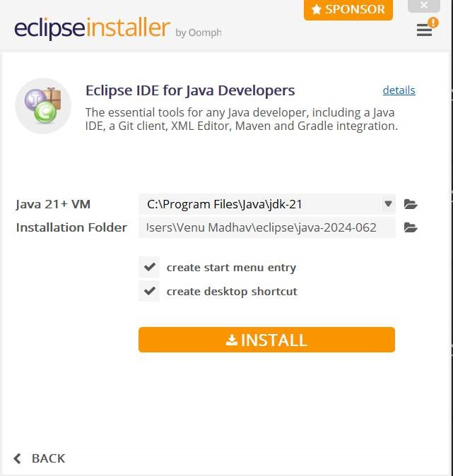

7.Click on install.

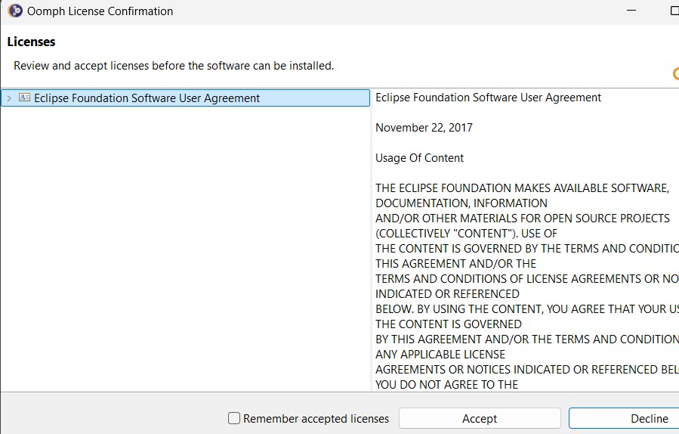

8.Click on accept now.

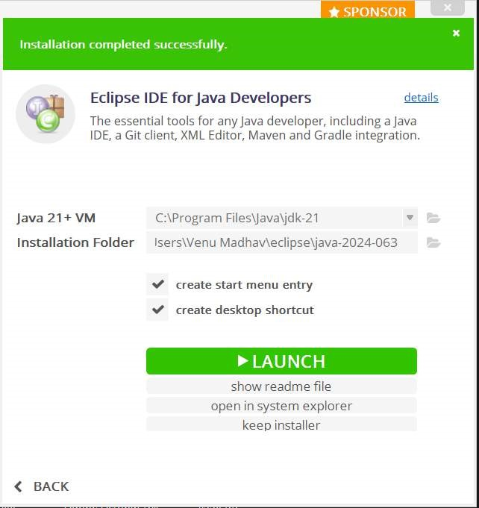

9.After installation, click on Launch.

Tomcat Installation:

* Visit [https://tomcat.apache.org/,](https://tomcat.apache.org/) navigate to download page of tomcat9 and select a Distribution for downloading

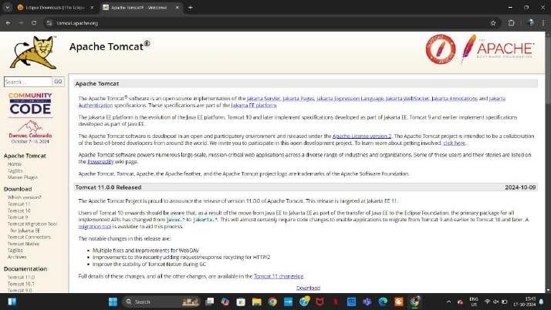

Run the setup for installation

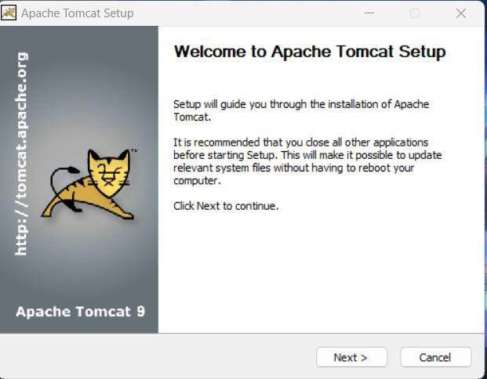

* Read the License agreement and agree with them

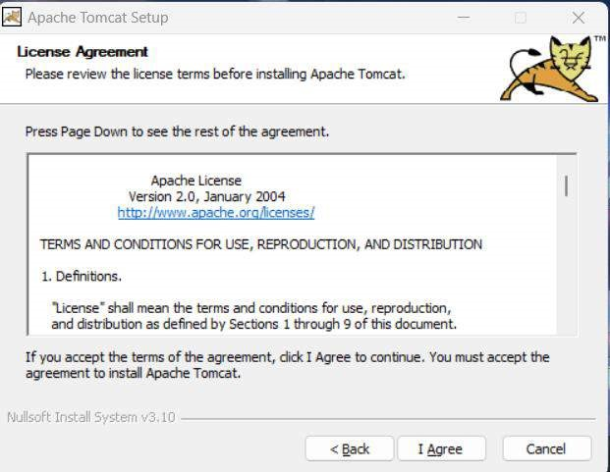

* Choose the components to be installed and move to the next step

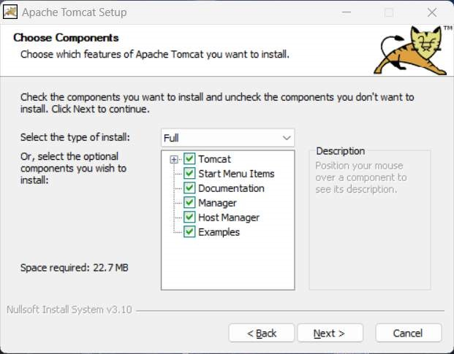

* Set the configuration by adding username and password

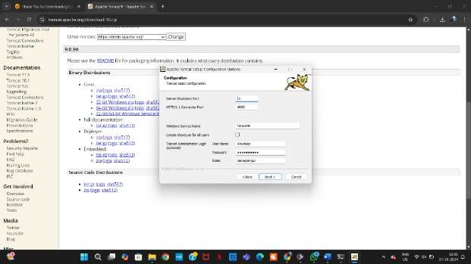

* Select the path of the pre-installed Java virtual machine

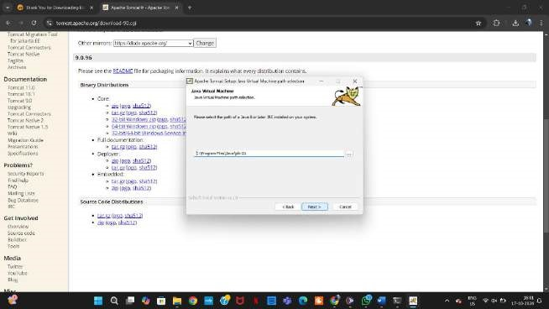

Select the installation path and move to the installation step

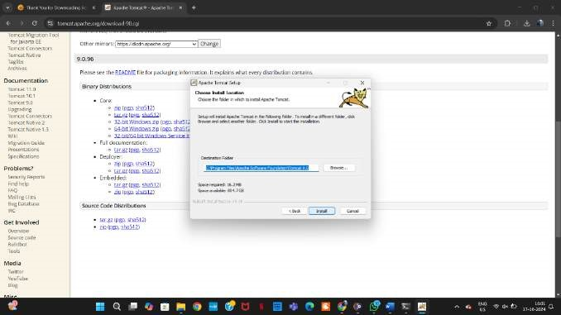

* After successful installation finish the setup

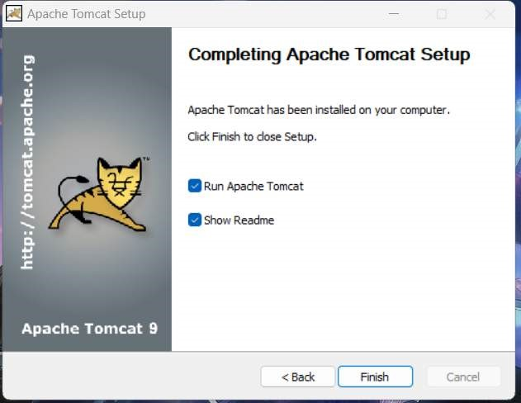

Go to the services and start the Apache Tomcat9 service

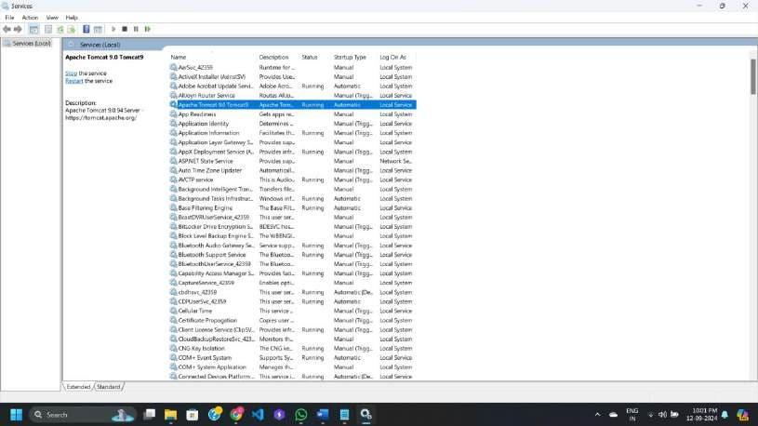

* Visit <http://localhost:8080/>and check if the tomcat9 is running and got installed successfully

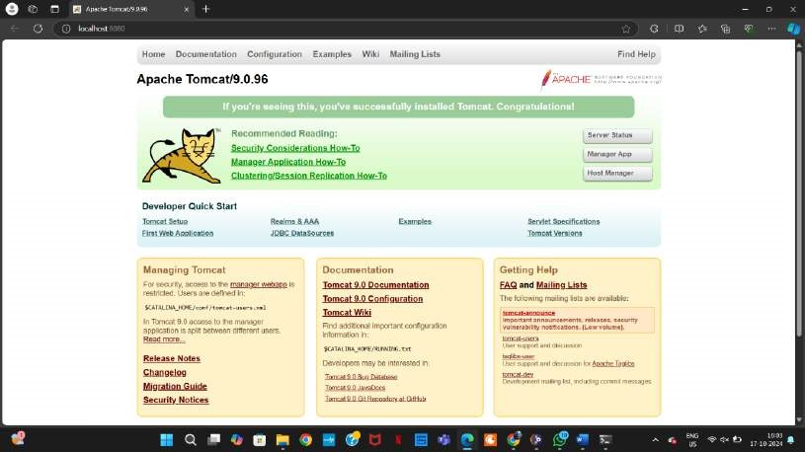

.

## Eclipse Installation

* Visit [https://www.eclipse.org/,](https://www.eclipse.org/) navigate to download page and select an installation file for download

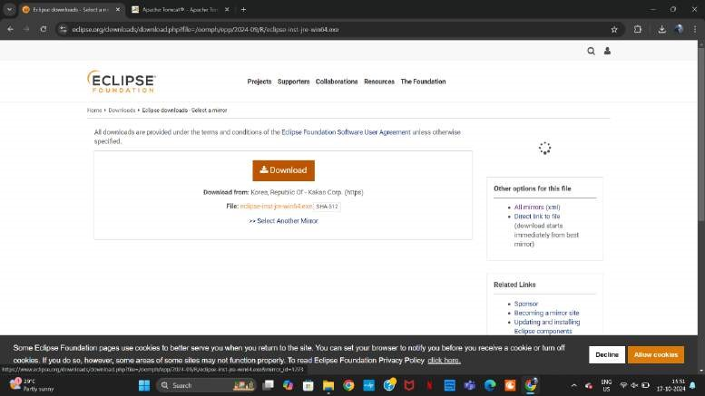

* Run the installer and select Eclipse IDE for Java Developers in the given options

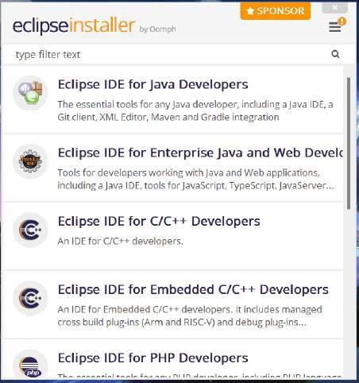

* Give the JVM location, and installation location

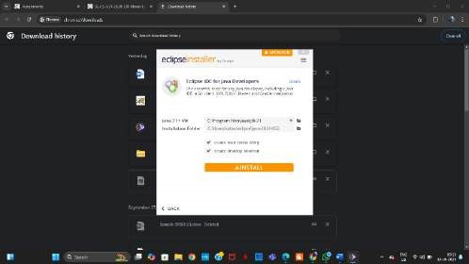

* Start the installation process

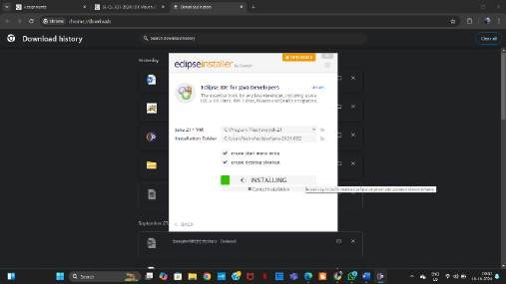

* After Installing click on launch

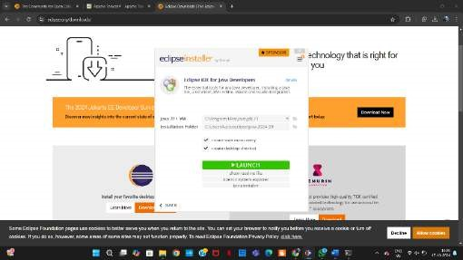

* Choose a Workspace Directory

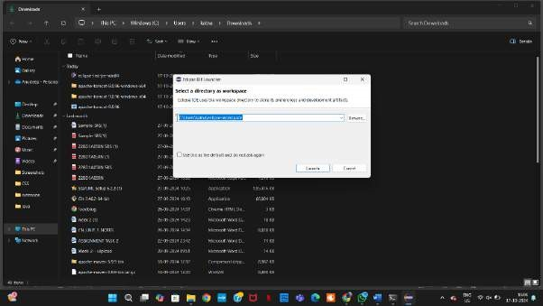

* Now open the IDE to ensure successful installation

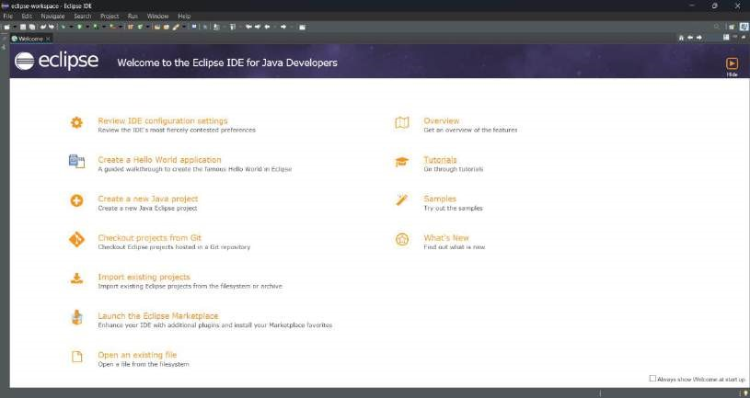

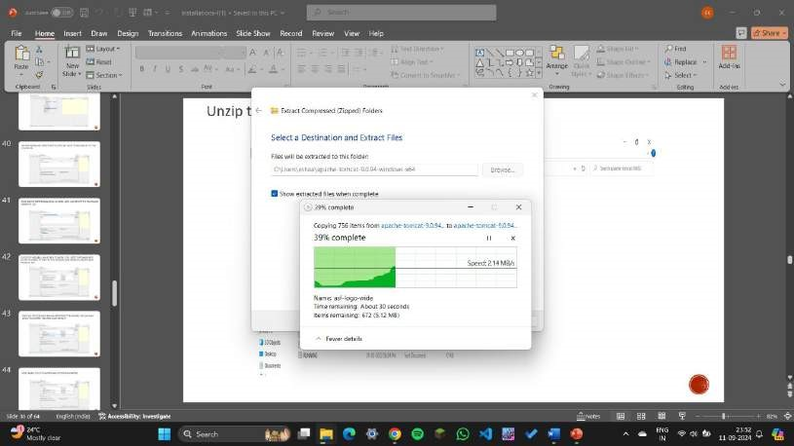

11.Extract the file in the path specified above.

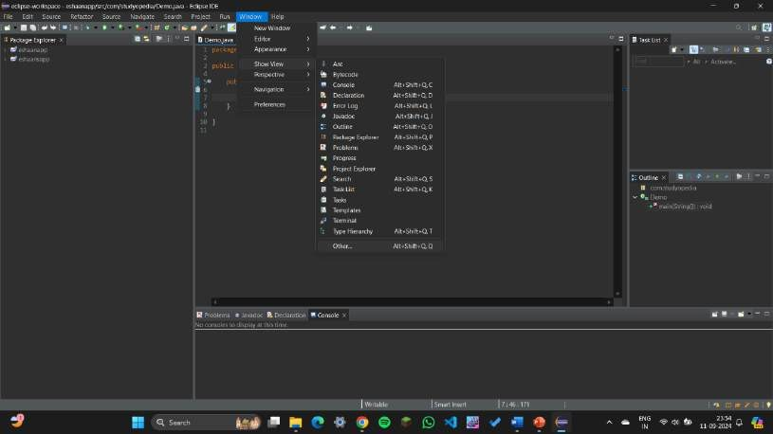

12.Click on Window ->Show view -> Other.

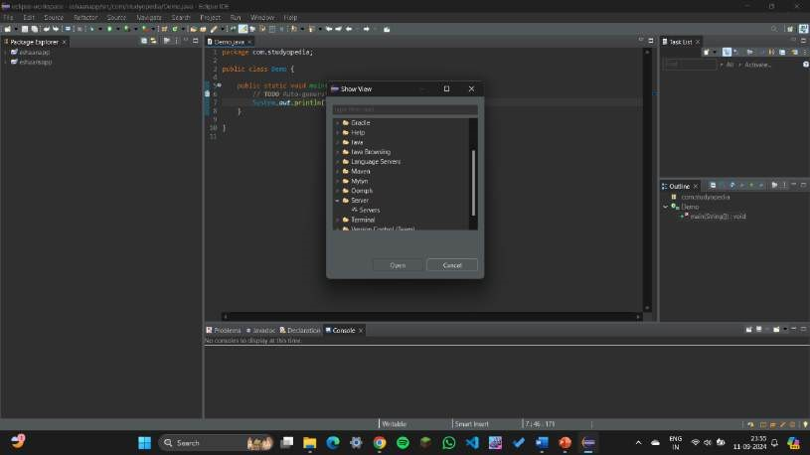

13.Click on Server -> Servers.

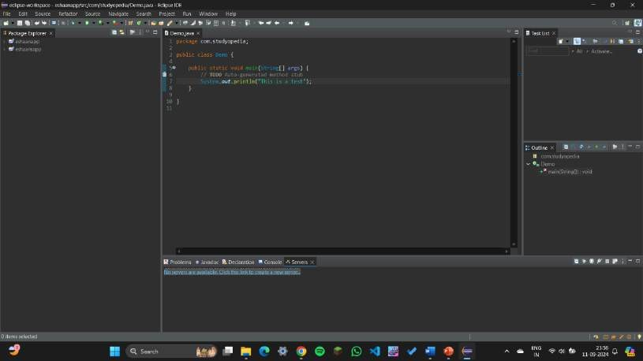

14.Create new server by clicking on the blue link.

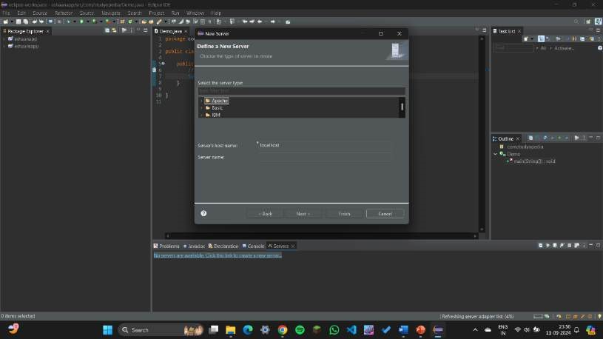

15.Define the server under Apache.

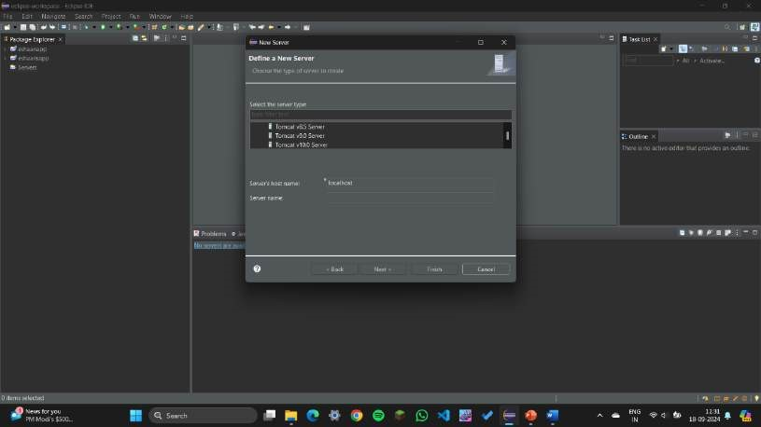

16.Click on Tomcat Server v9.0.

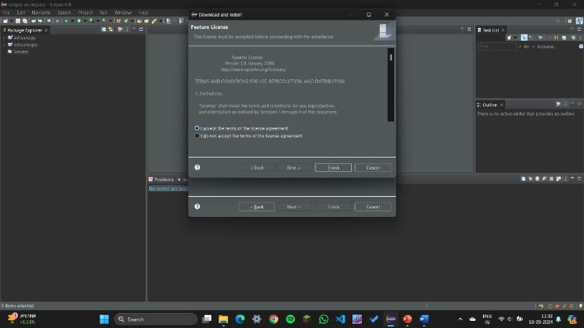

17.Click on Accept and then Finish.

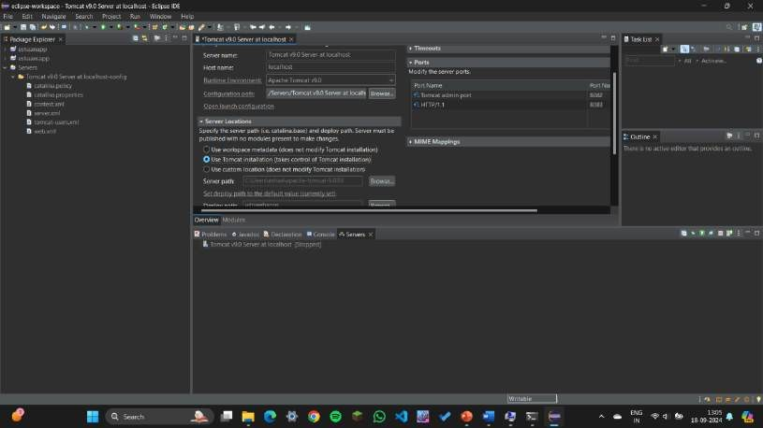

18.Update the port numbers as 8082 and 8083.

19.Under server locations click on Use Tomcat installation.

20.Save the file.

21.After saving the file, click on restart server.

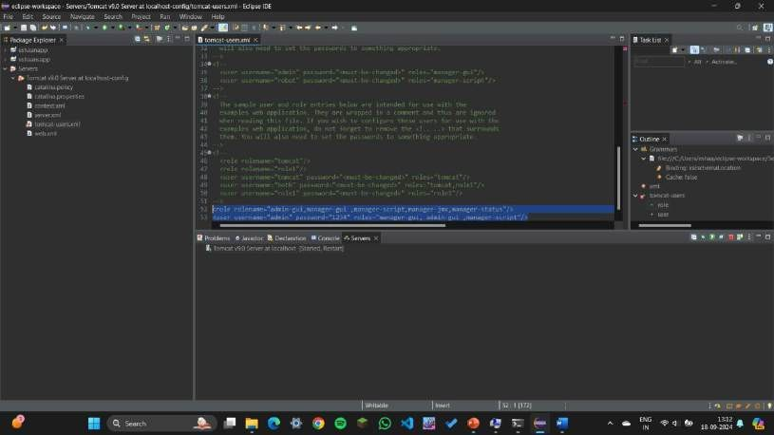

22.Under servers folder, open tomcat_users.xml file and write the highlighted text as mentioned above.

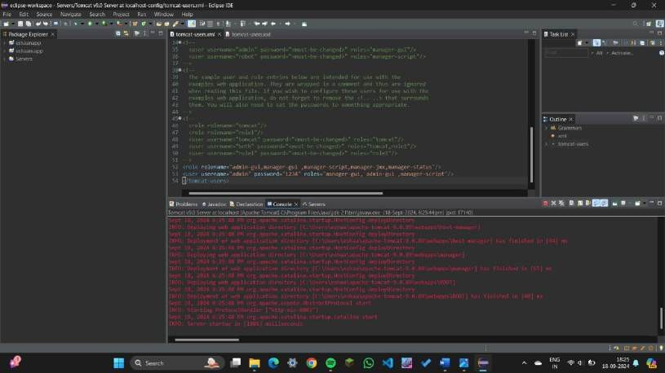

23.Start the server.

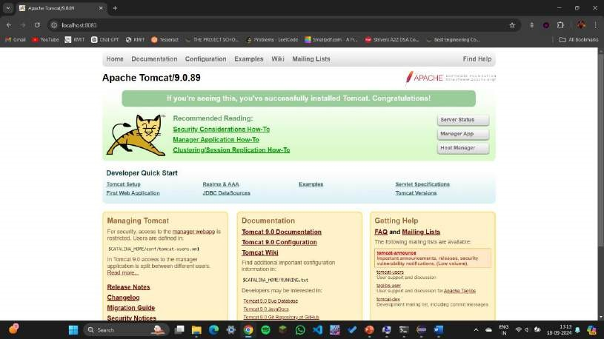

24.The port will open like this after successful installation of Tomcat.

JDK Installation

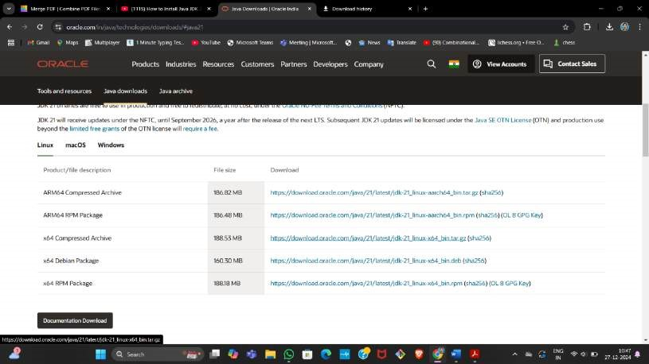

Go to Oracle.com and download jdk-21 package

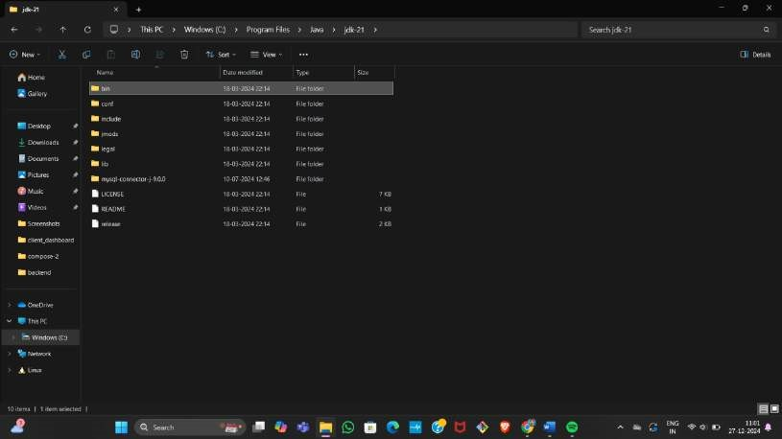

Copy the bin folder path of the jdk-21 java folder by following the path “C:\Program Files\Java”

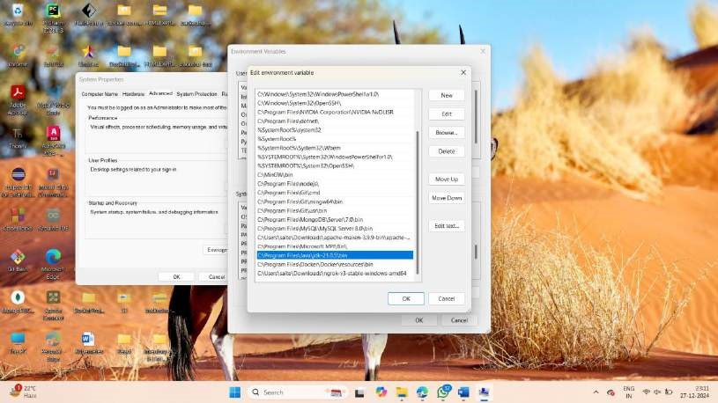

Open environment variable and under “System variables” create a new path and paste the path of the bin folder of jdk-21 and click ok.

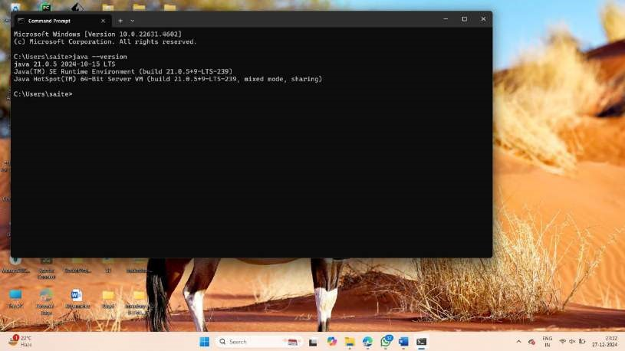

Open command prompt and type the command “java –version” to check whether the jdk-21 setup is successful or not . JDK version is displayed upon successful setup.

# Experiment-4

**A. BASIC GIT COMMANDS - VERSION, CONFIG, INIT, STATUS, ADD,**

**COMMIT, DIFF, HELP**

## 1. Git Version: Check if Git is installed using git –version

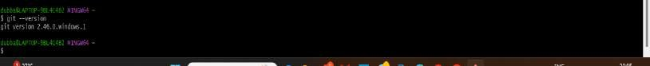

1. **Git Config:** Set up your name and email using git config.



1. **GIT INIT:** Initializing the git by creating a Git repository

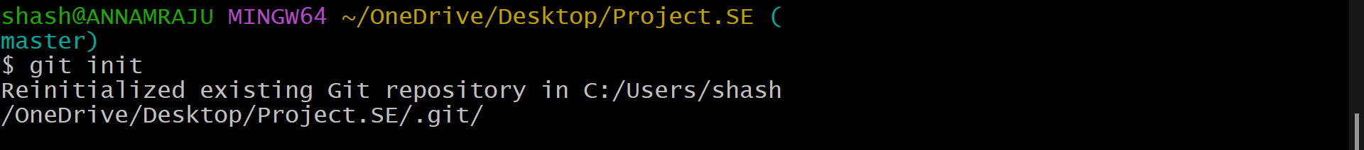

1. **GIT STATUS:** checking the current state of the files

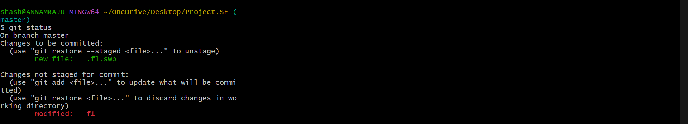

1. **GIT ADD:** It adds the files to the staging area



1. **GIT COMMIT:** It is used to save the changes and explains what has changed

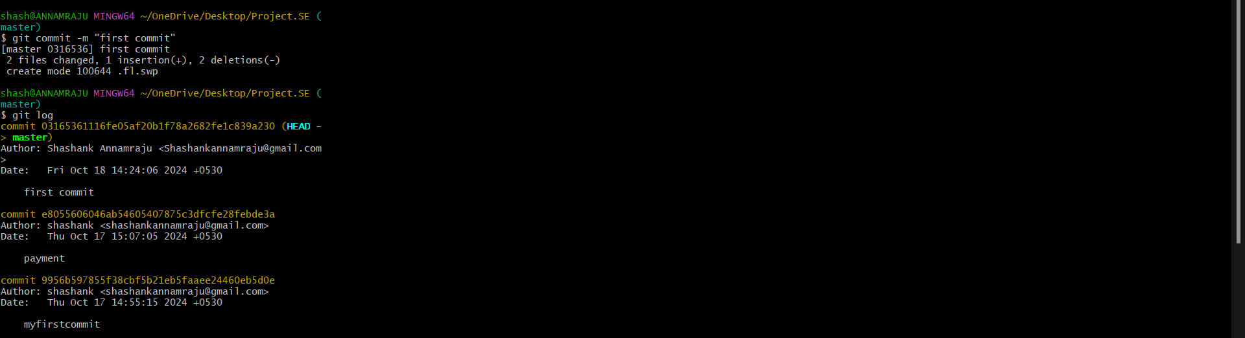

1. **GIT DIFF:** It compares the changes between current files and the last commit

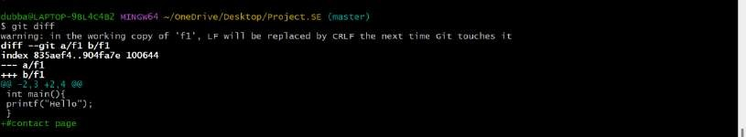

1. CAT : It displays the contents of the files.



**B. GIT COMMANDS: WORKING WITH LOCAL AND REMOTE REPOSITORIES - BRANCHES, MERGE, REVERT, LOG**

1. **GIT BRANCH:** A branch is a workspace where we can work on new features

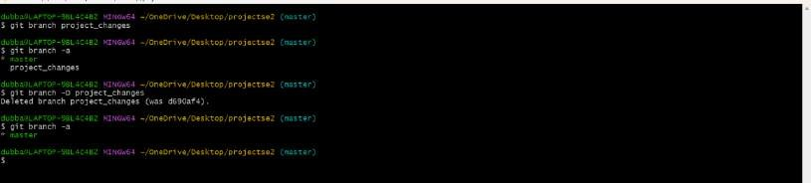

1. **GIT LOG:** It shows the full history of the project.

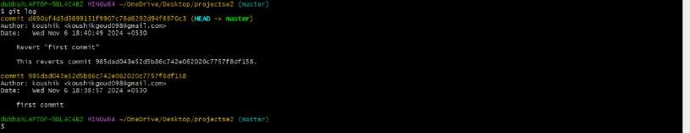

1. **GIT LOG ONELINE:** It shows the commit history in one line.



1. **GIT REVERT:** It creates new commit that undoes the changes made in previous commit.



5.**GIT MERGE TEST**

Merges the "test" branch into the current branch

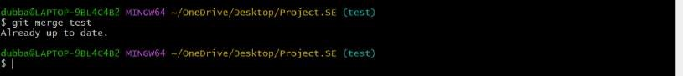

6**.GIT CHECKOUT**

Switches to a specified branch or commit.



**C. GIT COMMANDS: WORKING WITH REMOTE REPOSITORIES - REMOTE, CLONE, PULL, PUSH, FORK**

1. **GIT REMOTE:** It manages the connections to other Git repositories stored in internet like GitHub.

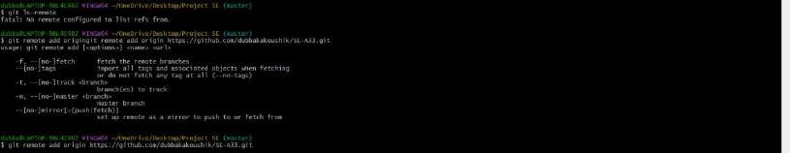

1. Now push the branch using following command.

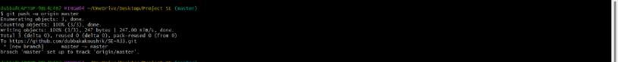

1. **GIT CLONE:** It is used to download a copy of project from remote repository.



Now check the status using Git status command.

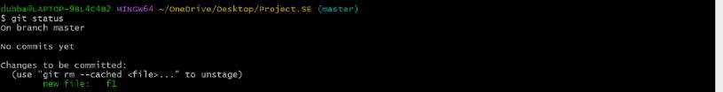

• Now check whether it’s pushed or not in GitHub.

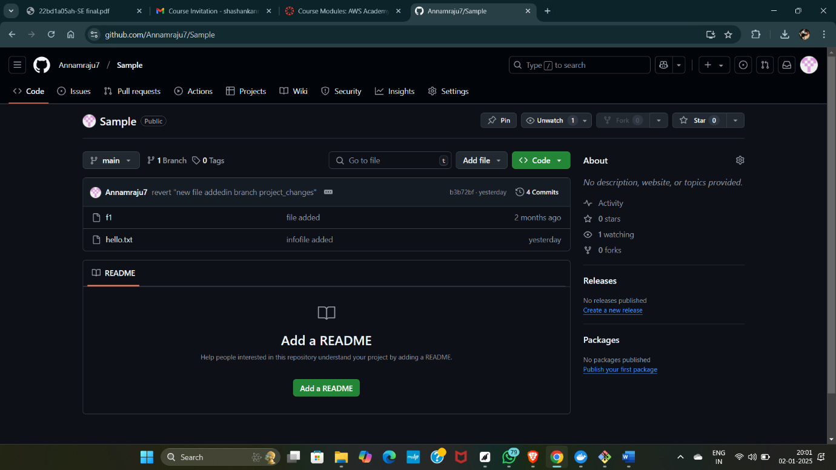

# Experiment-5

## A) MAVEN JAVA PROJECT

* Go to Eclipse and add a new Java maven project .

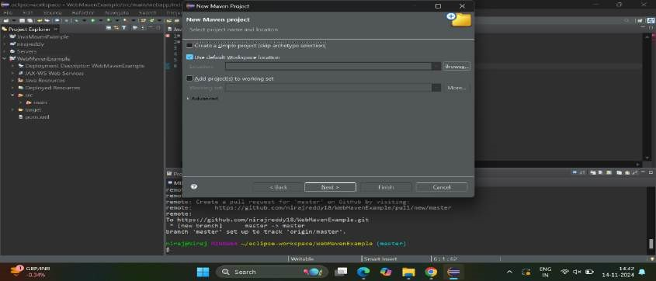

* Click on next.
* Now filter for org.apache.maven and select for quick start.

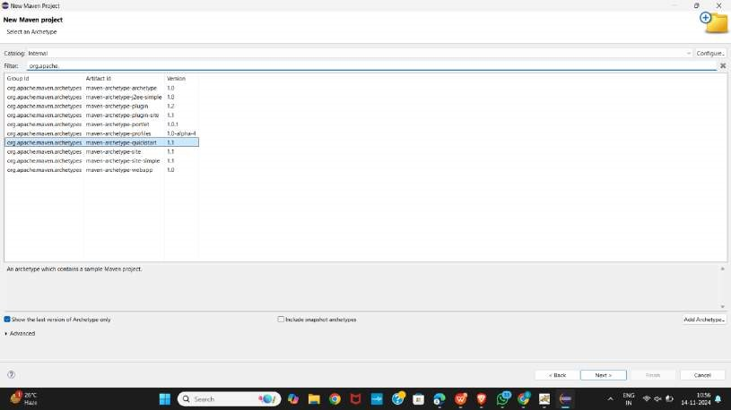

* Now give group id and artifact id.

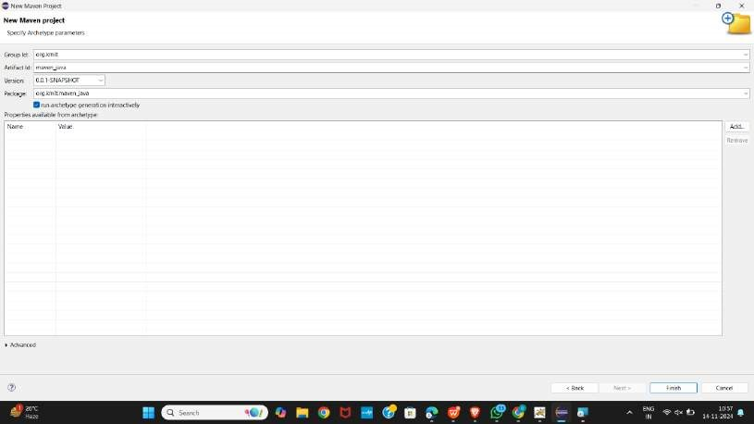

* Now open pom.xml in the package folder. Also open app.java from src main

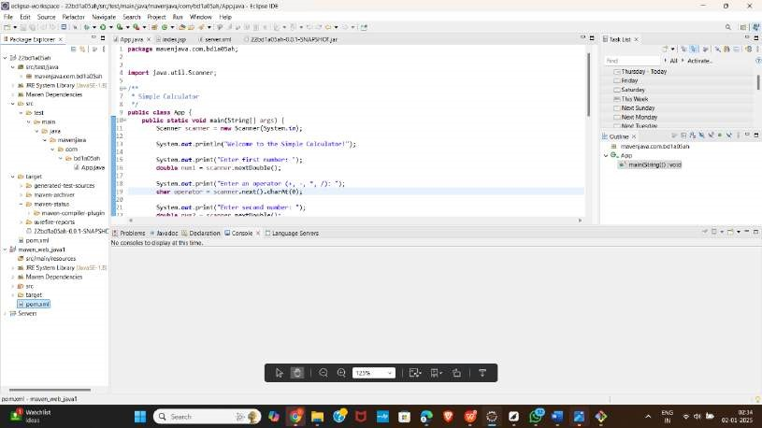

* Now clean it by using maven clean.

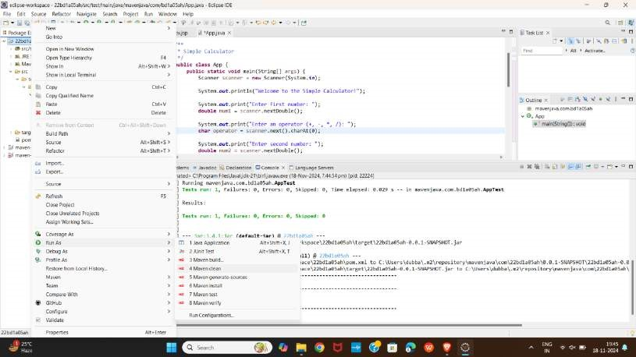

* Now it should show build success in console.

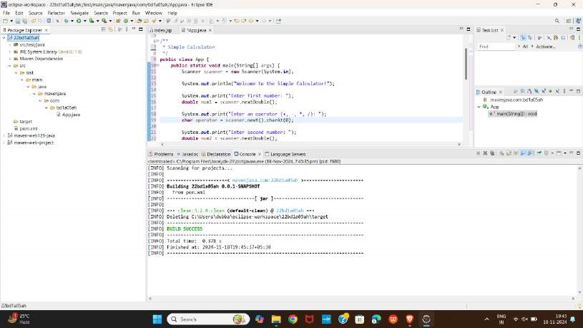

•

* Now install using maven install and it should output build success

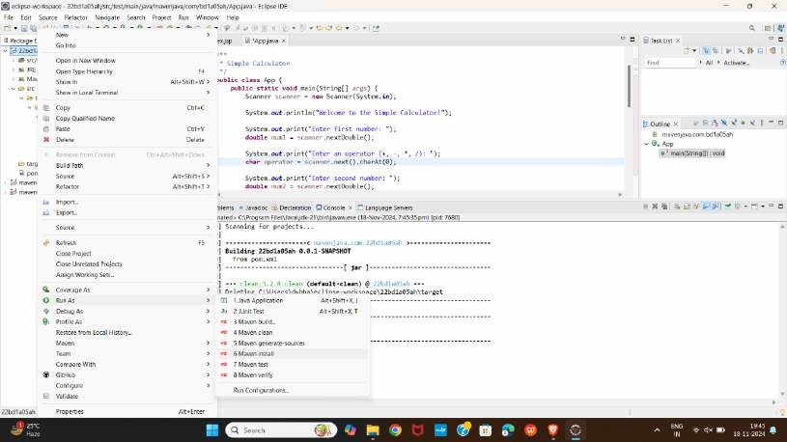



* Now test using maven test and it should output build success



* Now build using maven build and give clean install test at goals and apply and run

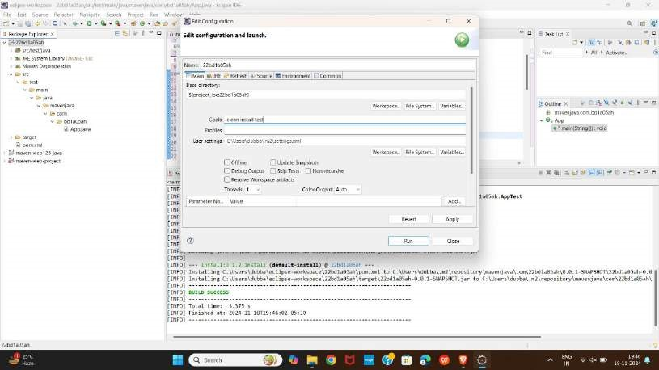

* Now open github and create a new repository and given maven template at .gitignore and create a new repository.

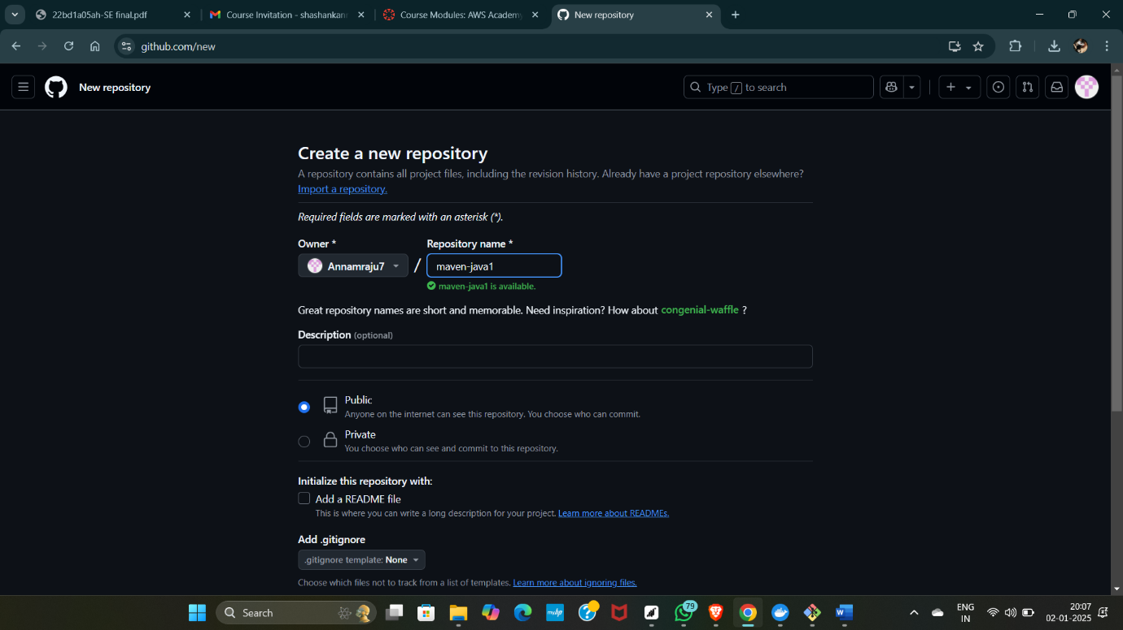

* Now open git bash and clone it using git clone.

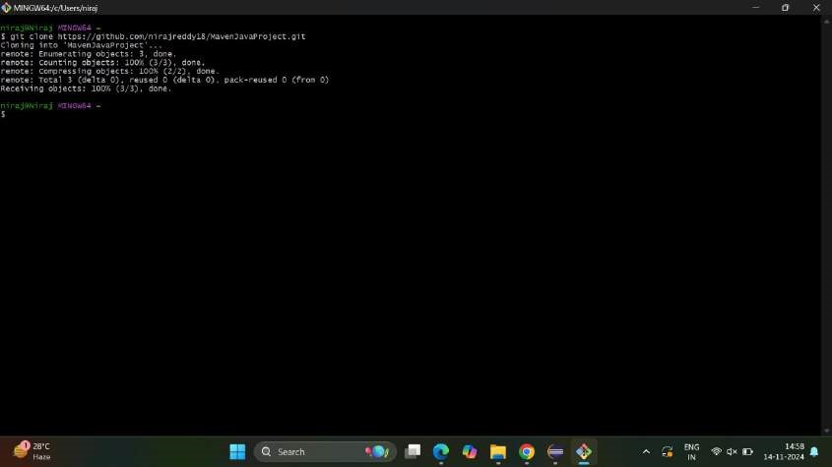

Now use cd MavenJavaProject.

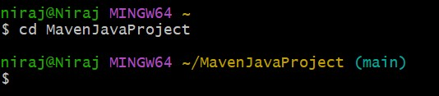

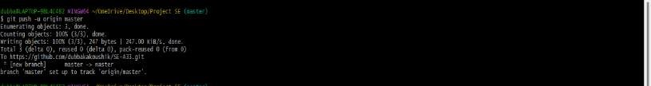

* Now reload the github page to see the contents that have added.

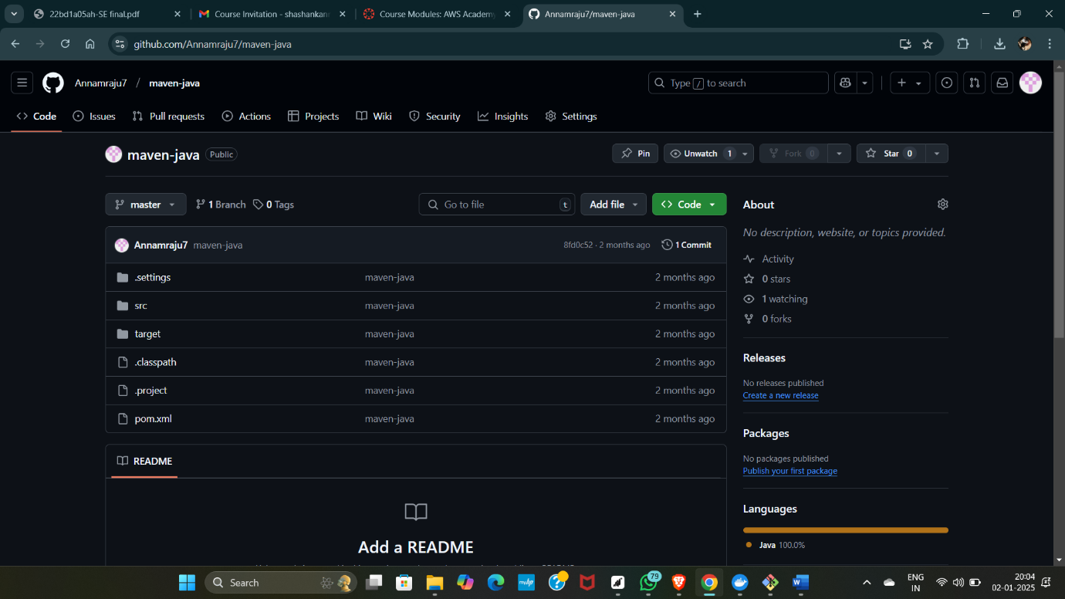

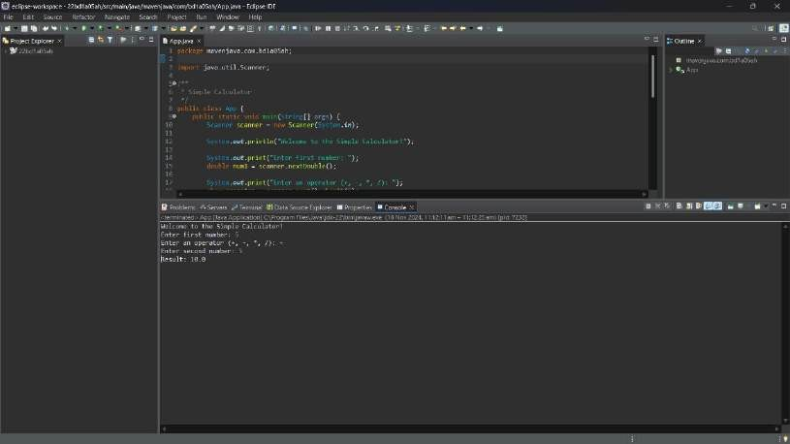

## B) MAVEN WEB PROJECT

* Now open Maven project again from file.

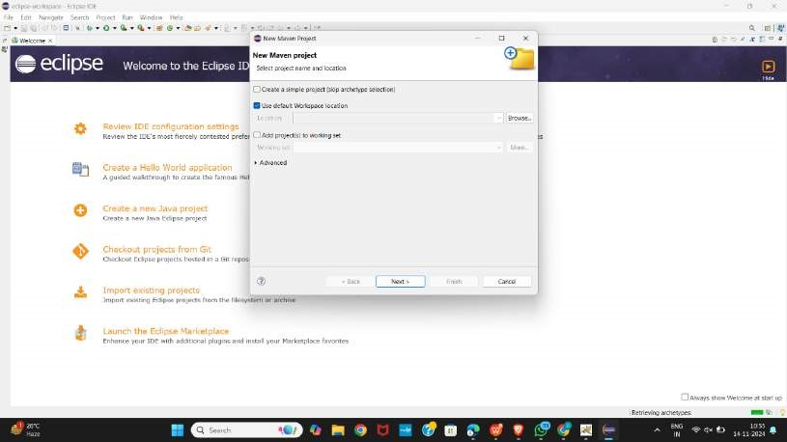

* Now filter it using org.apache.maven and select for web app and click on next.



* Now give group id and artifact id and click on finish.

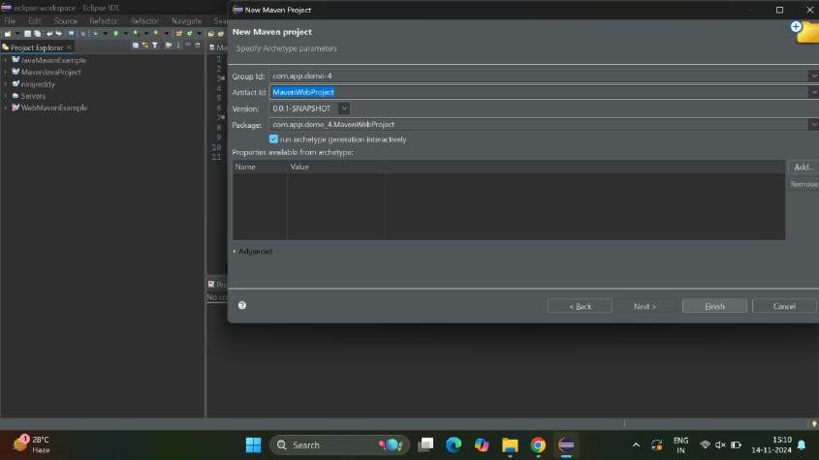

* Now open pom.xml.

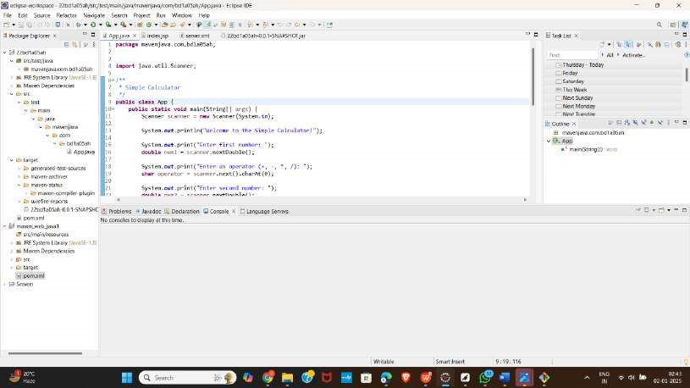

* Now open index.jsp and change the content inside.

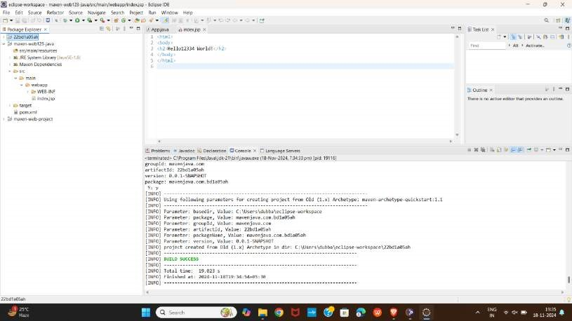

* Now use maven clean and it should output build success.

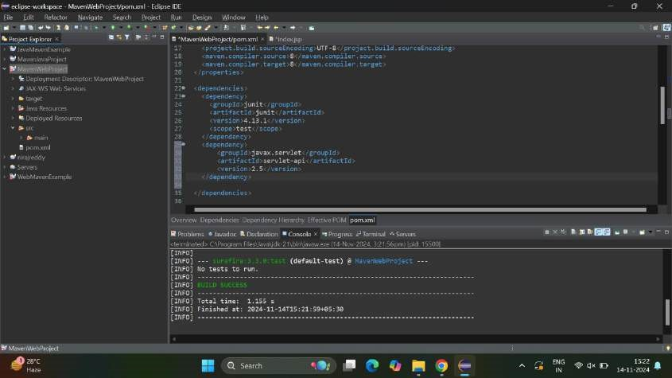

* Now use maven build and specify the goals as clean install test and apply and run it.

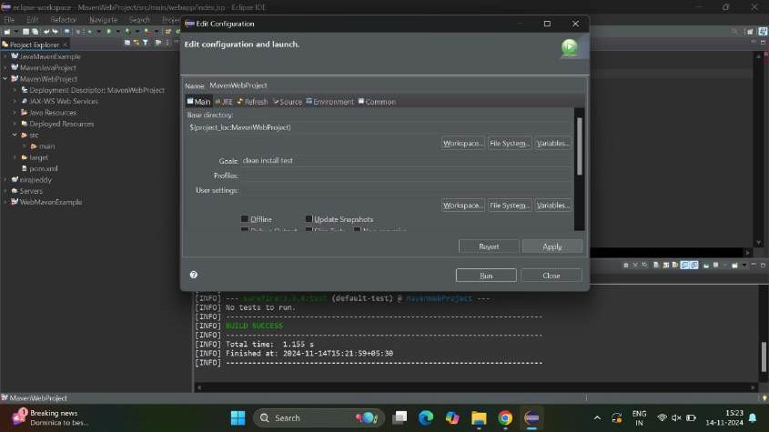

Now apply maven clean function

It will show output as success

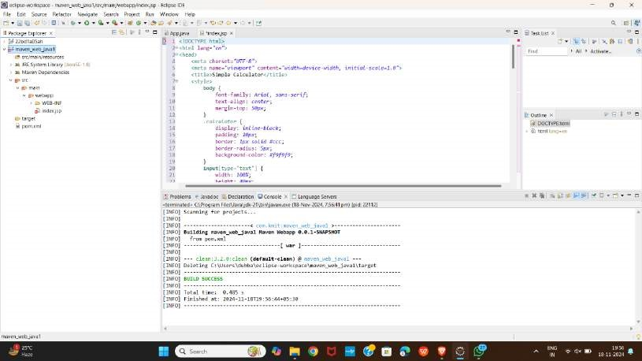

* Now do maven install operation

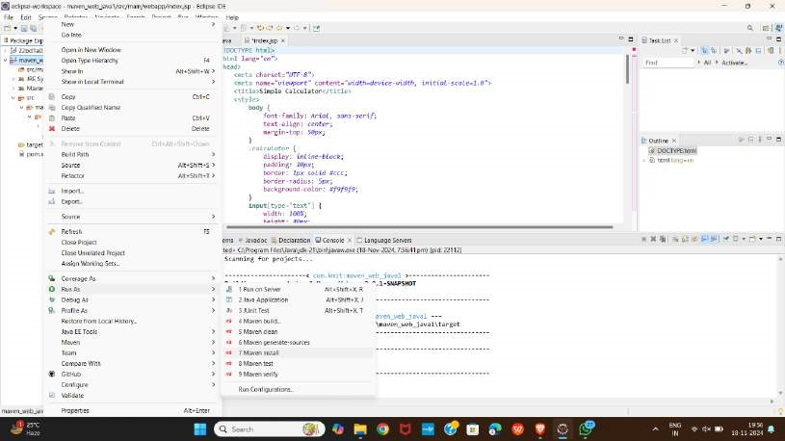

* Now open Github and create a new repository and specify template as Maven at .gitignore.

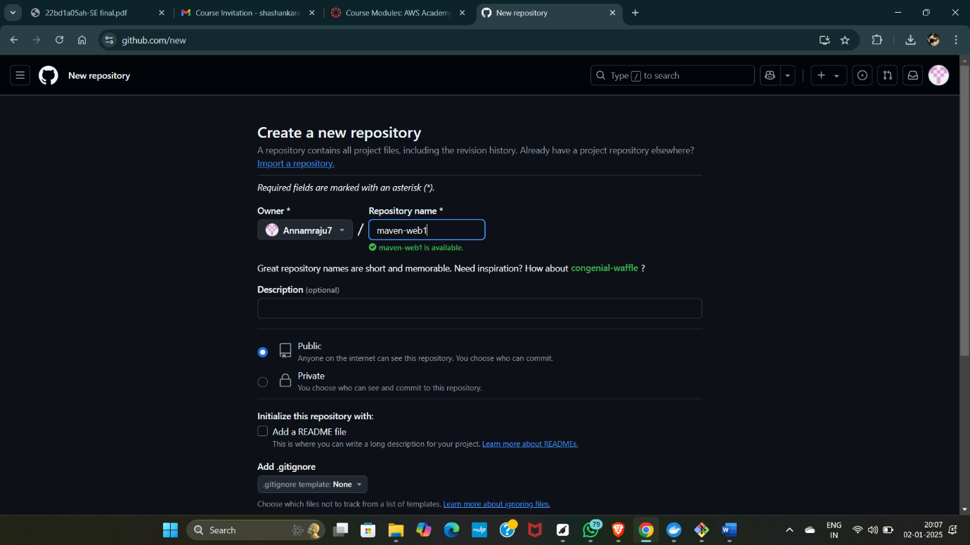

* Now open git bash from eclipse using local terminal.

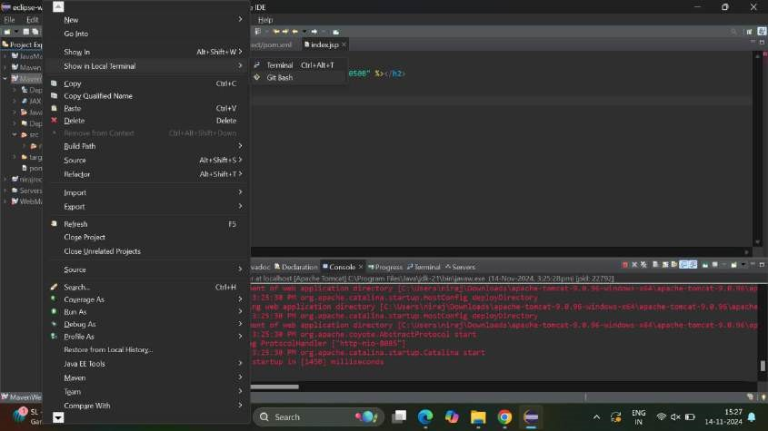

Now initialize a git repository and use ls command to check the list of files.

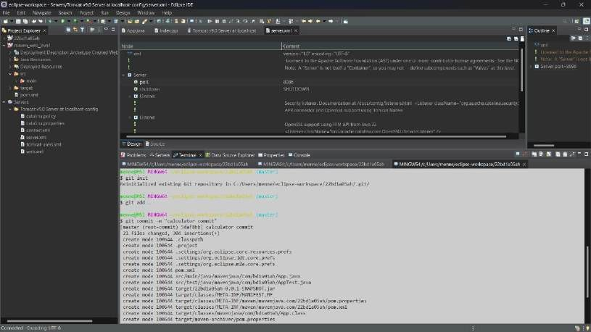

* Now add the files using git add command.

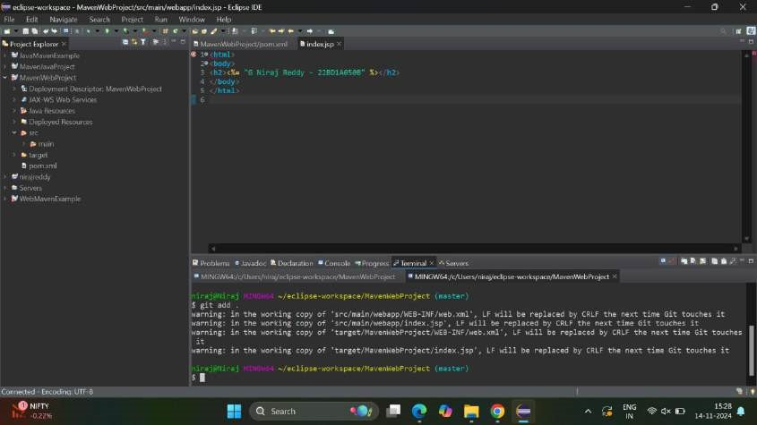

Now commit the changes using git commit command.

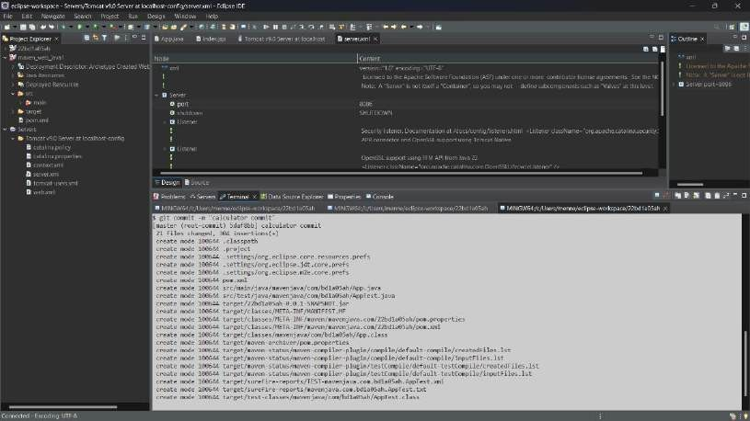

Now push the project to the github using git push command.

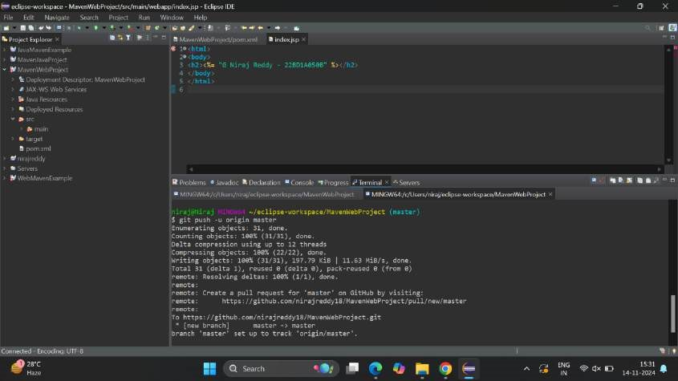

Then the output of the following is

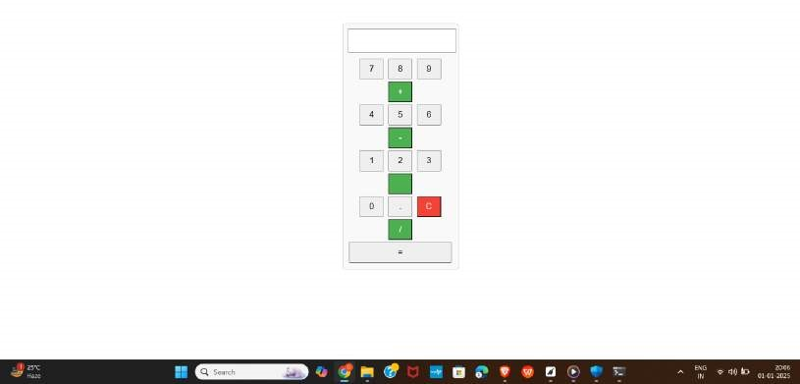

# C) JENKINS INSTALLATION

* Go to jenkins.io in a browser, open the official site and click on download.

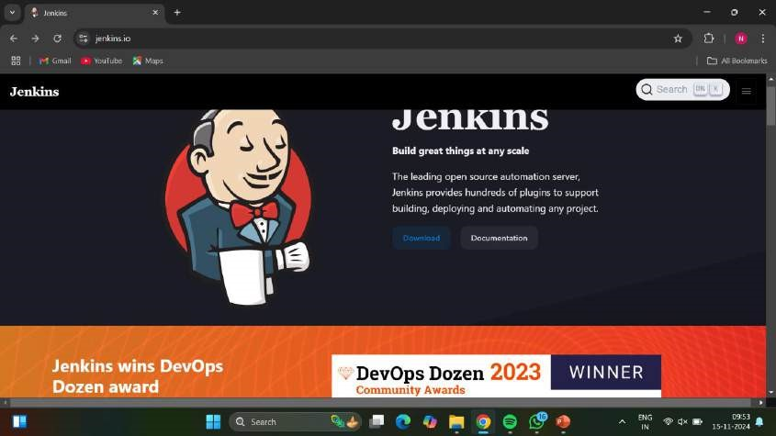

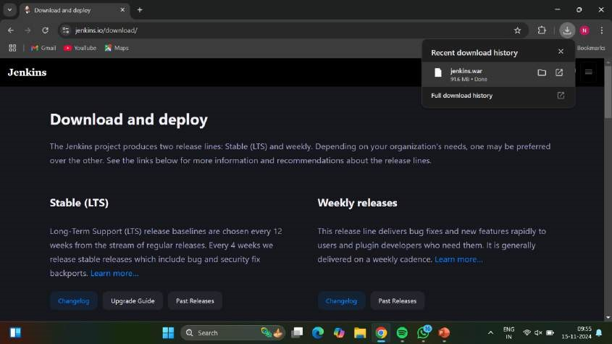

* Download the generic java package and click on windows.

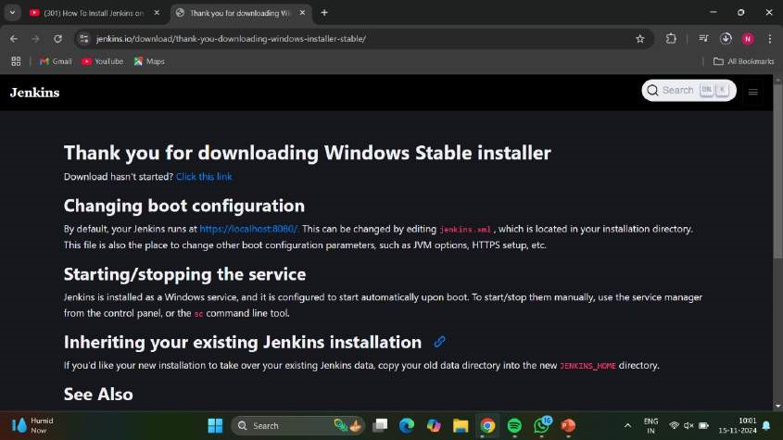

Now open jenkins and click on next.

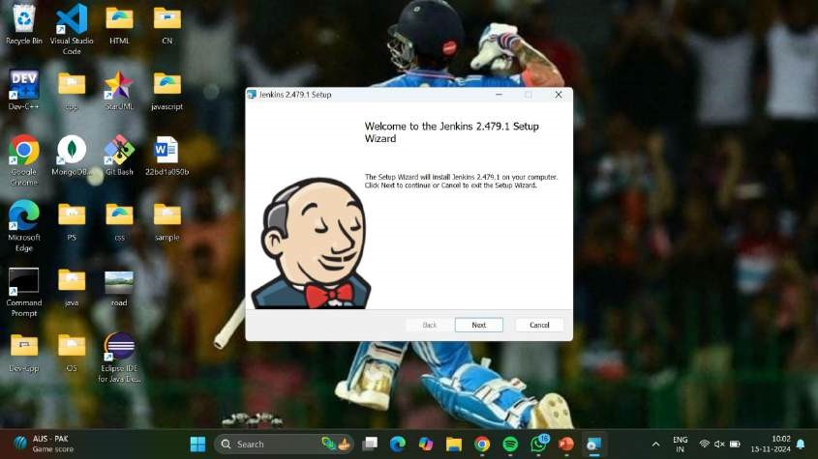

* Now click on next for dropping the file in program files.

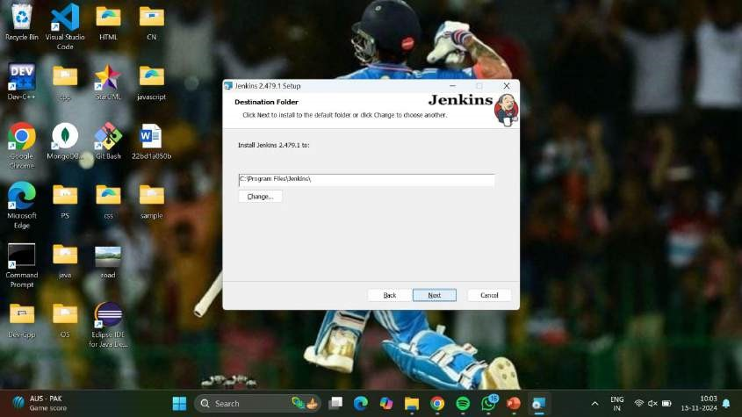

Now it shows a page which asks account and password.

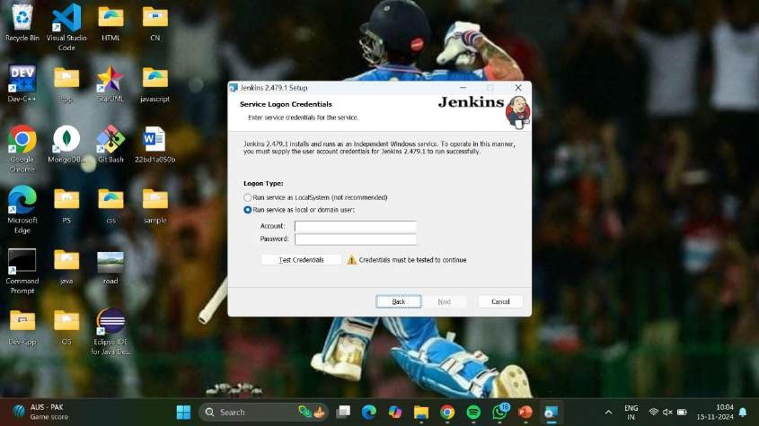

* Choose run service as Local system option.

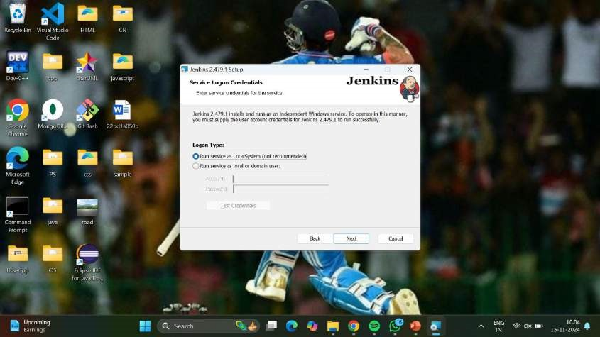

And click on next.

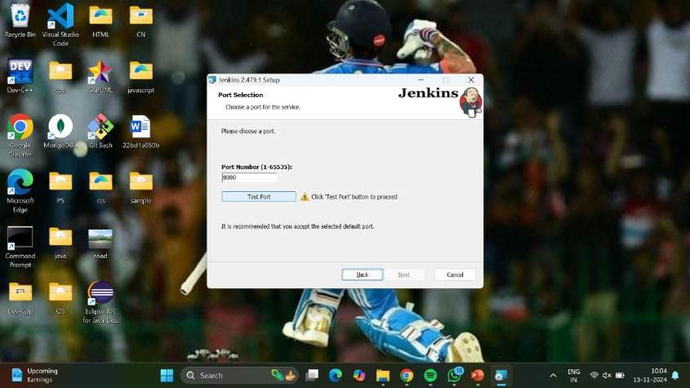

* Click on test port.

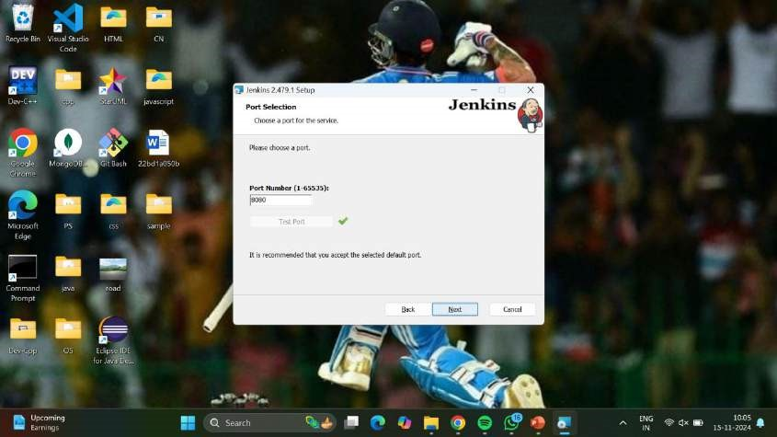

Now click on next.

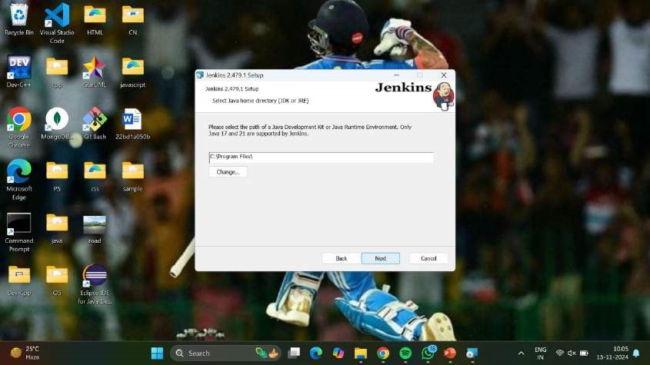

* Now select java home directory.

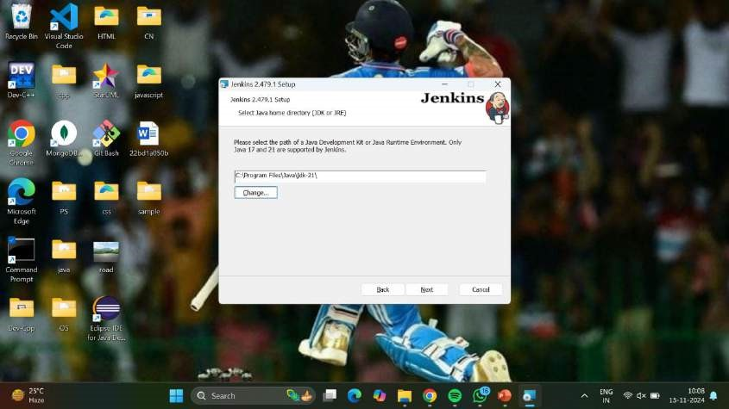

Click on next.

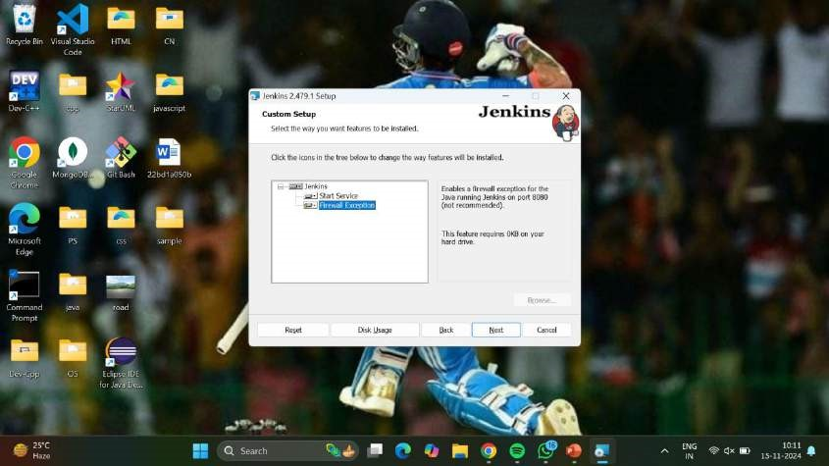

* Now click on install.

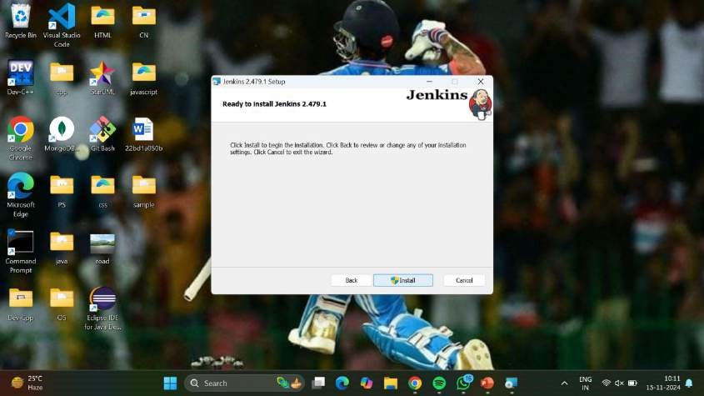

It will show status of installing.

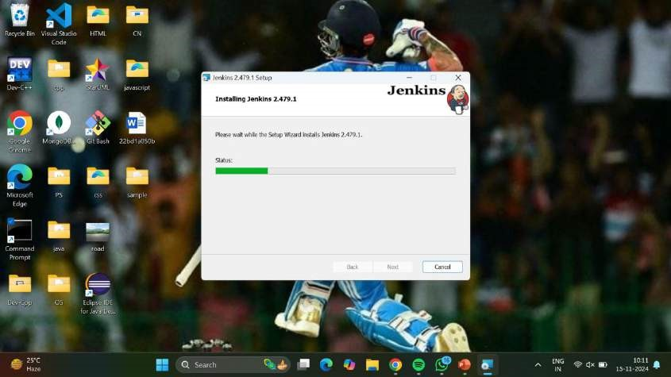

* After installing click on finish.

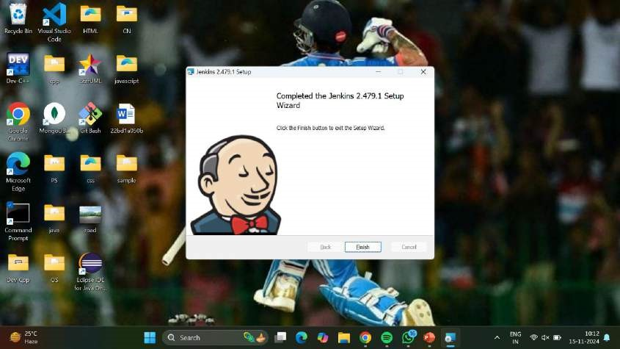

Now open localhost:8080.

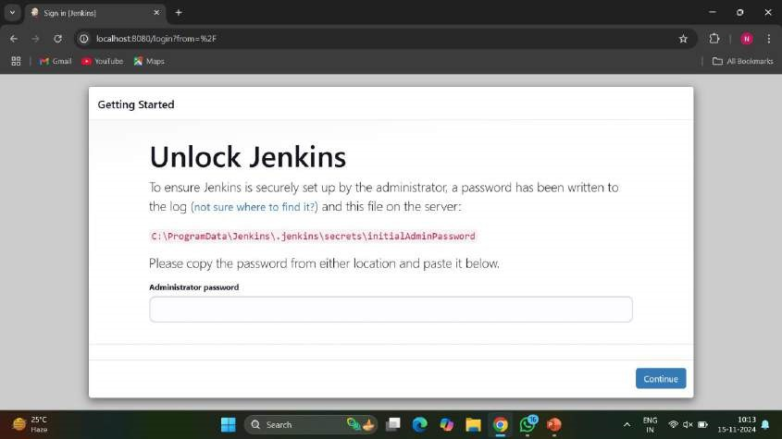

* Now copy the password.

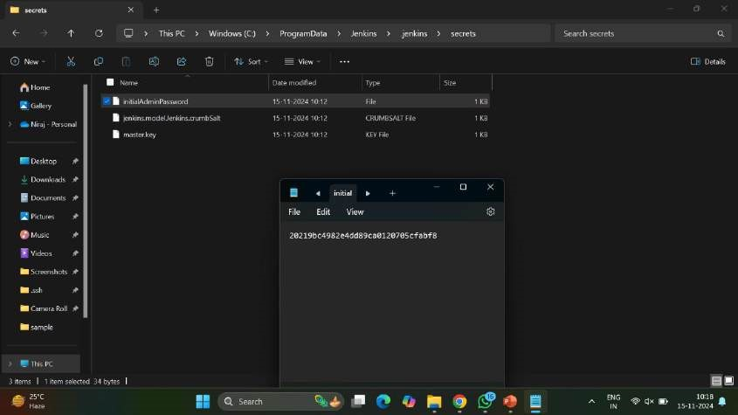

Paste the password in jenkins and click on continue.

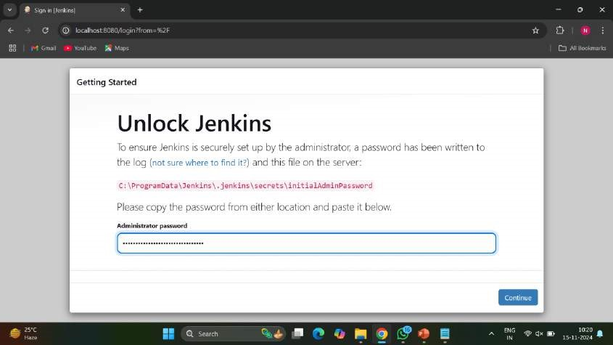

* After continuing, install the suggested plugins.

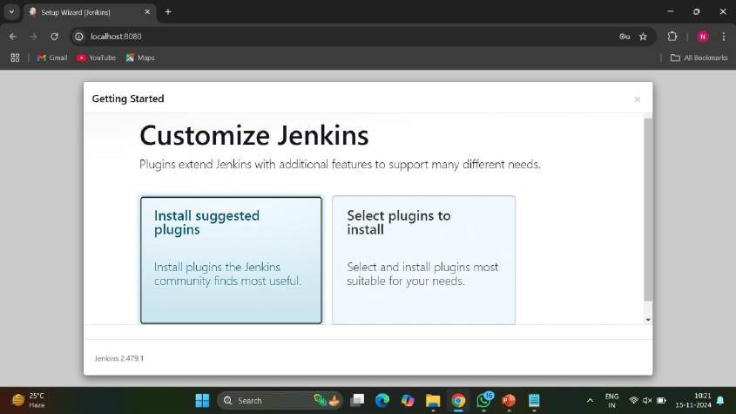

Now it will open to page where everything is installing.

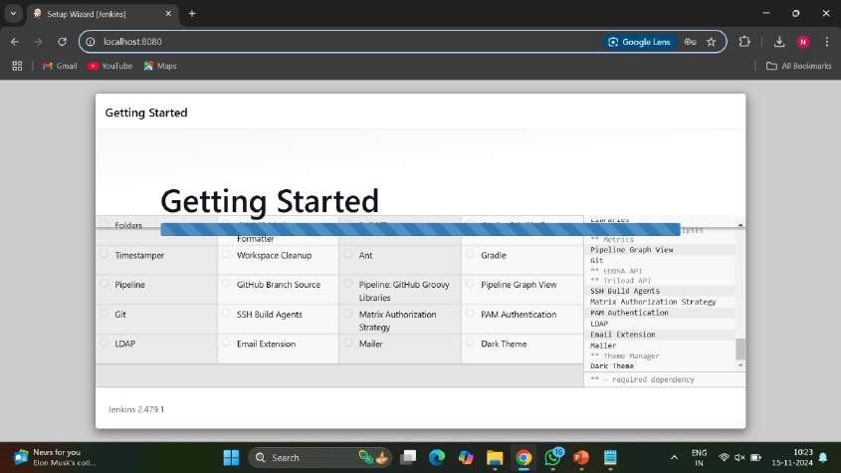

* Now create first admin user, then click on save and continue.

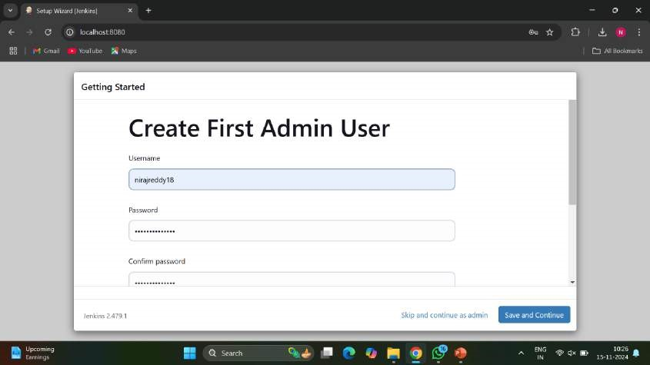

After that click on save and finish.

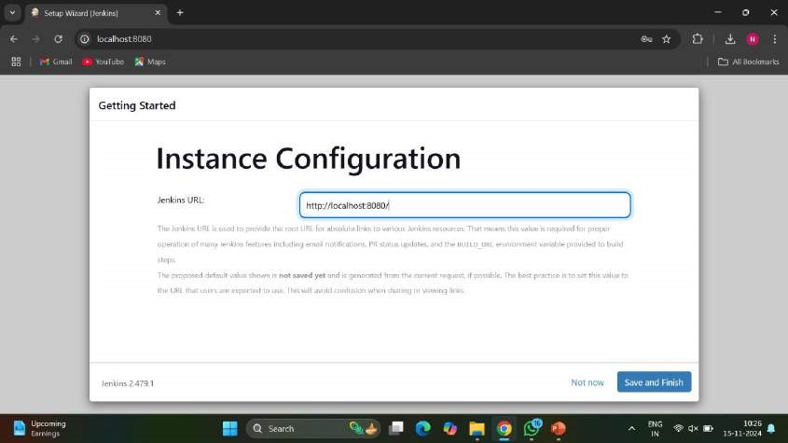

* Now the jenkins is ready and click on start using jenkins.

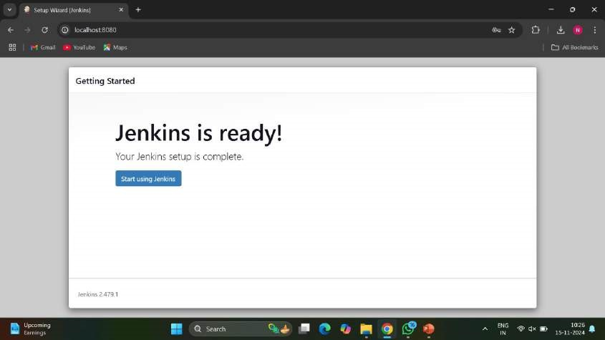

Now it shows a dashboard and head towards manage jenkins.

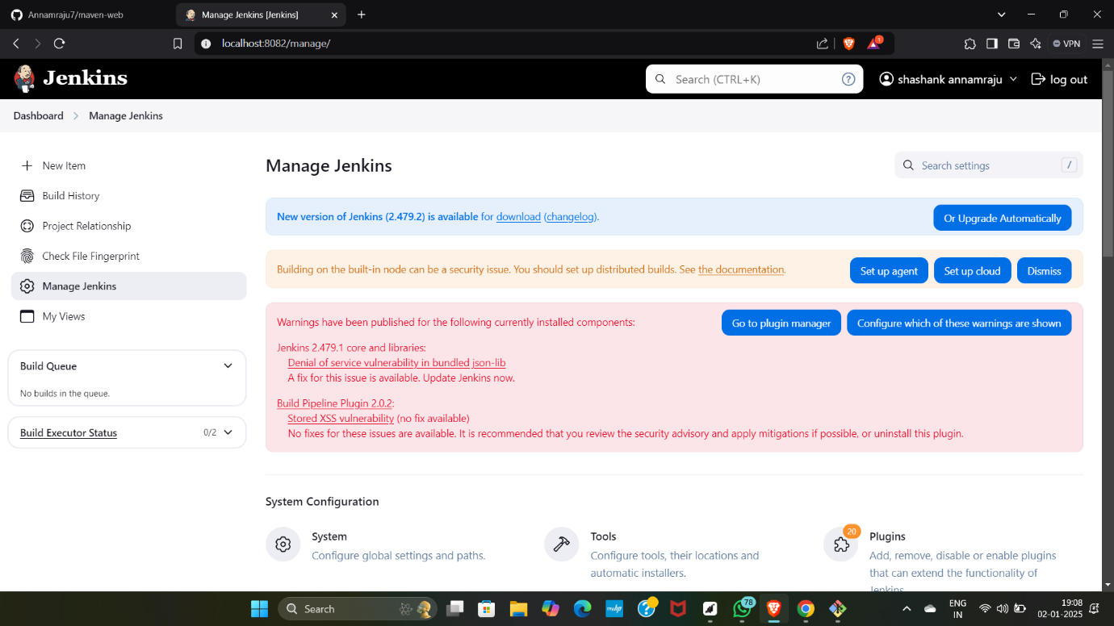

* Now go to available and first install the maven integration.

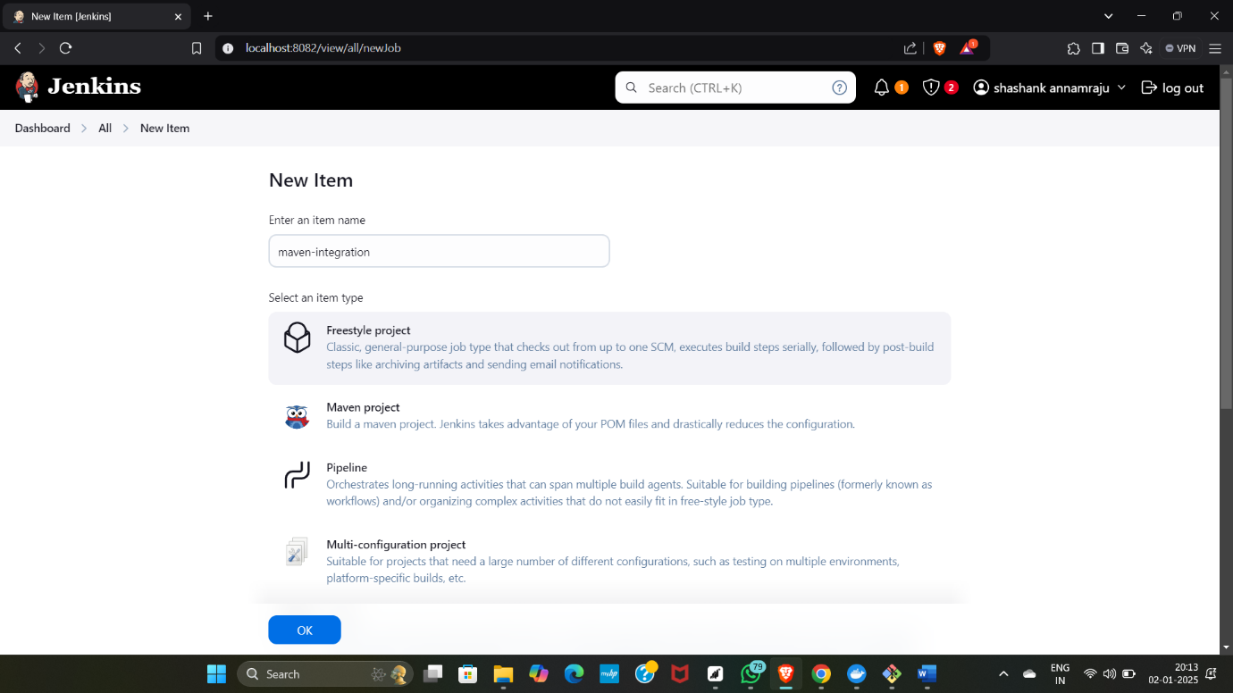

Now install build pipeline.

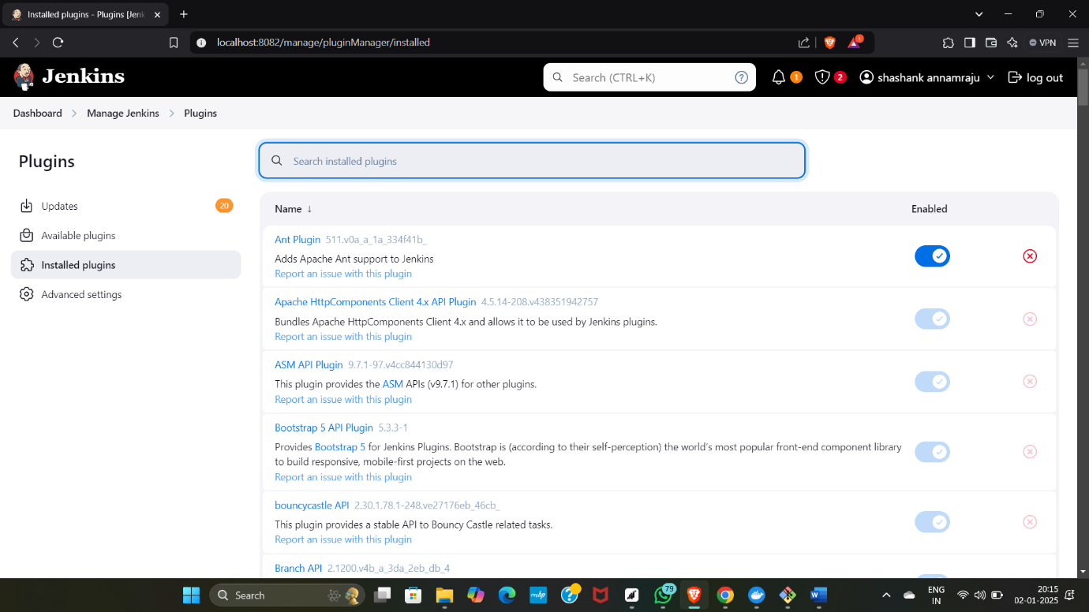

* Now install pipeline utility steps.

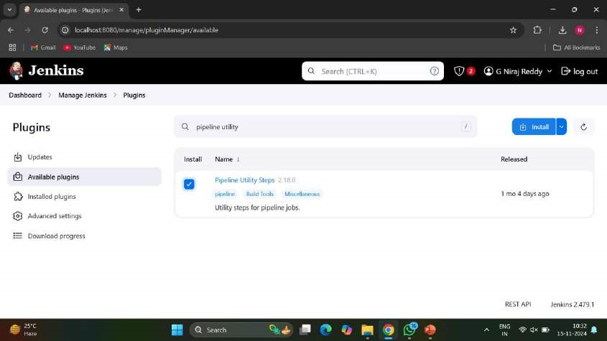

Now install copy artifact.

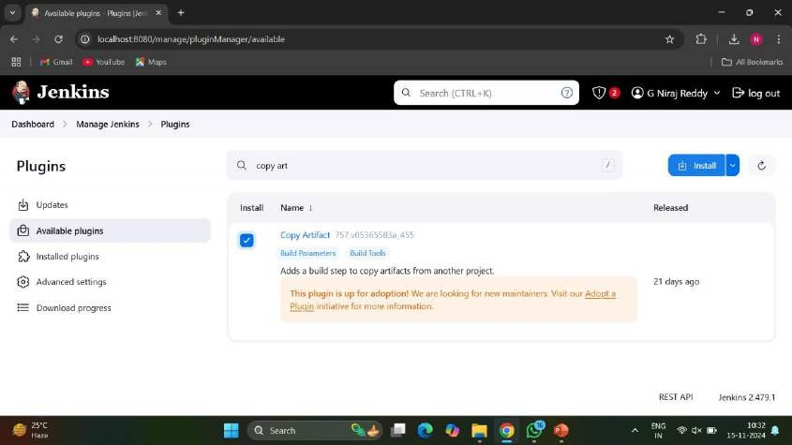

* Now install deploy to container.

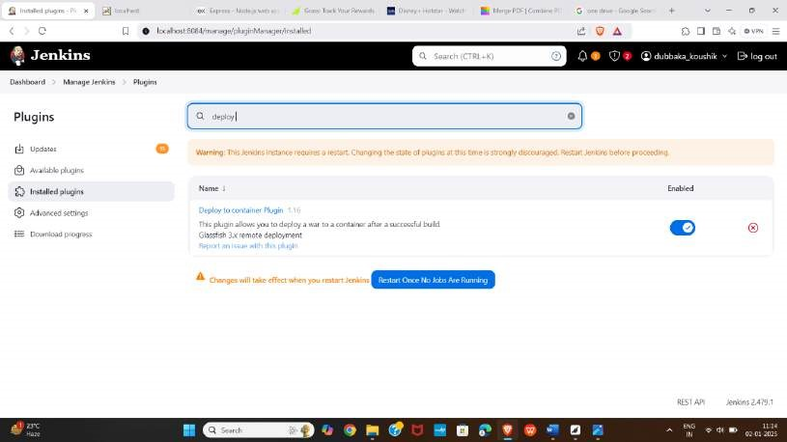

Now we need to configure jenkins with maven, so go to manage jenkins and click on tools.

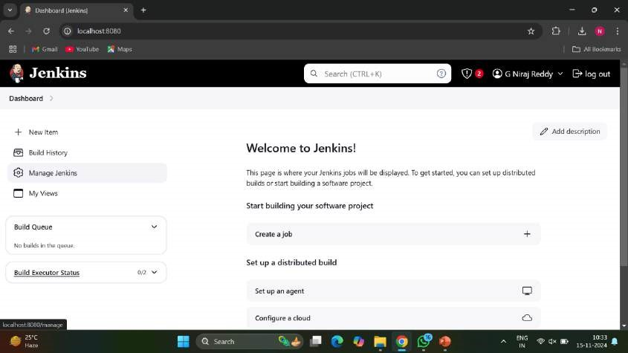

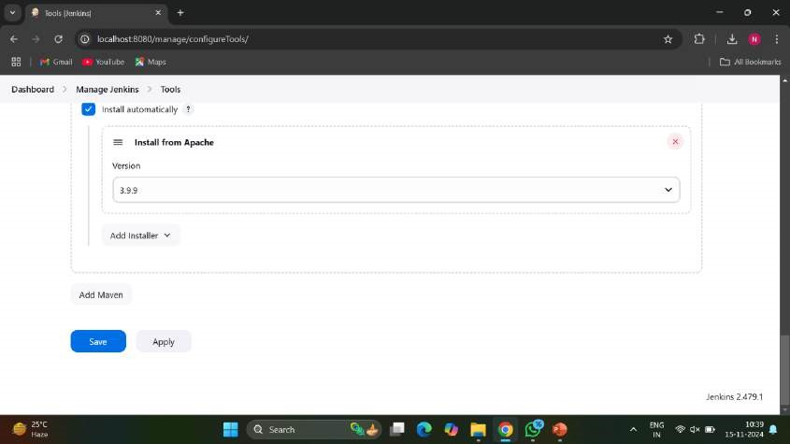

* Now go down for jdk.

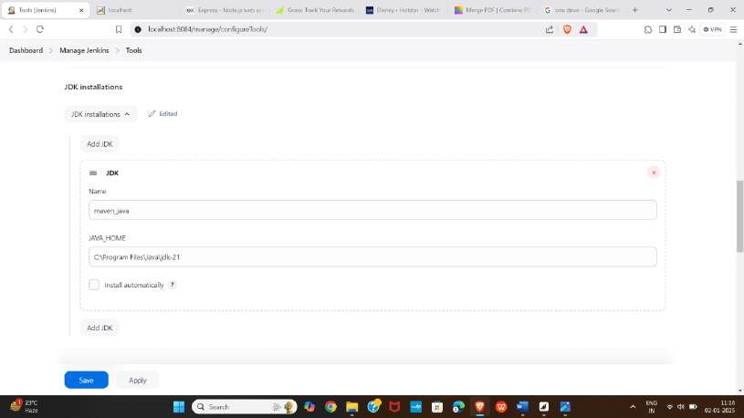

* Now go down for git and click on apply and save.

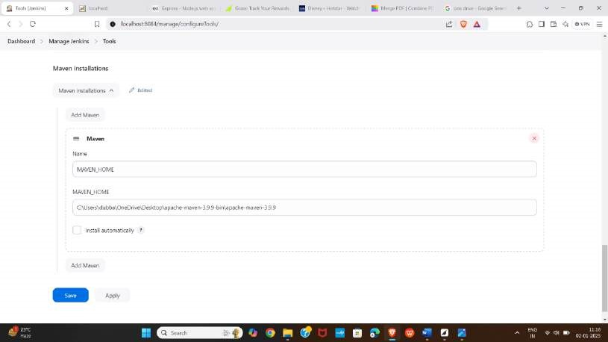

* Now reload the github page.

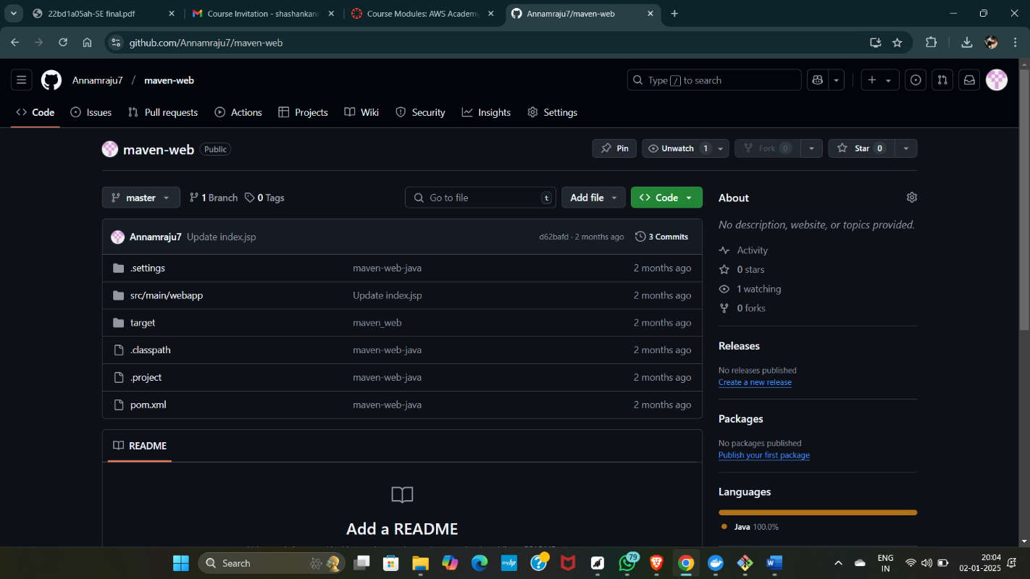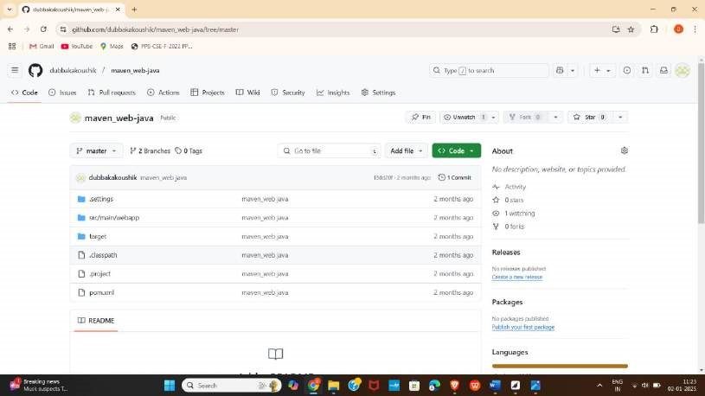

# EXPERIMENT-6

## A) BUILDING THE CI/CD FREESTYLE PIPELINE

**USING JENKINS FOR MAVEN JAVA PROJECT**

* Open jenkins and click on new item and give a name and select free style project and click ok.

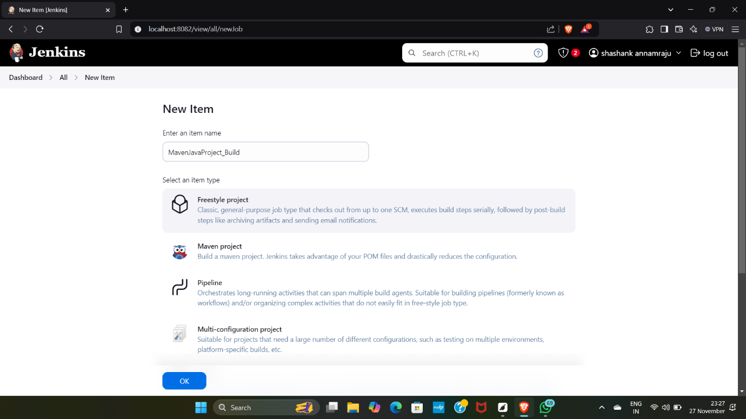

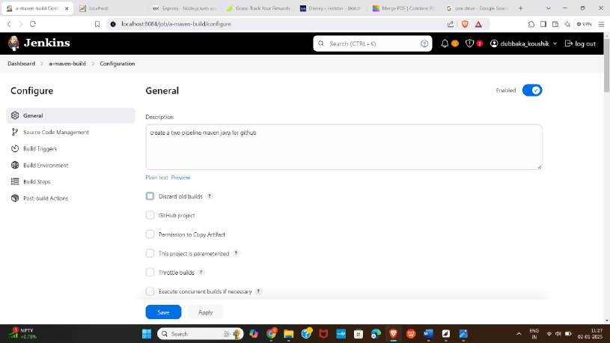

•

Now

extract

the

git

repository

url

of

maven

java

project

and

paste

it

under

git.

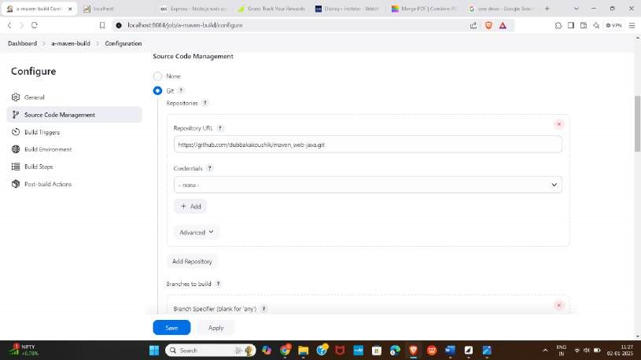

* Now go to add build steps and click on invoke top level maven targets.

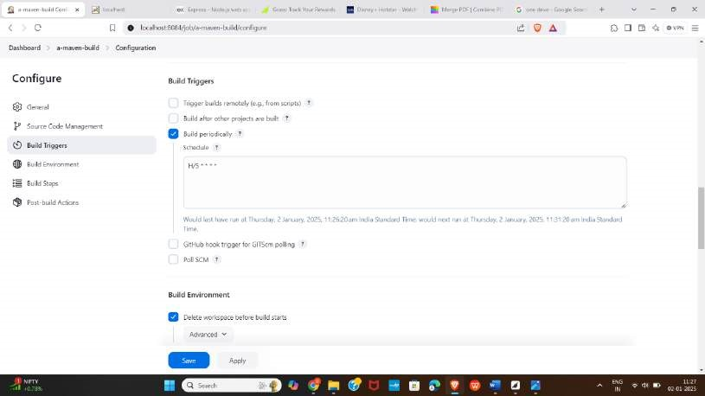

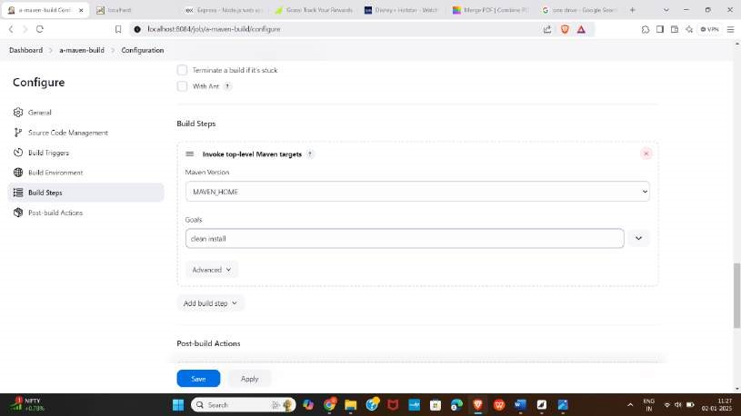

* Now again invoke top level maven targets and give install as goals.

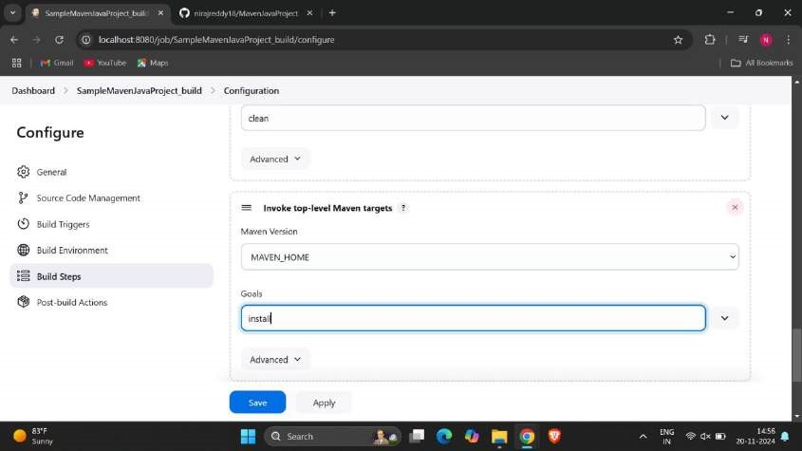

* Now go to add post build actions and click on archive the artifacts and again click on add post build actions and select build another projects and apply and save.

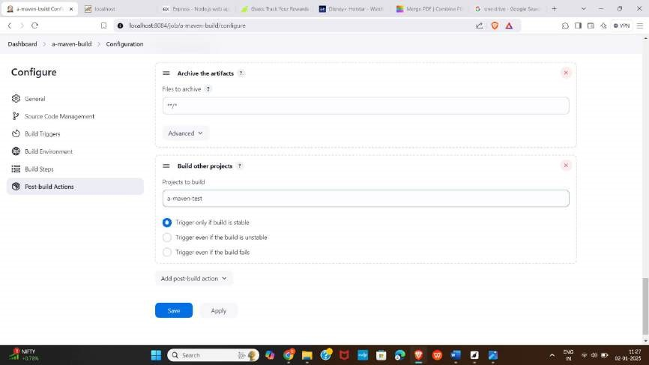

again click on new item ang give a name for test and select freestyle project

and click on ok.

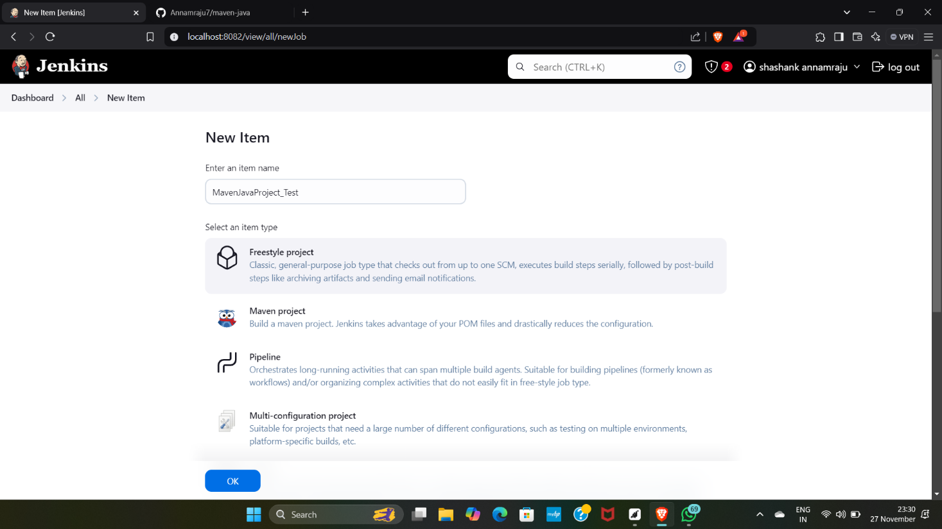

* Now select delete workspace in build environment.

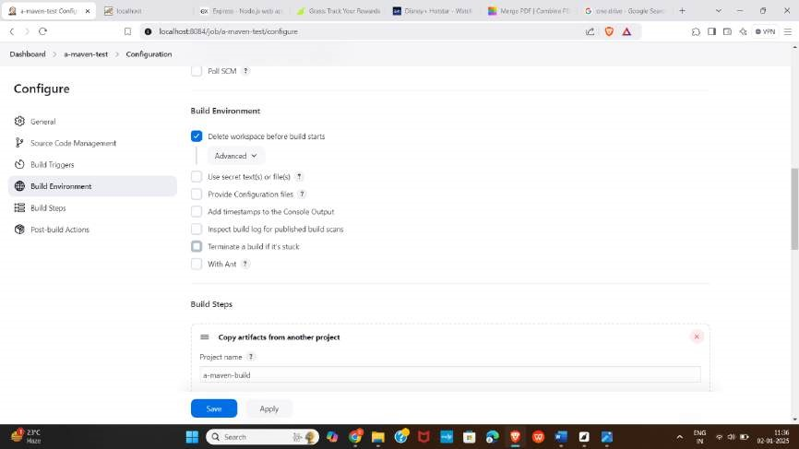

select copy artifacts from another project in build steps,

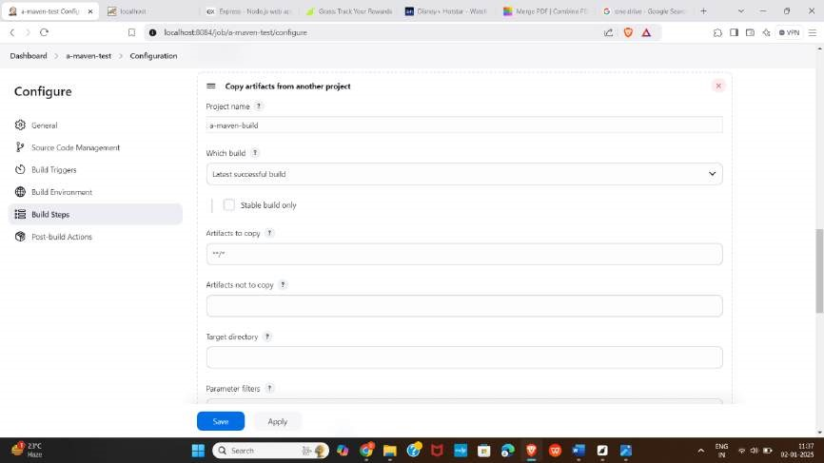

* Now invoke top level maven targets.

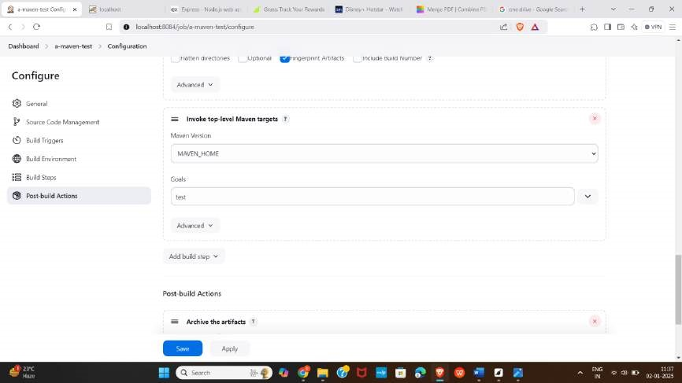

archive artifacts in post build actions and click on apply and save.

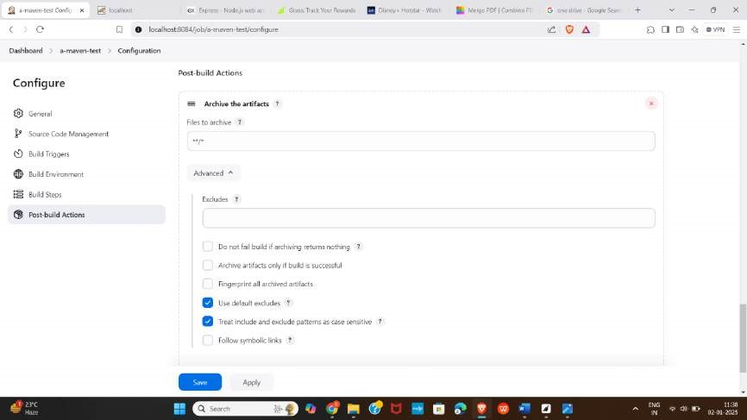

* Now click on + symbol in dashboard and give a name and select build pipeline view and click on ok.

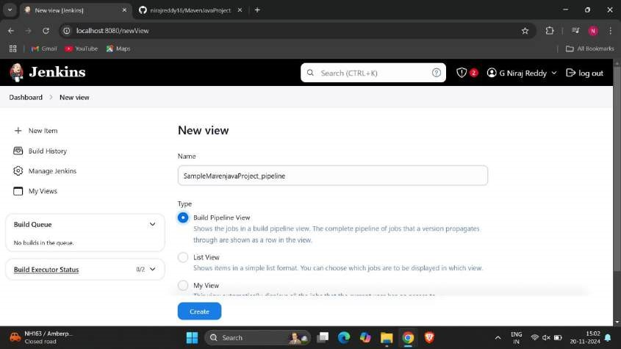

select the build that has created as initial job.

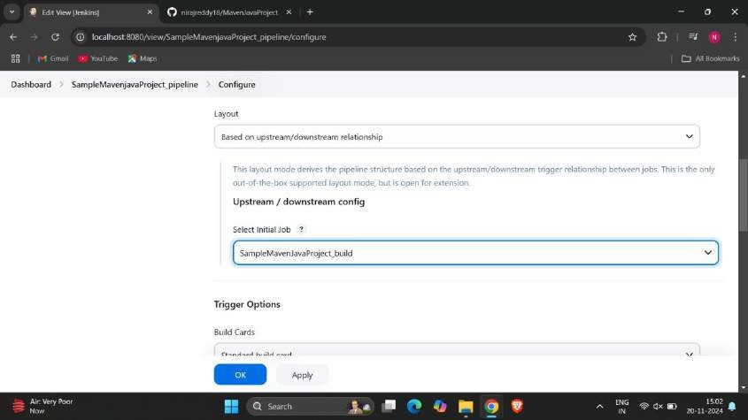

* Now check the output.

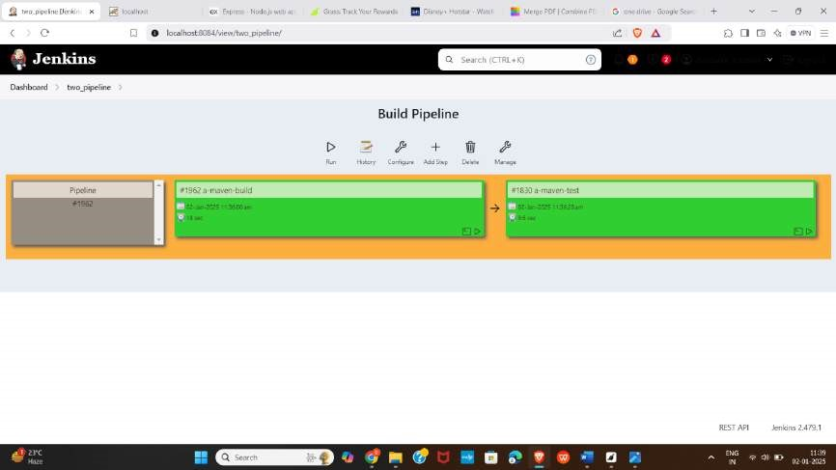

Check the console output.

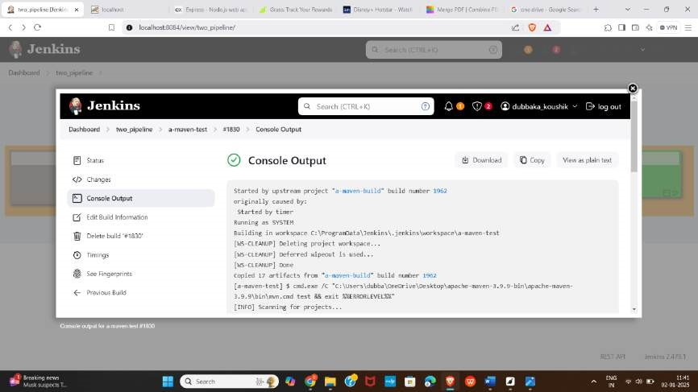

# B)BUILDING THE CI/CD FREESTYLE PIPELINE USINGJENKINS FOR MAVEN WEB PROJECT WITH POLL SCM

* Open Jenkins and click on new item and give a name and select free style project and click on ok.

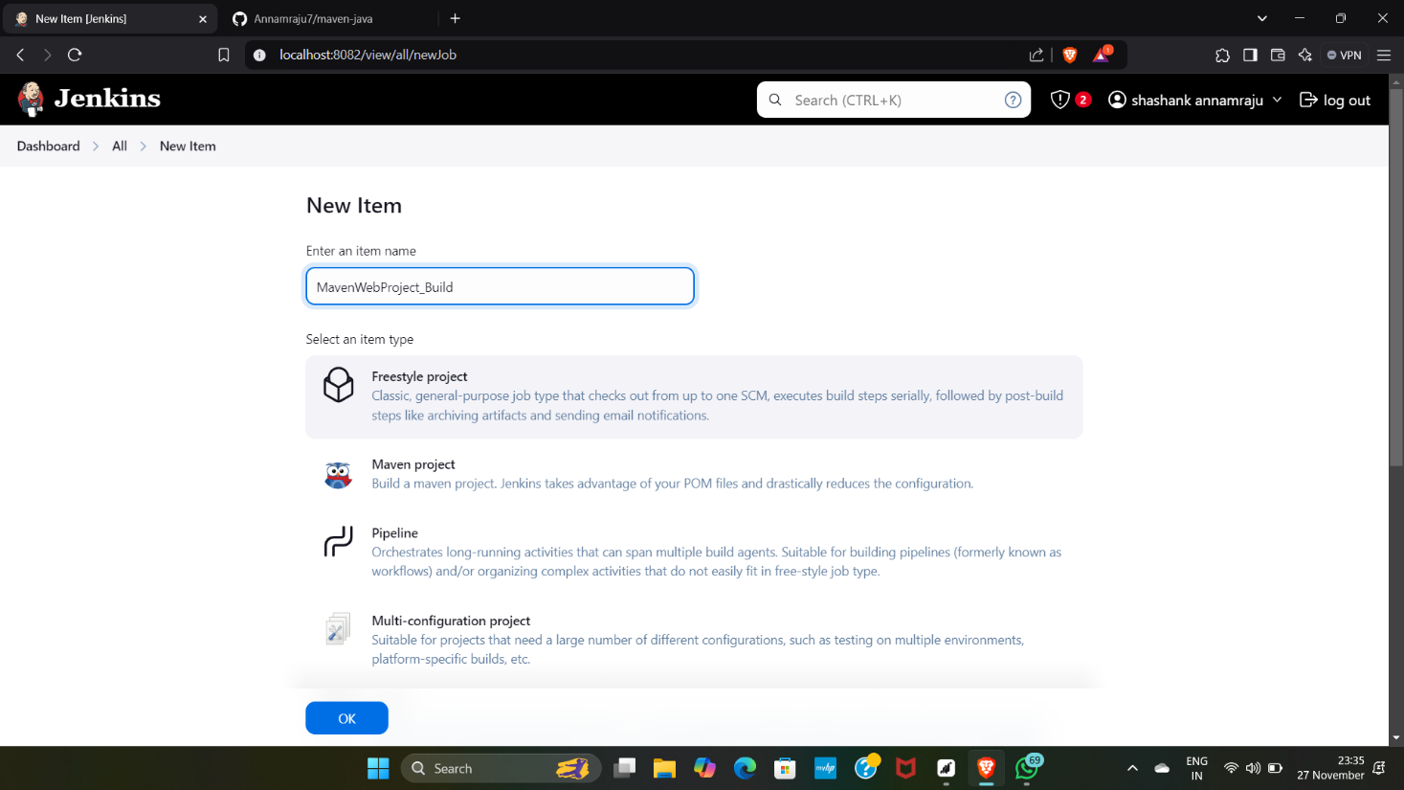

Now give the git repository url from github.

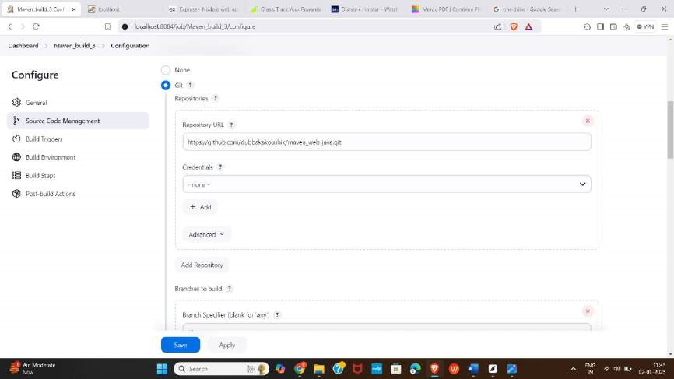

* Now check the branch as master as we have copied the url from master branch.

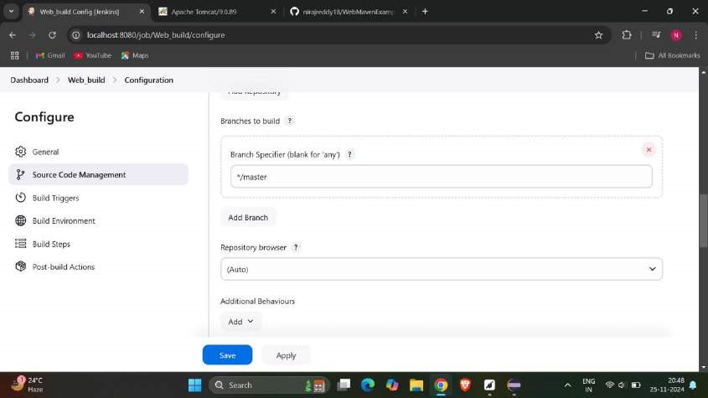

* Now select poll scm and give * * * * *.

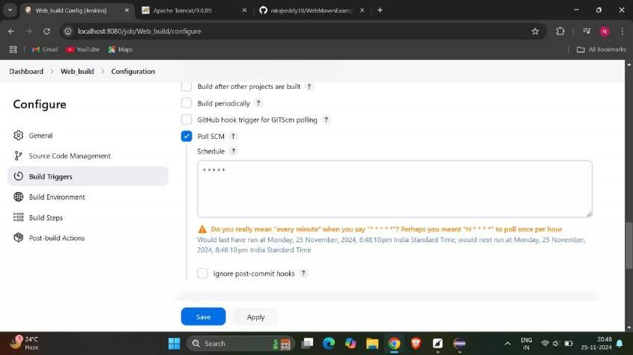

Now invoke top level maven targets from build steps and specify clean in goals.

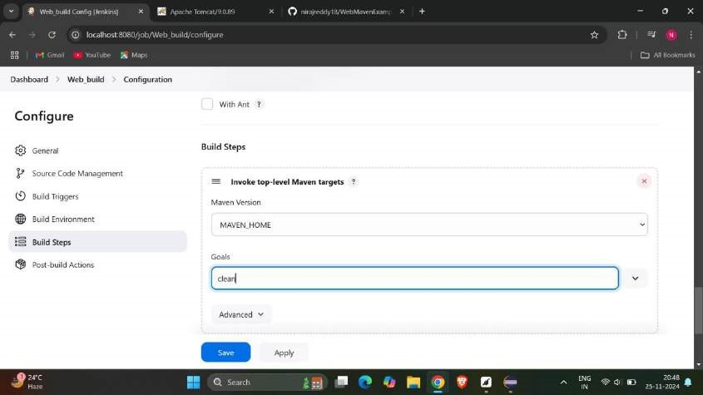

* Now again select it and give install as goals.

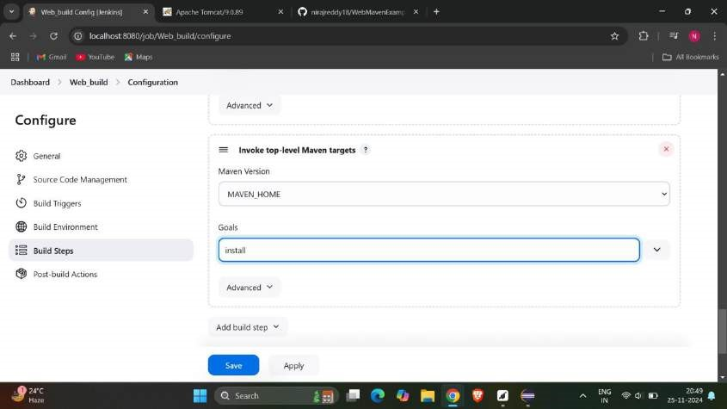

In post build actions select archive the artifacts and build other projects and click on apply and save.

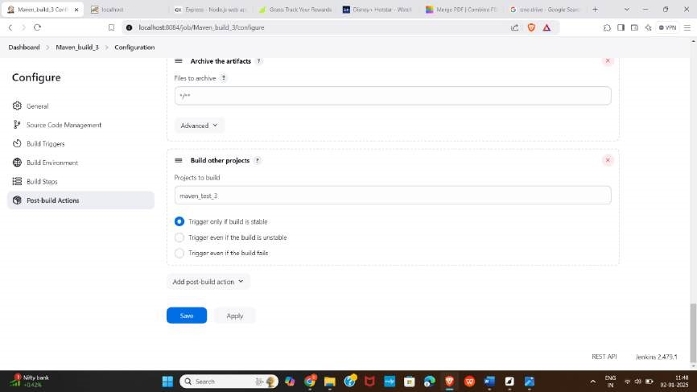

* Now create a new item and give a name for test and select freestyle and click ok.

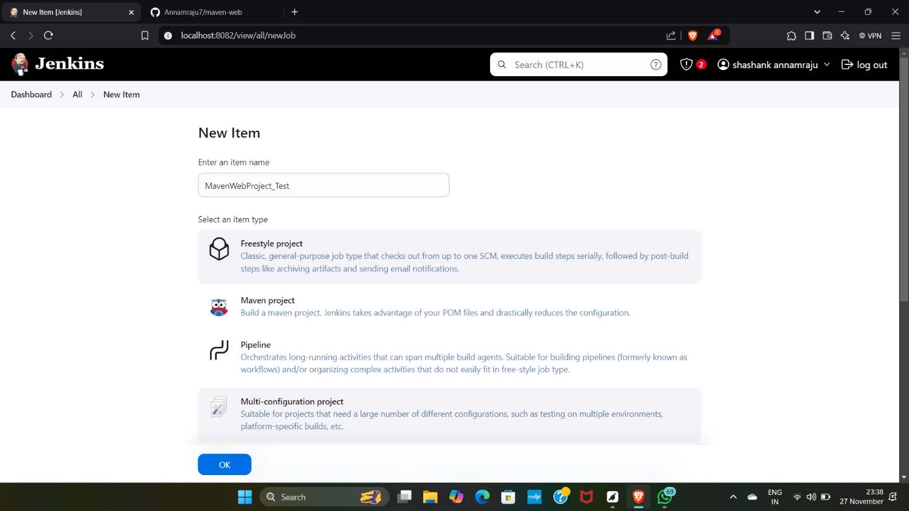

Select delete workspace in build environment.

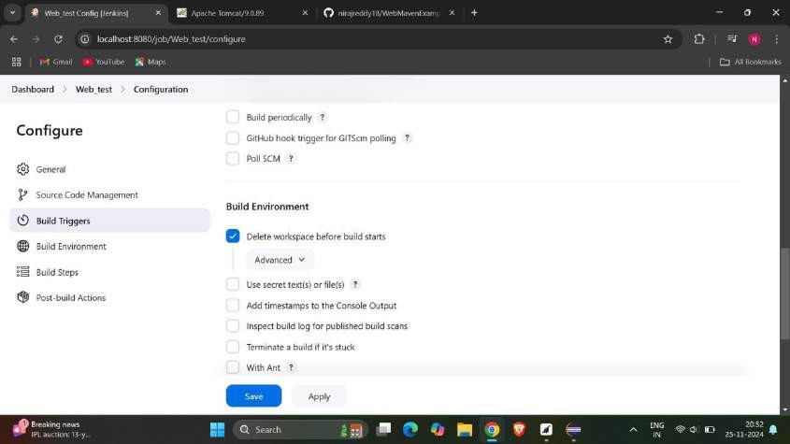

* Now select copy artifacts from another project.

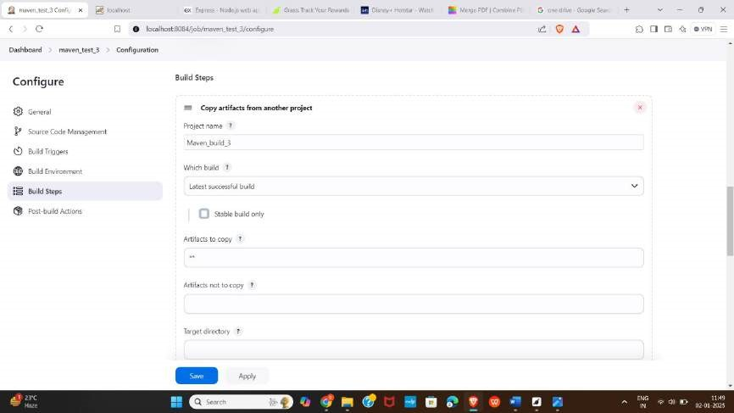

Select invoke top level maven targets and specify goals as test.

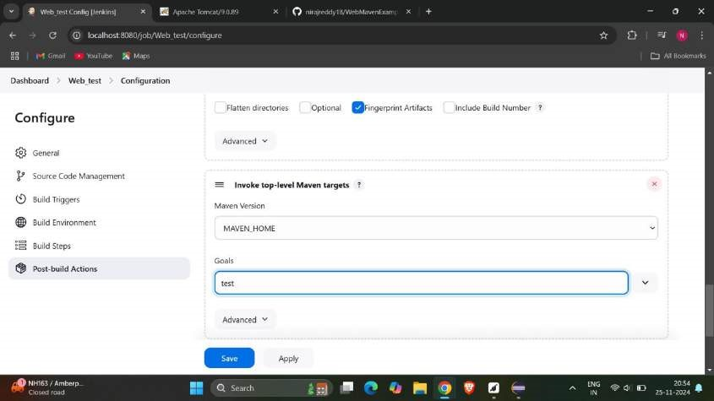

* Now archive the files and select build other projects and click on apply and save.

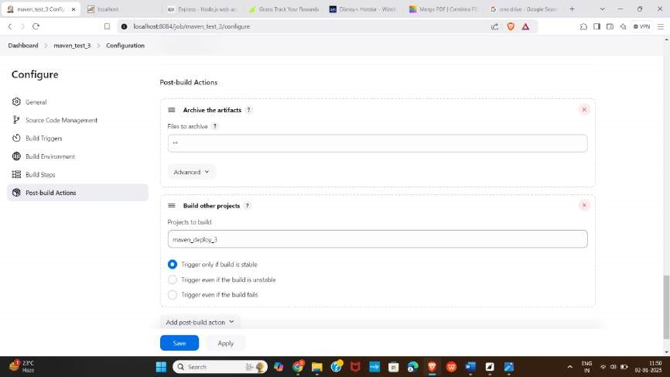

select new item in dashboard and give a name and select free style project.

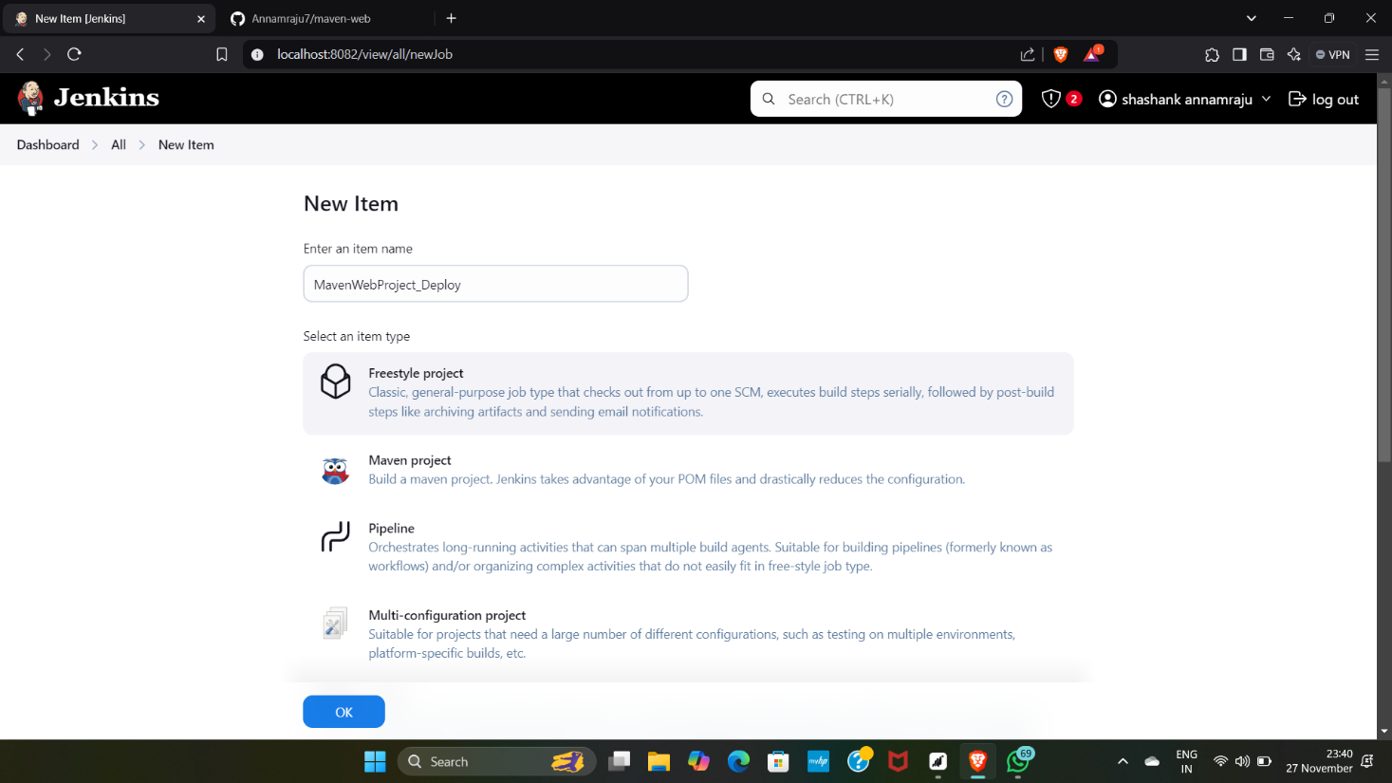

* Now select delete workspace in build environment.

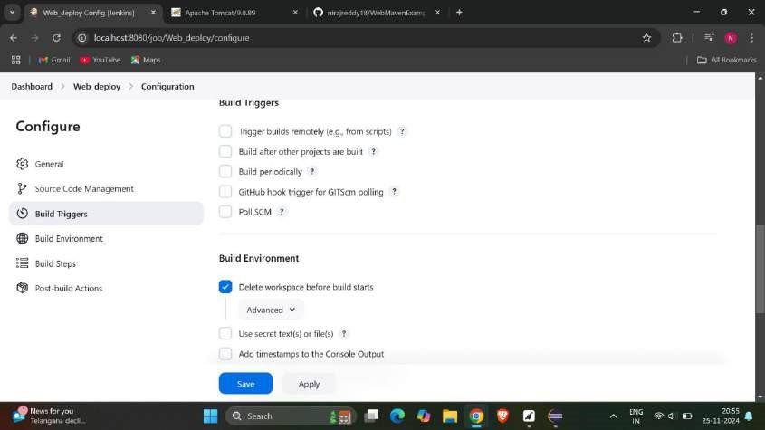

select copy artifacts from another projects.

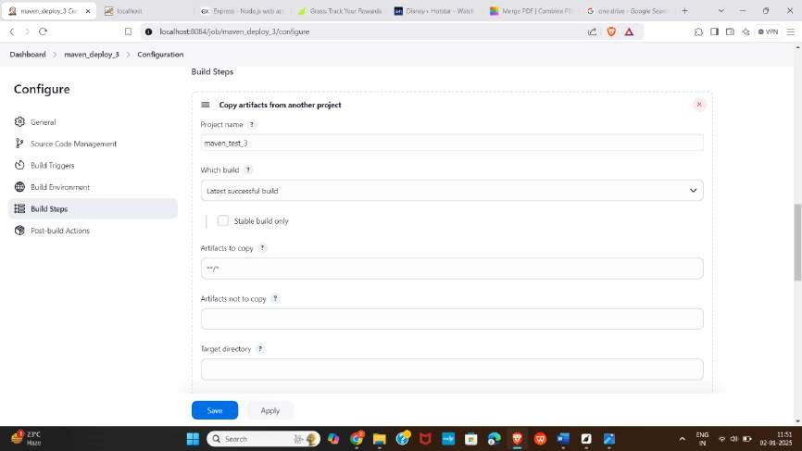

* Now provide username and password in jenkins add container.

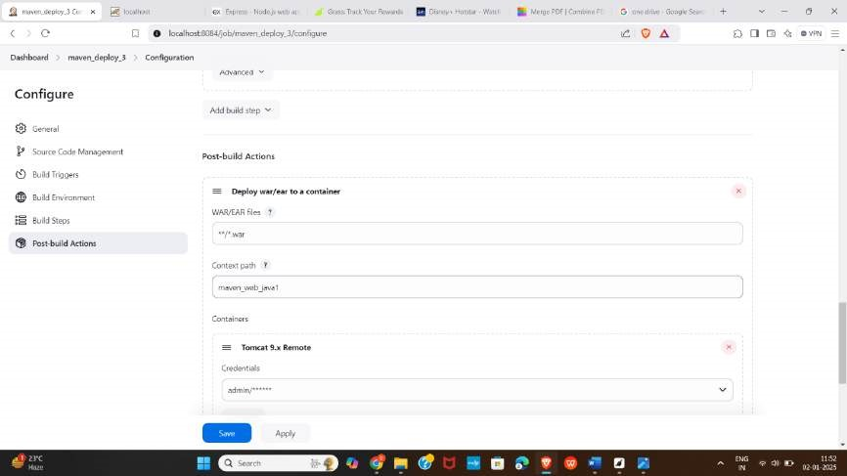

give the url of tomcat.

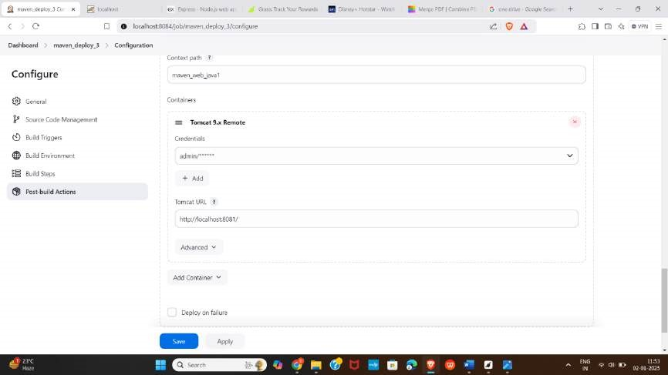

* Now create a pipeline by selecting + in dashboard.

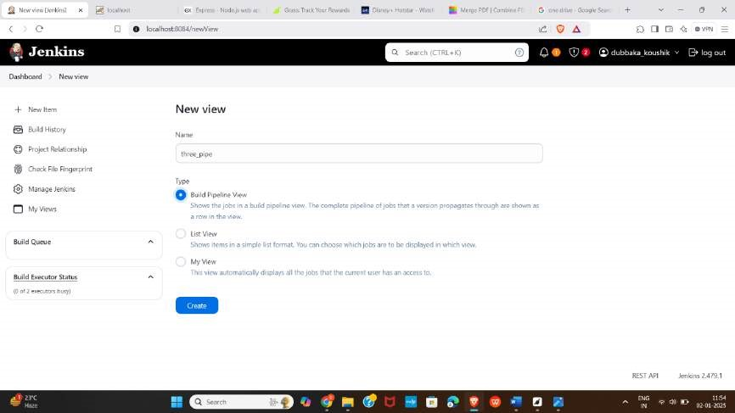

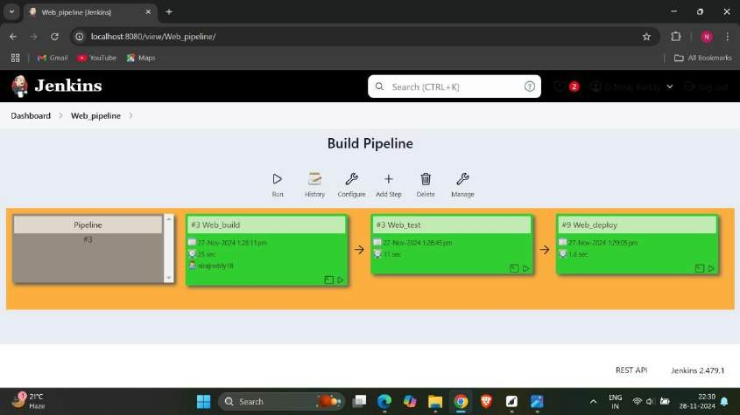Select maven_build as initial job and click on apply and ok.

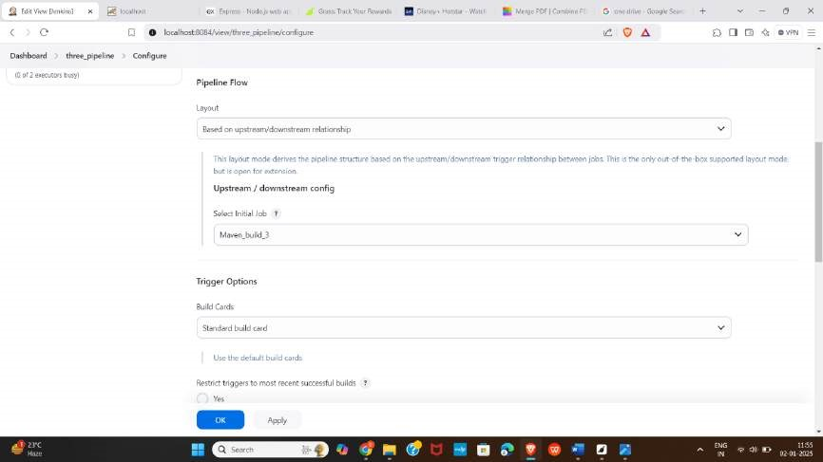

* Check the output.

Check the context path in tomcat manager app.

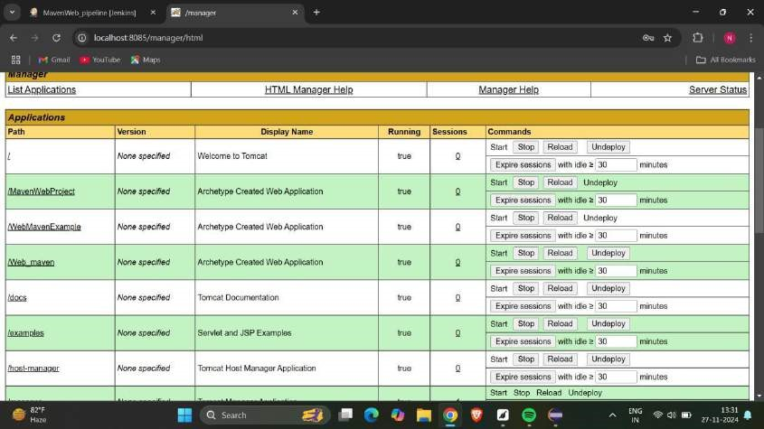

## C)JENKINS SCRIPT PIPELINE FOR MAVEN JAVA PROJECT

* Go to jenkins dashboard and click on new item.

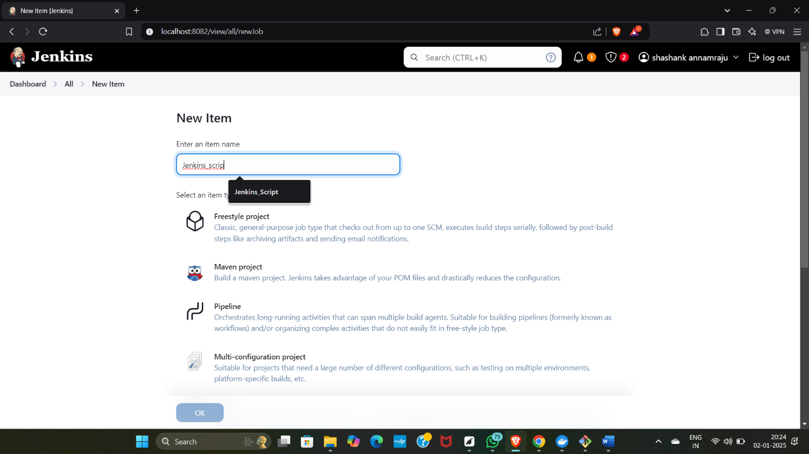

* In build triggers click * * * * *.

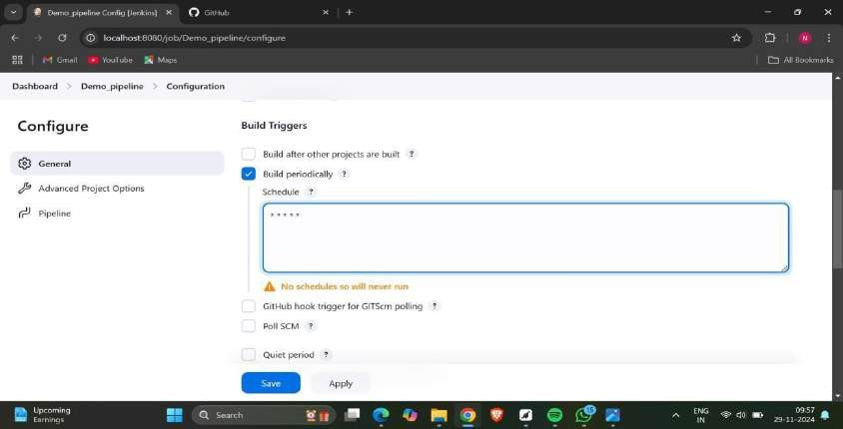

* Now give the script pipeline and click apply and save.

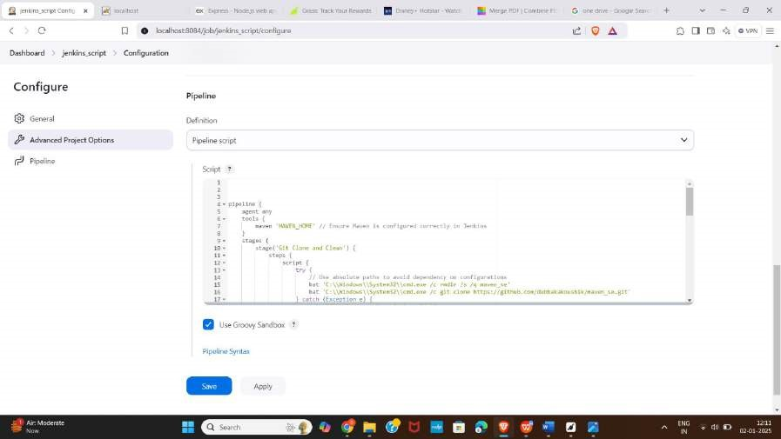

* Click on build now.

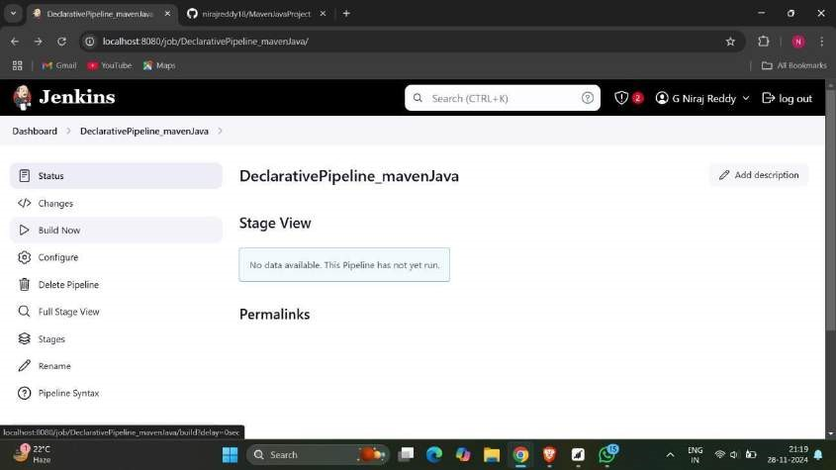

113

* The output should look like

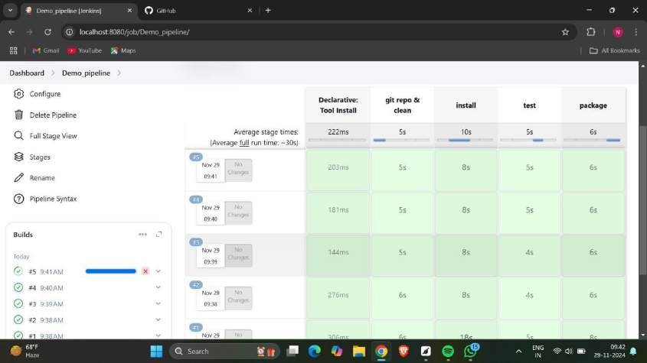

**Experiment-7**

# A) INSTALLATION OF DOCKER

* Open docker in website and choose the official site.

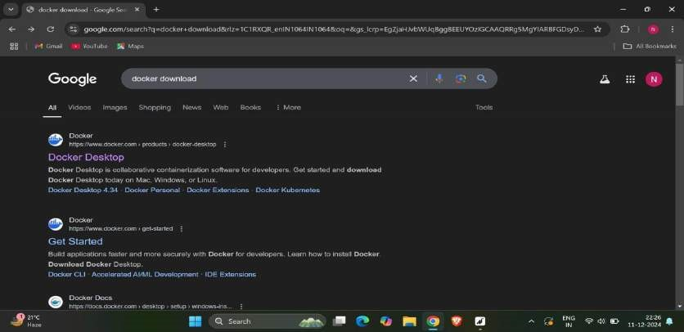

* Now choose the respective operating system and download it.

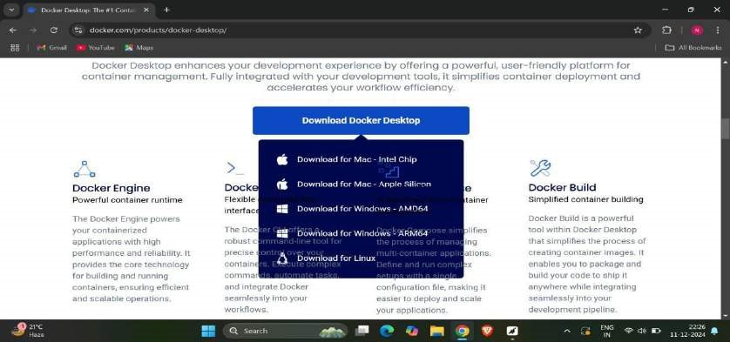

115

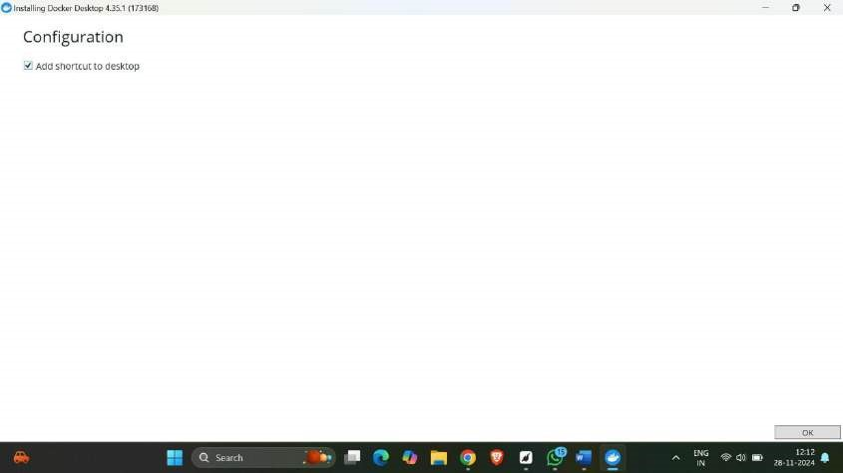

* Now you see unpacking the files.

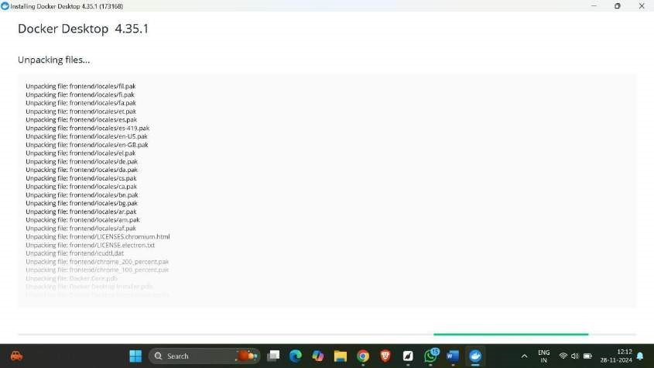

* Now click on finish to complete the installation.

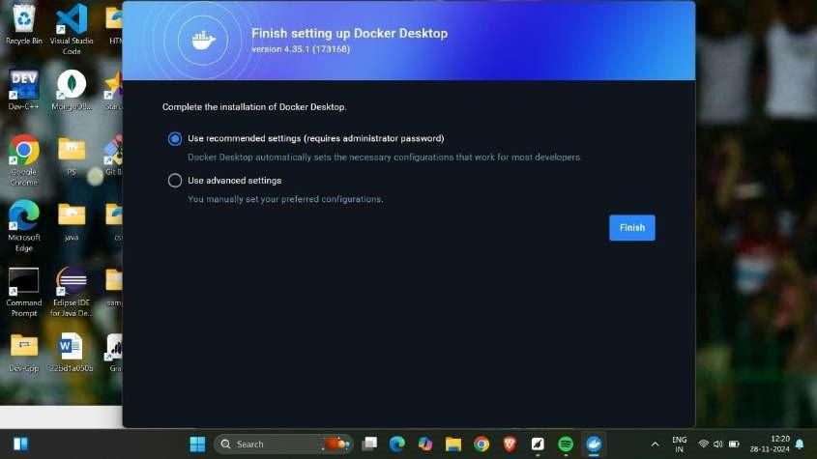

* Now we see a message that installation is succeeded.

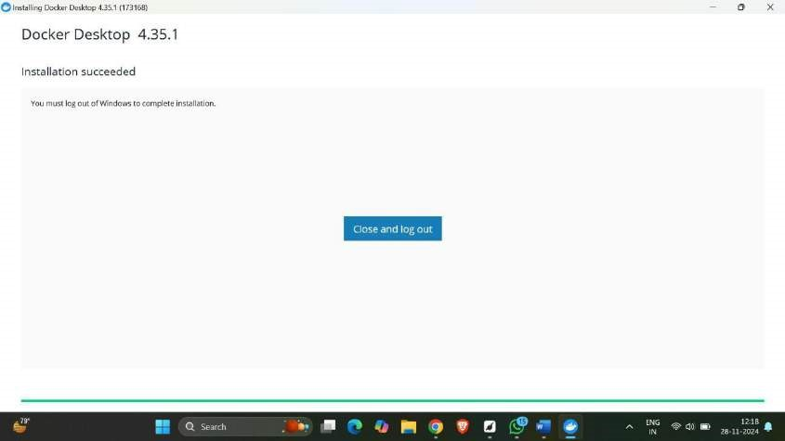

# ACCOUNT CREATION IN DOCKER

* Open docker desktop and create an account by giving credentials and sign up.

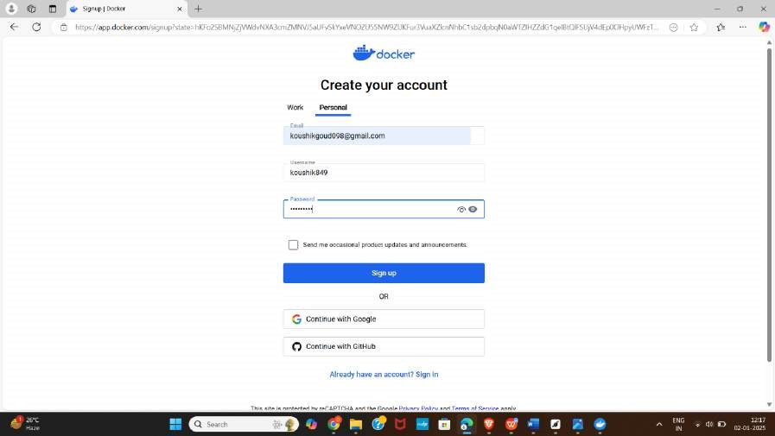

* Now enter password for continuing to docker online.

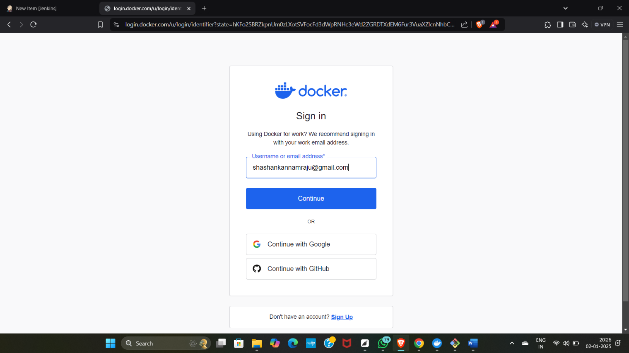

* Now open docker desktop.

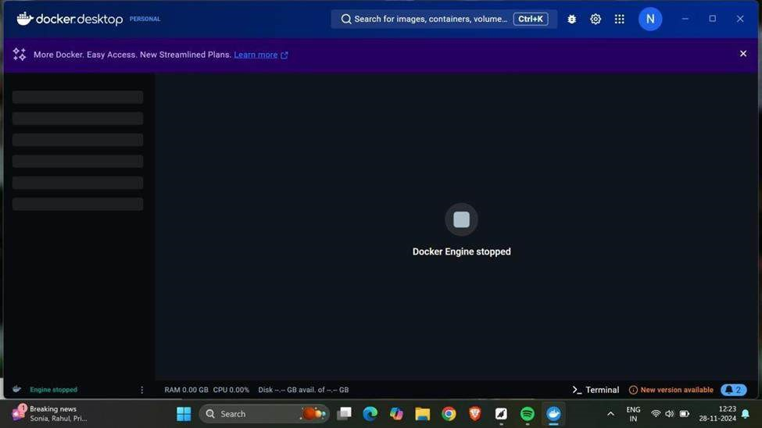

# MINIKUBE INSTALLATION

* Now go to docker desktop and open the settings.

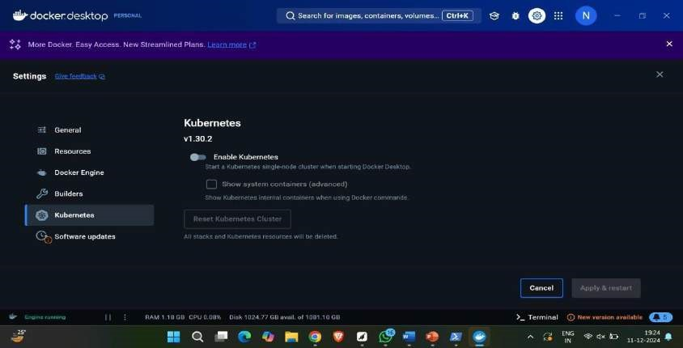

* Now enable Kubernetes and click on apply and restart.

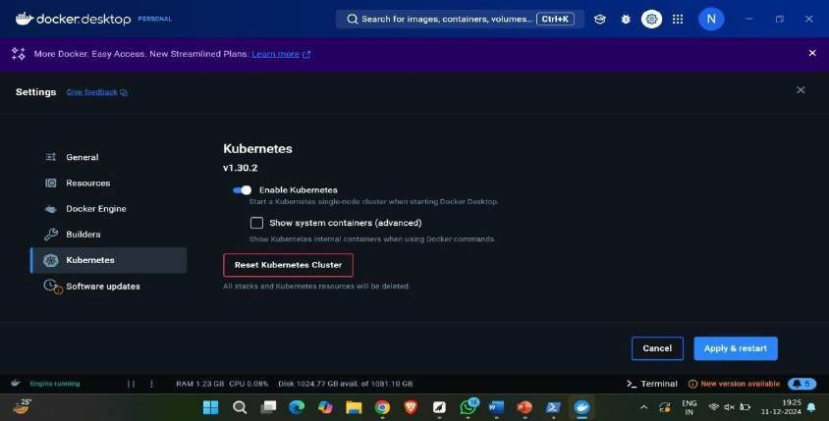

* Now click on install.

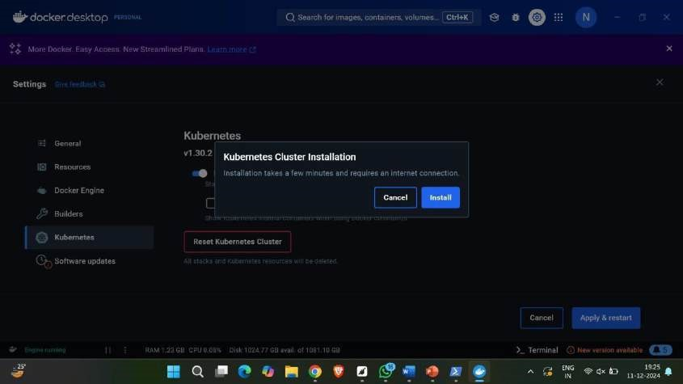

* After installing we see Kubernetes running in green color in left down.

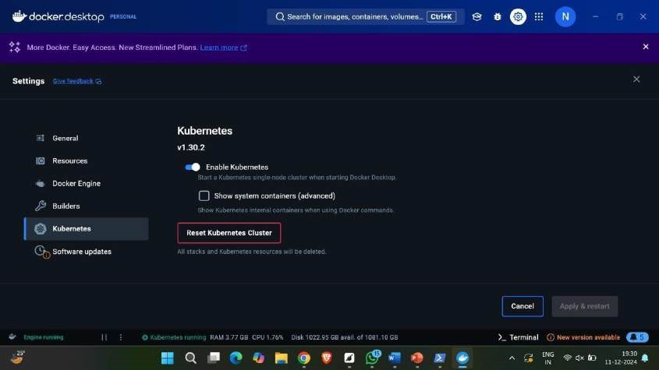

Nowopen minikube official website and download the minikube installer.

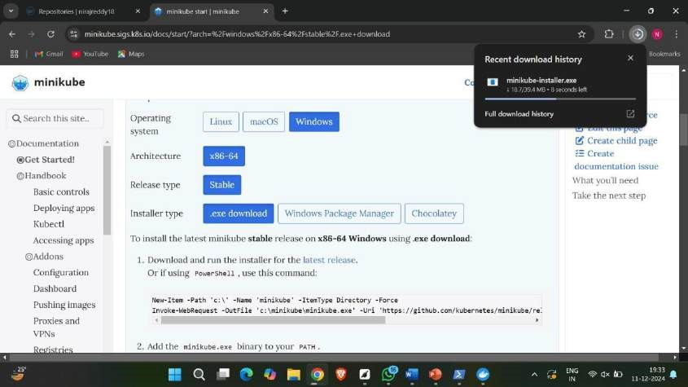

* Now open the installed file and finish the setup.

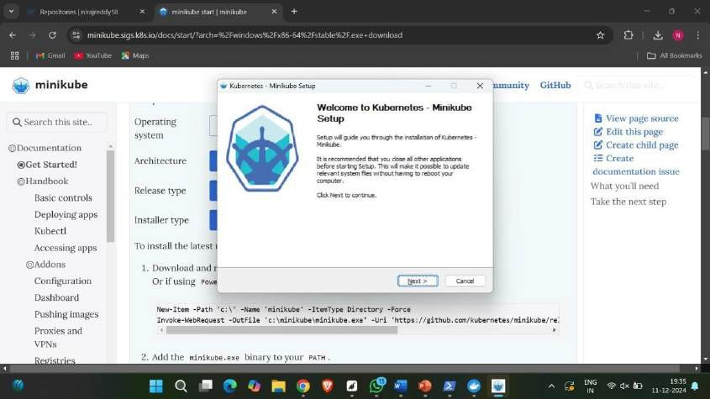

Afteragreeing to all the requirements click on finish.

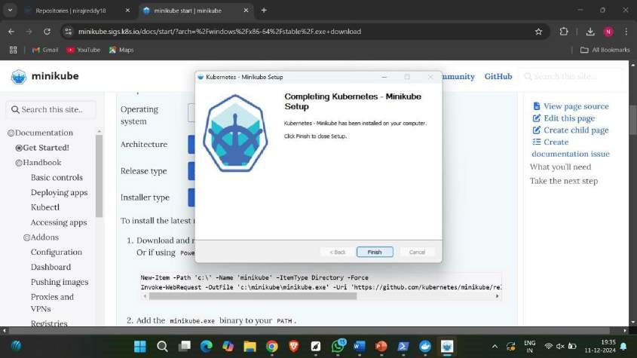

* Now set up the path using environment variables.

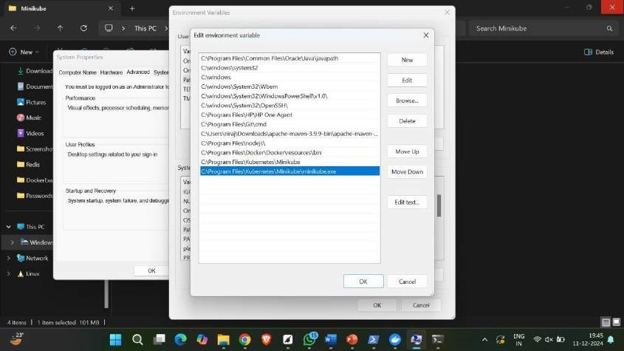

Nowcheck for the minikube version.

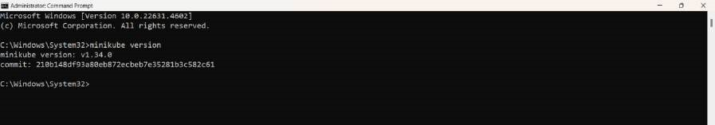

* Now open PowerShell and click minikube start.

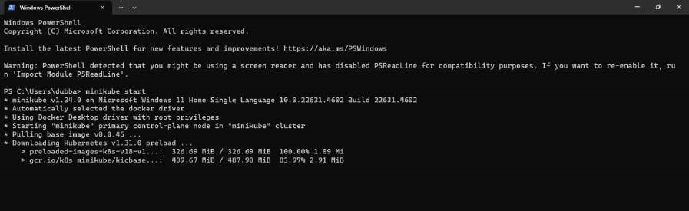

* Now click minikube ip.

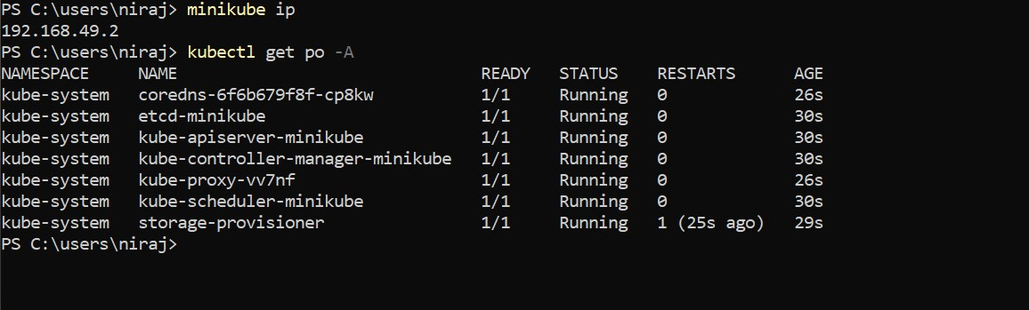

# B) EXECUTION OF CLI COMMANDS IN DOCKER

1. version: It is used to get the current version of the docker.

Syntax: docker –version (or) docker version



1. images: Docker Image is an executable package of software that includes everything needed to run an application.



1. pull: The docker pull command is used to download Docker images from a registry. Here we have pulled ubuntu and nginx

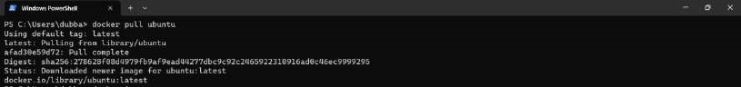

1. run: The docker run command runs a command in a new container, pulling the image if needed and starting the container.



1. echo: echo is a command that outputs the strings that are passed to it as arguments



6)ls: It returns all the files in the present working directory.



7)exit: It comes out from the loop.



In the same way, pull nginx and tome

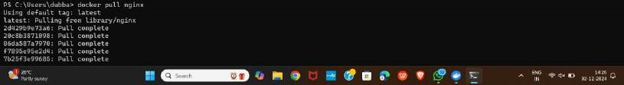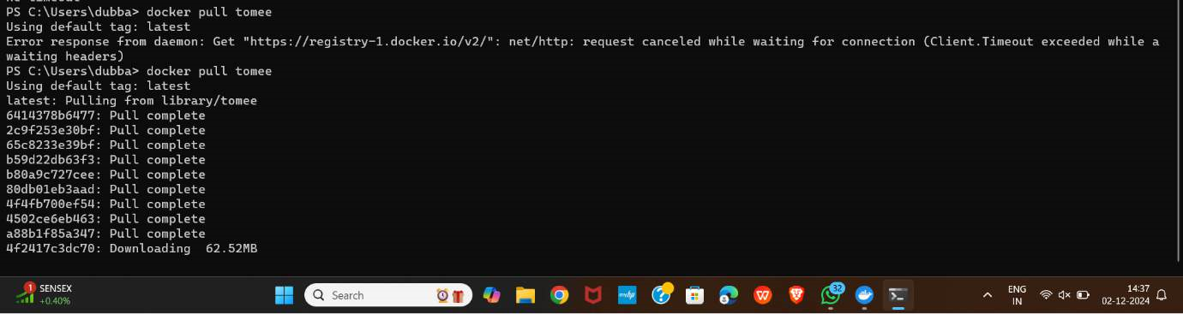

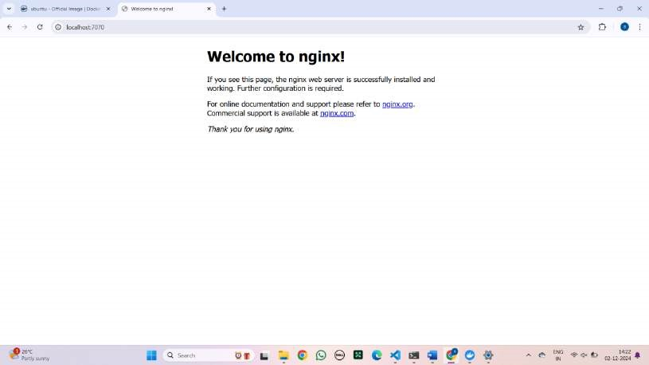

Type the localhost number that you have given above and the following page will be opened.

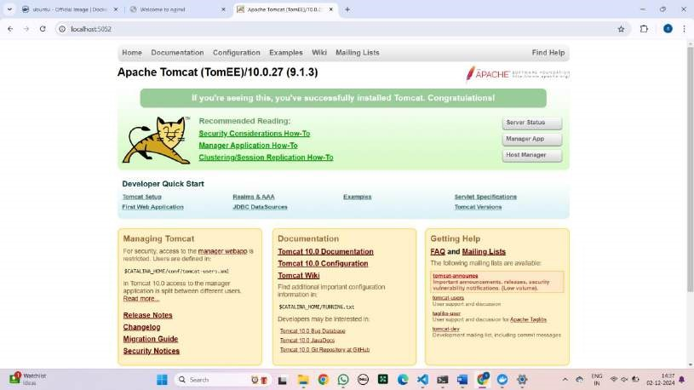

8)ps: docker ps command is used to list all the running containers in the docker host.



9)ps -a: This command lists all the containers on your system including running, stopped and exited containers.

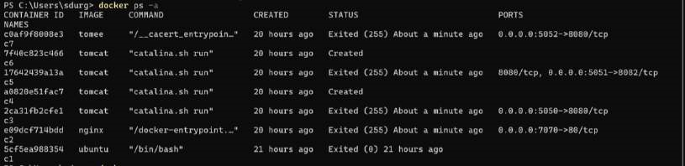

10)start: The docker start command is used to start a stopped container in Docker. It will not create a new container but will resume a previously created or stopped one.



11)exec -it: The docker exec -it command is used to run a command interactively inside a running container.



12)apt-get update: The apt-get update command in Docker is used to update the package lists from the repositories inside a container's operating system.

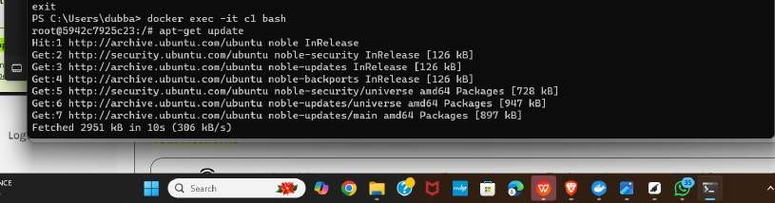

13) apt-get install: The apt-get install command in Docker is used to install packages within a container's operating system

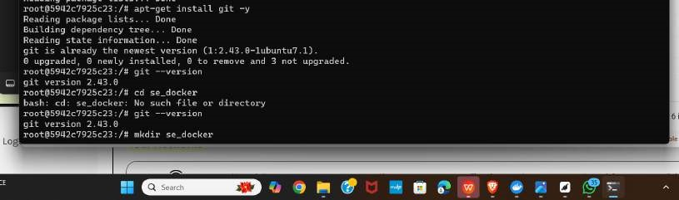

After the installation of git within the container check the version by typing the command “git –version”.



14)mkdir: This command is used to create a directory.



15)cd: This cd command stands for "change directory" is used to navigate between directories in a file system.



16)git init: This command initializes a new Git repository in the specified directory. When executed inside a Docker container, it creates a .git folder in the directory, marking it as a Git repository.

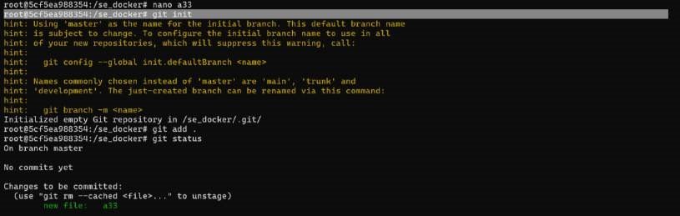

17)nano: The nano command is used to open the Nano text editor, a simple and easy-to-use command-line text editor for Unix-like systems. It is commonly used for creating and editing text files directly in the terminal.

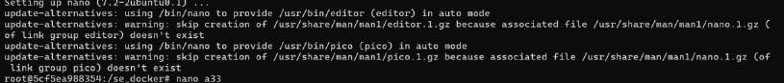

18)ls: This command list outs all the files and directories.



**B) MODIFYAND PUSH DOCKER IMAGE**

## COMMANDS TO CREATE A CONTAINER IN AN IMAGE

Step-1: Create an image and create a container in the image using the following command. run: The docker run command runs a command in a new container, pulling the image if needed and starting the container.

-it: The -it option is commonly used to run a container interactively.

--name: This is used to name the container. apt-get: The apt-get update command is used to update the package lists on a system that uses the Advanced Package Tool (APT).

## CREATING AN IMAGE USING COMMIT AND PUSHING THE IMAGE

Step-1: Pull the nginx image by using pull command. run: The docker run command runs a command in a new container, pulling the image if needed and starting the container.

-d -p: The docker run -d -p command is used to start a Docker container in detached mode (d) and map a host port to a container port (-p).

Syntax: docker run -d -p <host port>:<container port> <container> <image>

Step-2: After enter the host port in the chrome the following page is

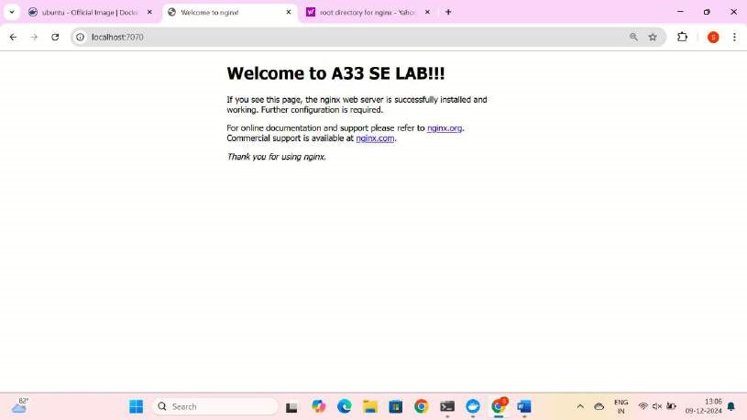

Step-3: The following command is used to create the container name and the image name.

run -it –name: The docker run -it --name command is used to start a new Docker container with an interactive terminal session (-it) and assign it a custom name (--name).

Syntax: docker run -it –name <container-name> <image-name>

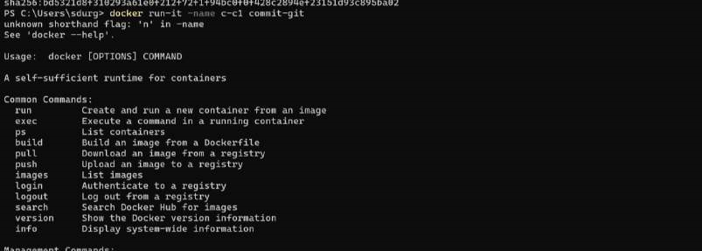

Step-4: The command tag is used to assign a specific identifier to a Docker image.

Syntax: docker tag <filename> <username>/<imagename>



Step-5: The docker login -u command is used to log in to a Docker registry with a specific username. This is often required to push or pull images from a private Docker registry or Docker Hub.

Syntax: docker login -u <emailId>



Step-6: This command is used to push into the docker hub.

Syntax: docker push <username>/<imagename>

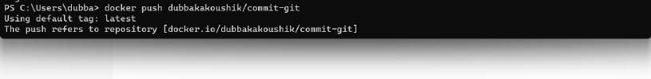

Step-7: Go to docker desktop and check

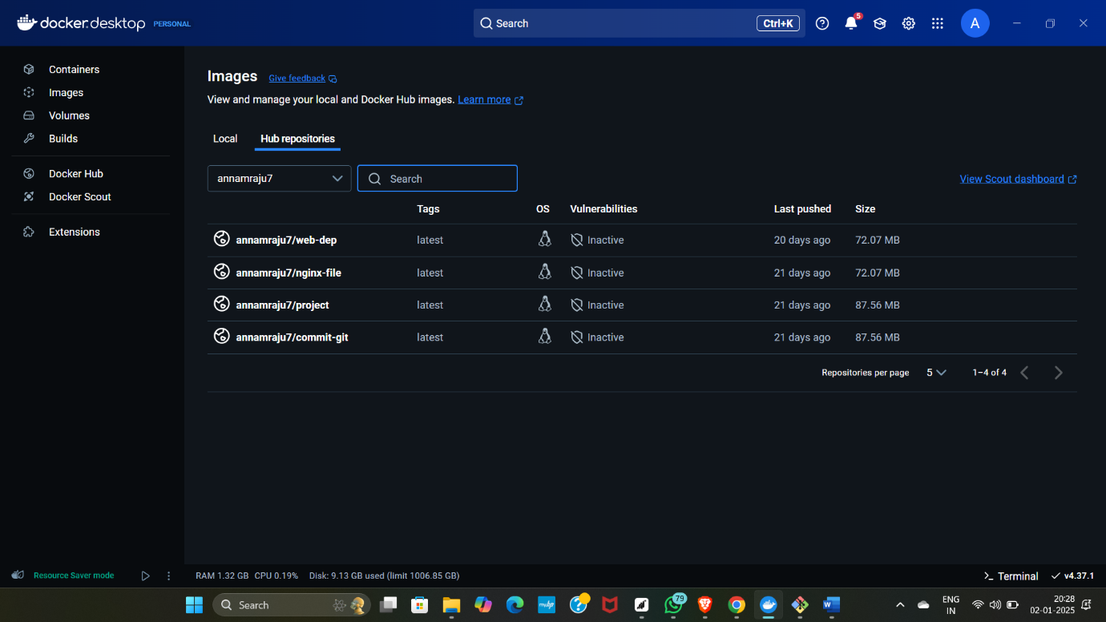

**C) CREATE AND PUSH DOCKER FILE IMAGE**

## CREATING AN IMAGE USING DOCKERFILE AND PUSHING INTO DOCKER HUB

Step-1: Create a folder

Step-2: Click on the folder and click on git bash here

Step 3: Using vin, write the command



Step-4: To build the image using dockerfile.

build -t: The docker build -t command is used to build a Docker image from a

Dockerfile and assign it a name (and optionally a tag) for easier identification and management

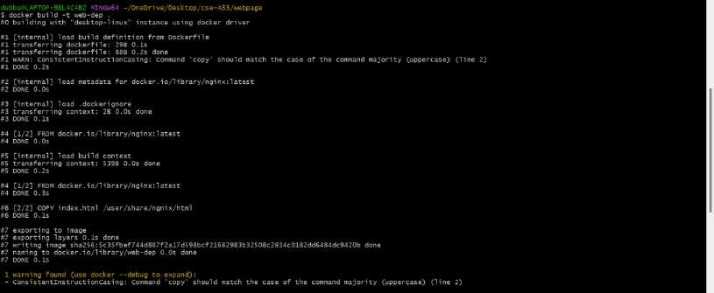

Step-5: See whether the created image is present in the images.

Syntax: docker images

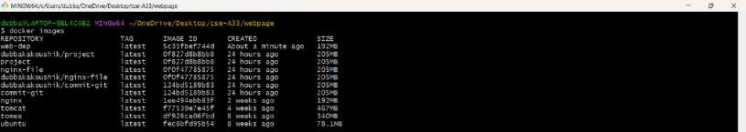

Step-6: The command tag is used to assign a specific identifier to a Docker image.

Syntax: docker tag <filename> <username>/<imagename>



Step-7: We should push the file into docker hub by the following command. push: The command push is used to push the image created into the docker hub.

Syntax: docker push <username>/<imagename>

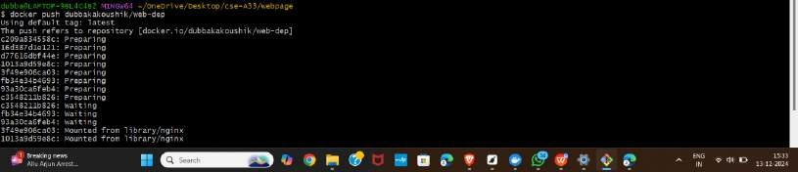

CREATING AN IMAGE USING DOCKERFILE WITH WEBDEP

Step 1: Create a folder with name A33 and create webpage folder in that. Now insert the basic index.html file with a title as “Welcome to CSA33”

Step 2: Open dockerfile and Write the following commands

FROM nginx

COPY index.html /usr/share/nginx/html



Step 3: Now, build the image by the following command



Step 4: Check for the image by using the command docker images



Step 5: Now run the image



Step 6 : Tag the image to be committed

Step 7: Login to your docker to push

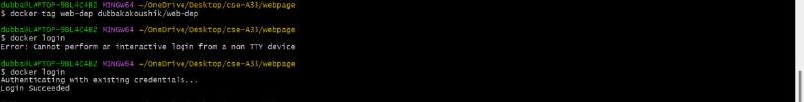

Step 8: Push the docker fi;e into the docker

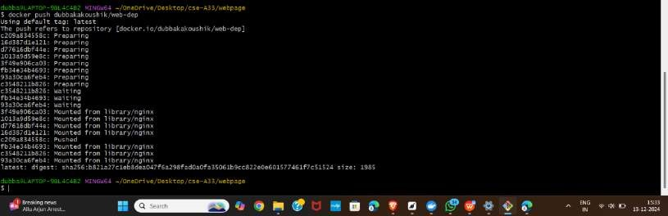

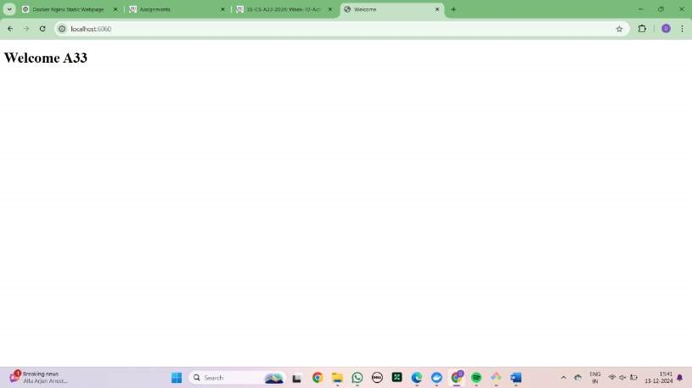

## D) RUNNING MULTIPLE CONTAINERS USING DOCKER COMPOSE

Step 1: Create a yml file and insert the code

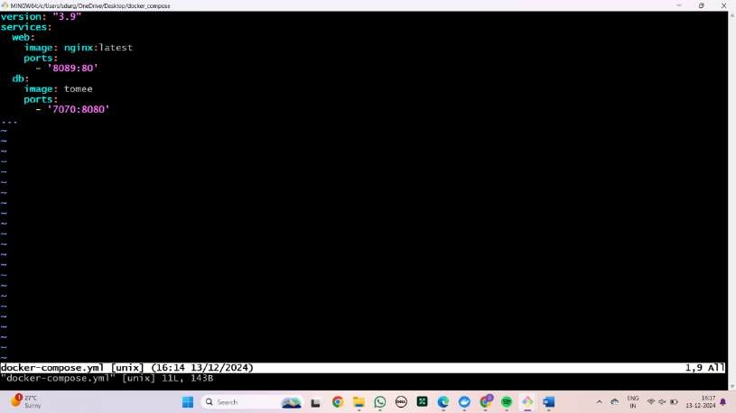

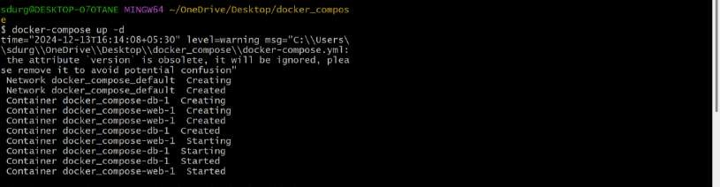

Step 3: Shut down the port

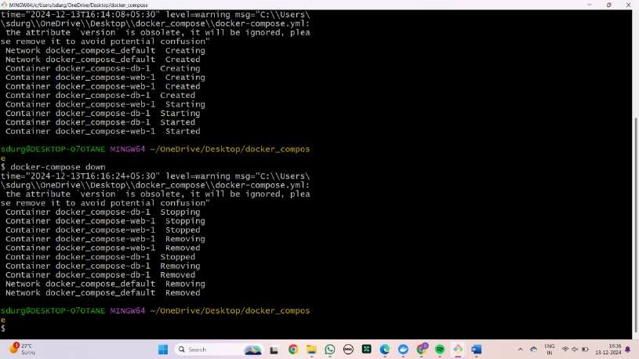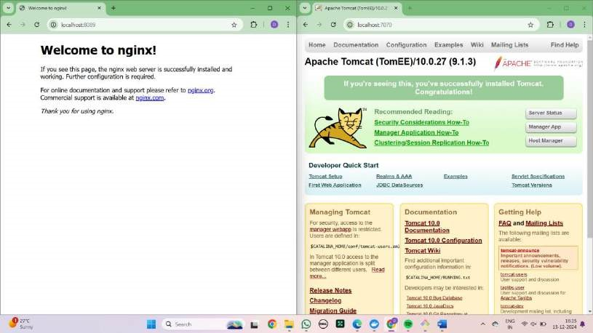

## E) DEPLOYING AND SCALING APPLICATIONS USING MINIKUBE

step 1: check version of minikube



Step 2: Run the command -Mini start



Step 3: Minikube status

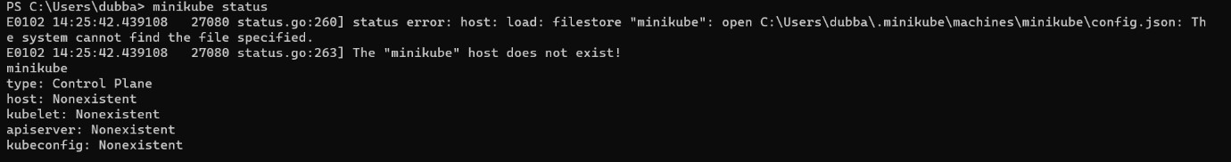

Step 4: Kubectl get nodes

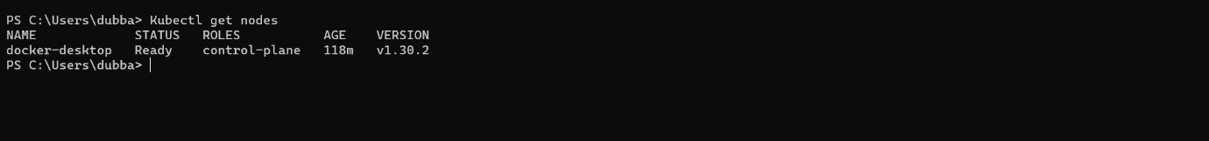

Step 5: Kubectl get pods



## Creating the nginx deployment

Step 1: To create the deployment for nginx server

Kubectl create deployment <deployment name > --image=nginx

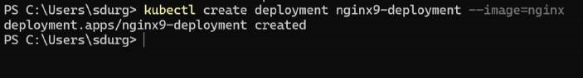

Step 2: To check the pod status

Kubectl get pod



Step 3: To check service

Kubectl get service

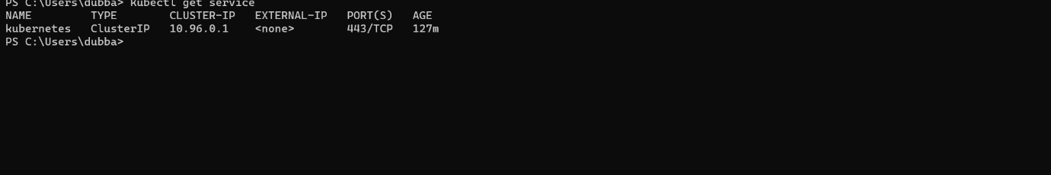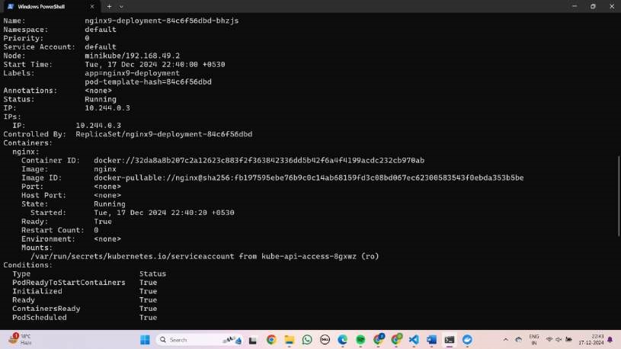

Step 4: To access the nginx page

Kubectl expose deployment nginx-deployment - -type=NodePort - -port=80



Step 5: Copy the above http path and paste it in browser to access it

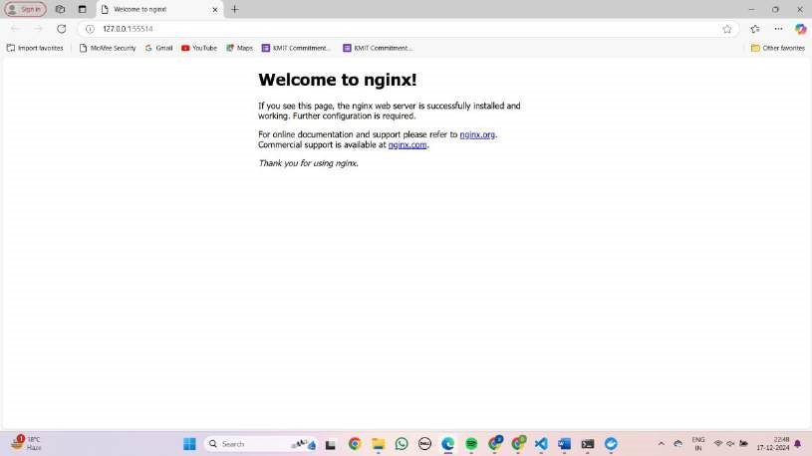

**F) DEPLOYING AND MANAGING MONITORING SYSTEMS USING NAGIOS IN DOCKER**

## Nagios installation

Step 1: Open <https://hub.docker.com/>and search for jasonrivers/nagios

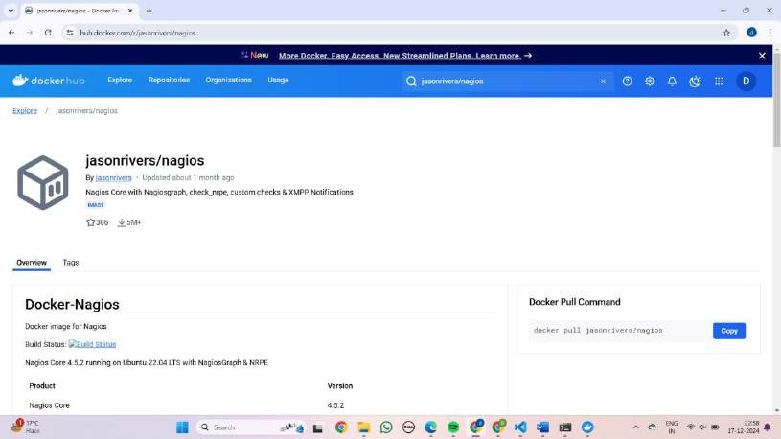

Step 2: Copy the pull command and run in the Power shell

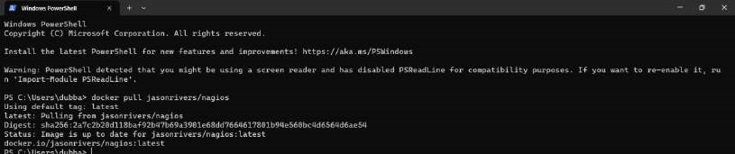

Step 3: It image will be pulled to the docker

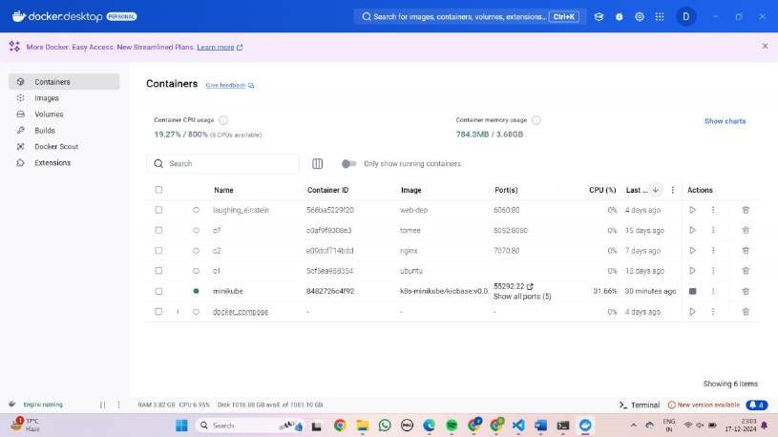

Step 4: Check whether the image is pulled by the command Docker images

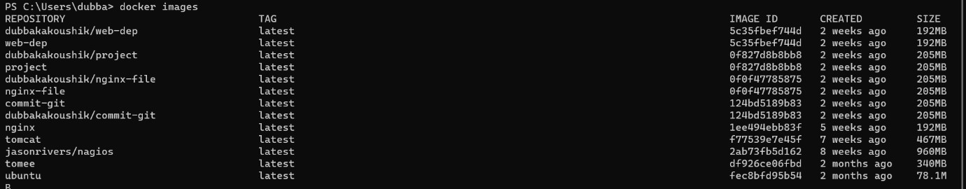

Step 5:In order to open nagios run the command

Docker run - -name nagio -d -p 6060:80 jasonrivers/nagios



Step 6:Open the localhost with the given port number in the browser And login with credentials Username-nagiosadmin

Password-nagios

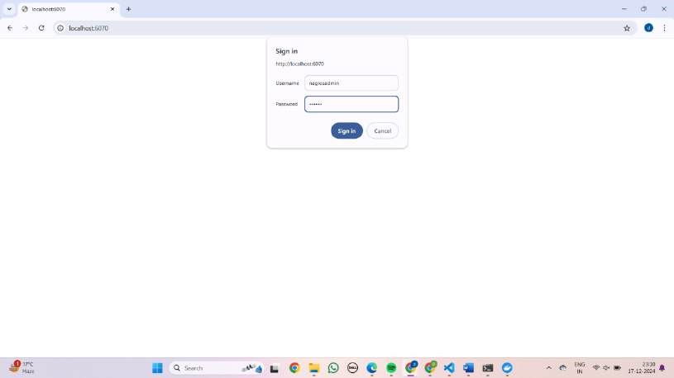

Step 7:Click on the host

Step 8: We get the status details of the system.

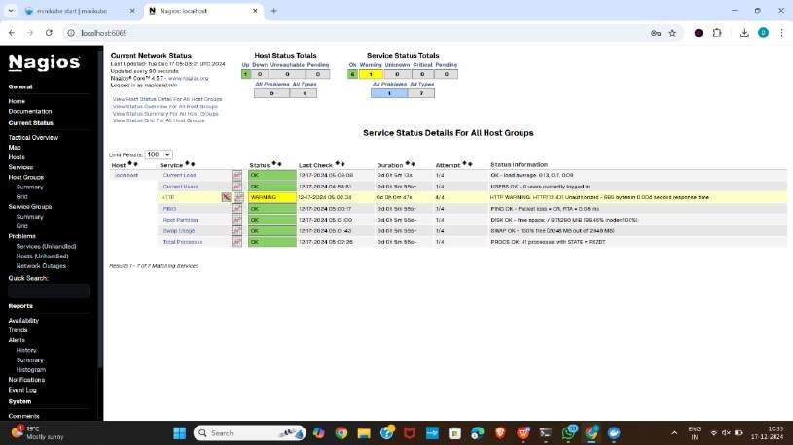

**Experiment-8**

# A) AWS ACADEMY LEARNING ACCOUNT CREATION

## AWS LOGIN

Direct into your email for the invitation

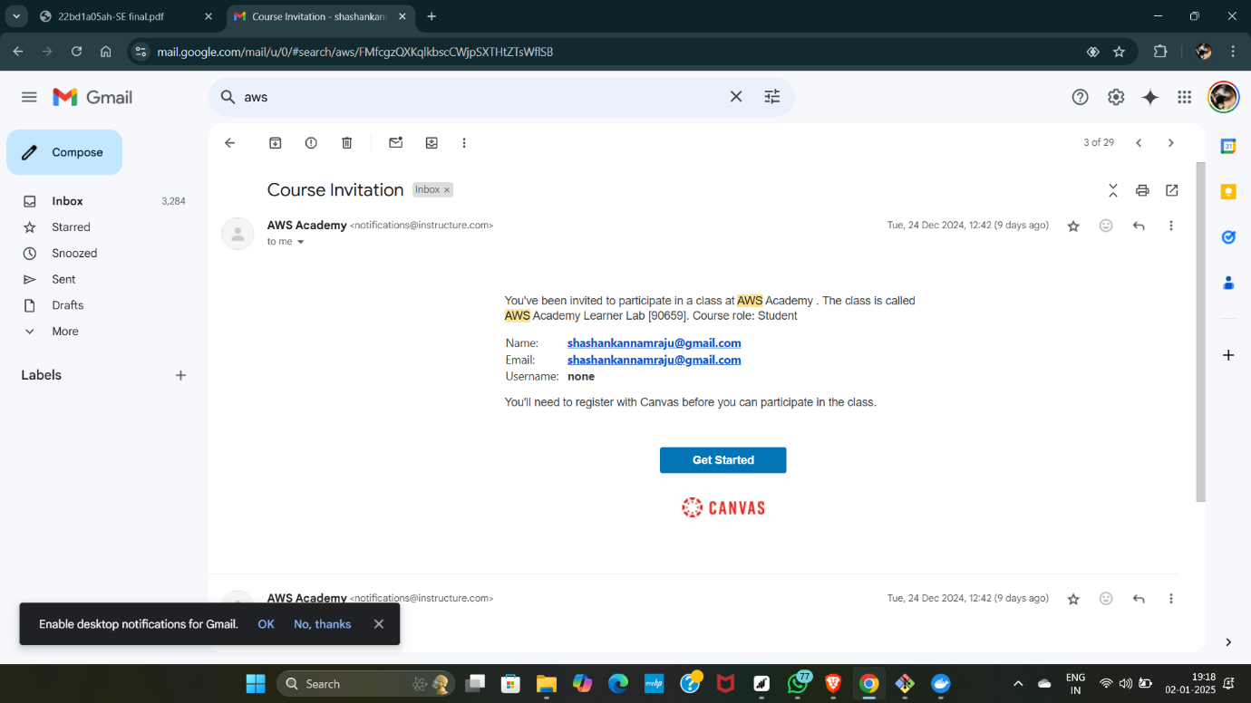

• Now click on create my account.

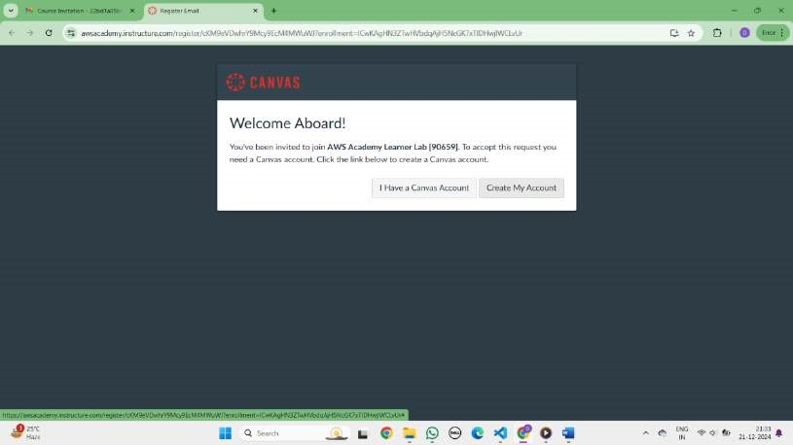

Set up your password for the email you are registered

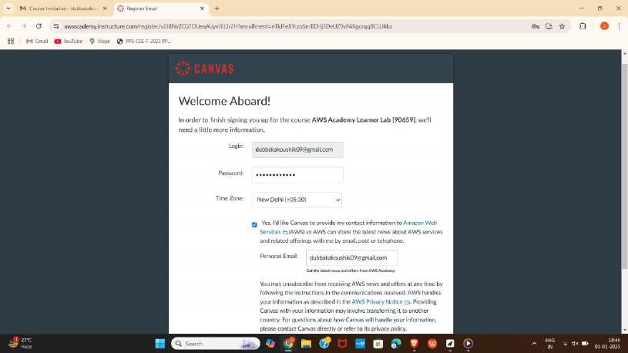

Now we can see a new tab opening that is Aws academy learner lab.

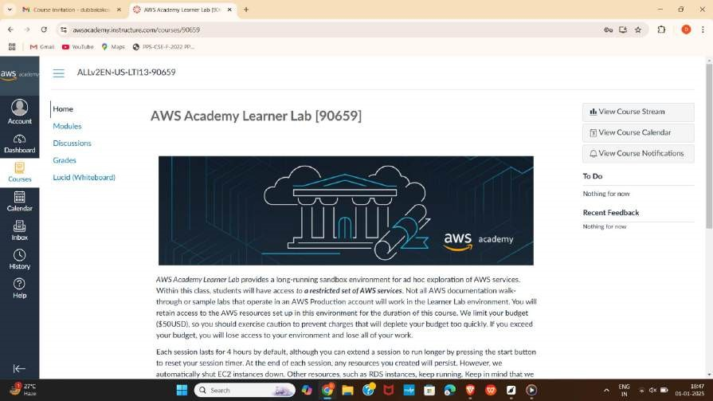

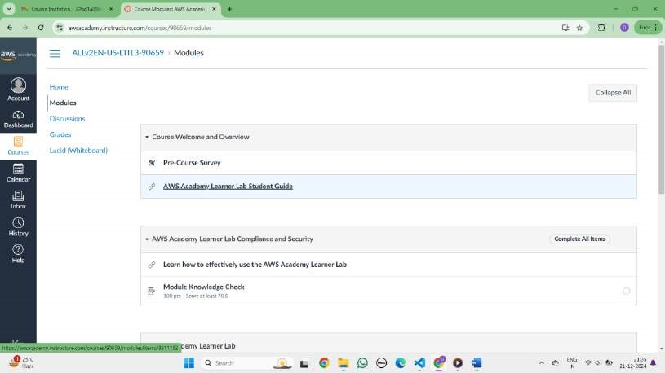

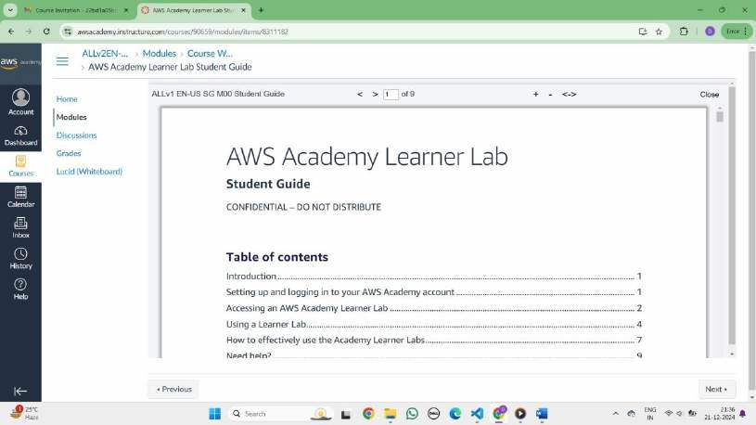 click on I agree and continue

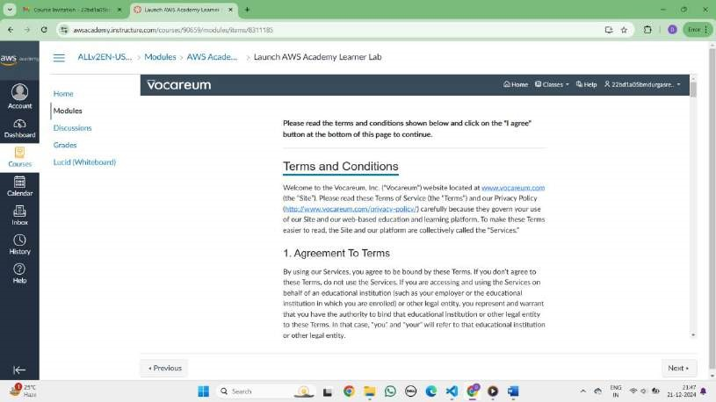

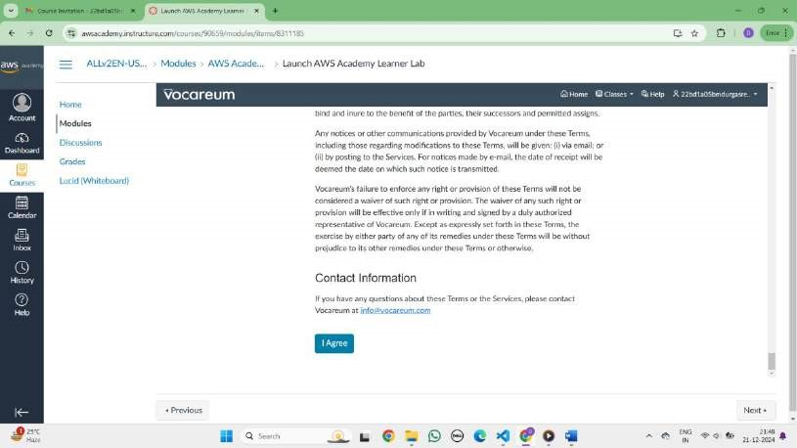

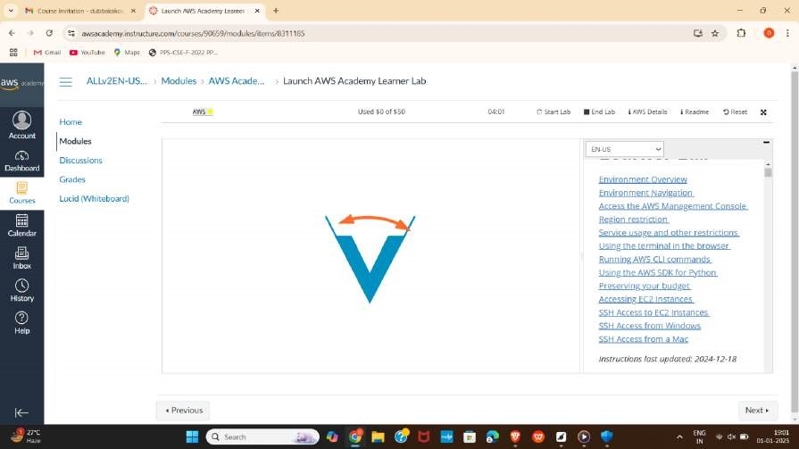

The AWS lab is started!

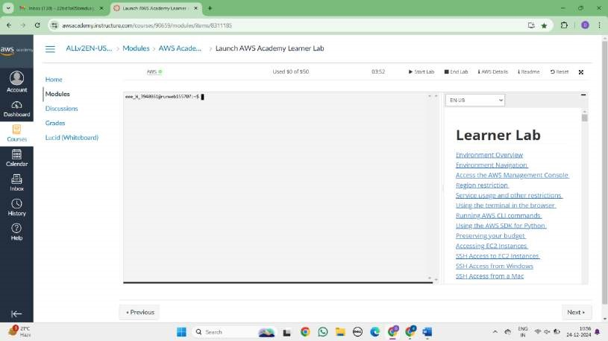

Now click on that Aws and we can see a new console home.

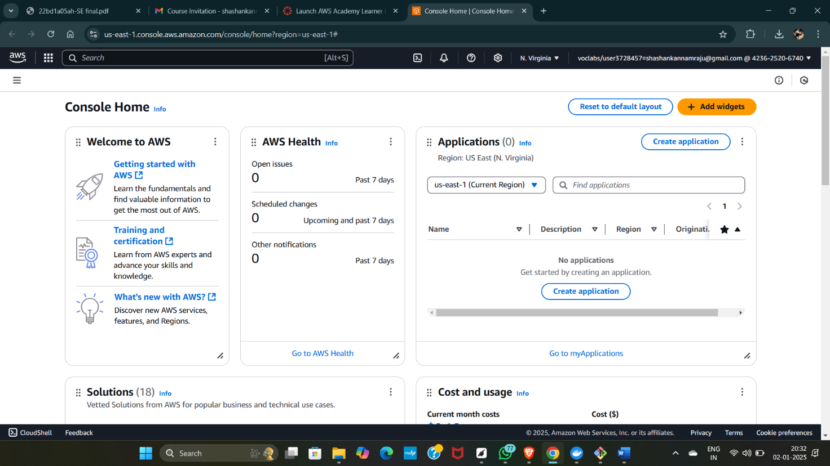

Now go back and click on end lab.

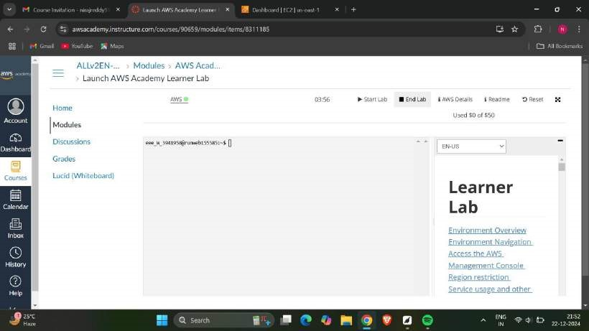

Now click on yes.

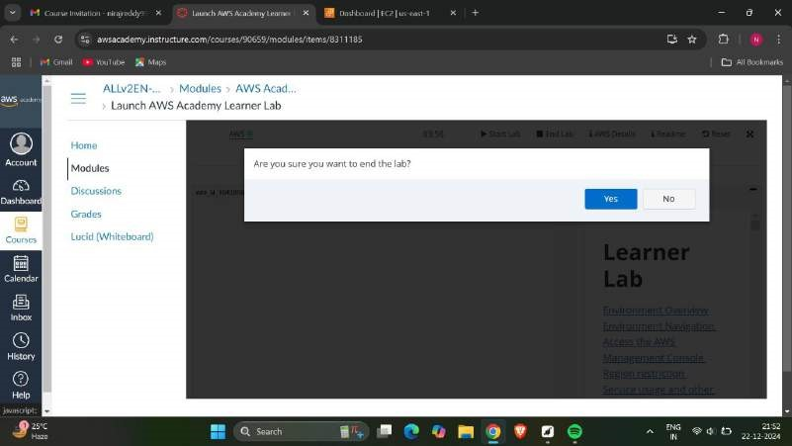

.

# B) PROJECT DEPLOYMENT IN THE AWS CLOUD USING EC2 INSTANCE

Click on start lab

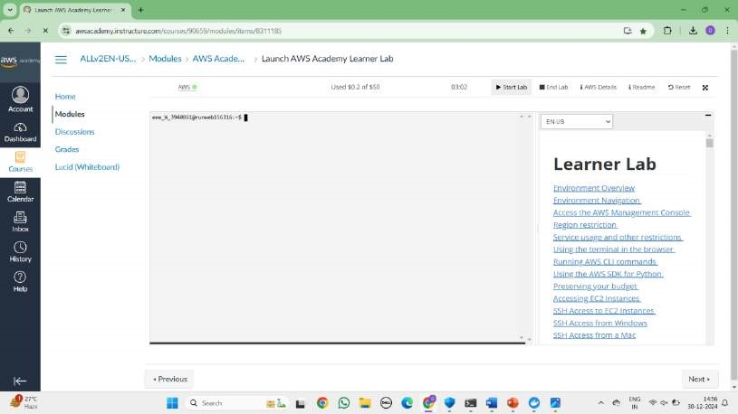

Click on EC2

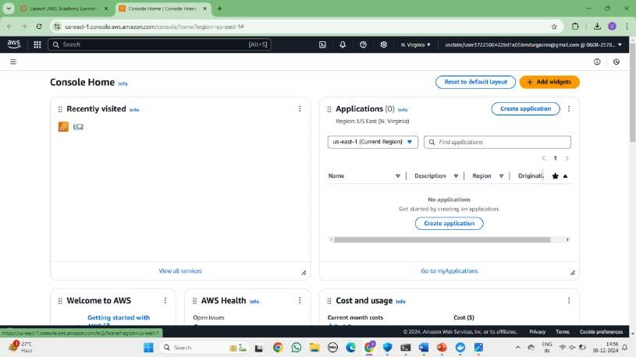

Click on Launch Instance

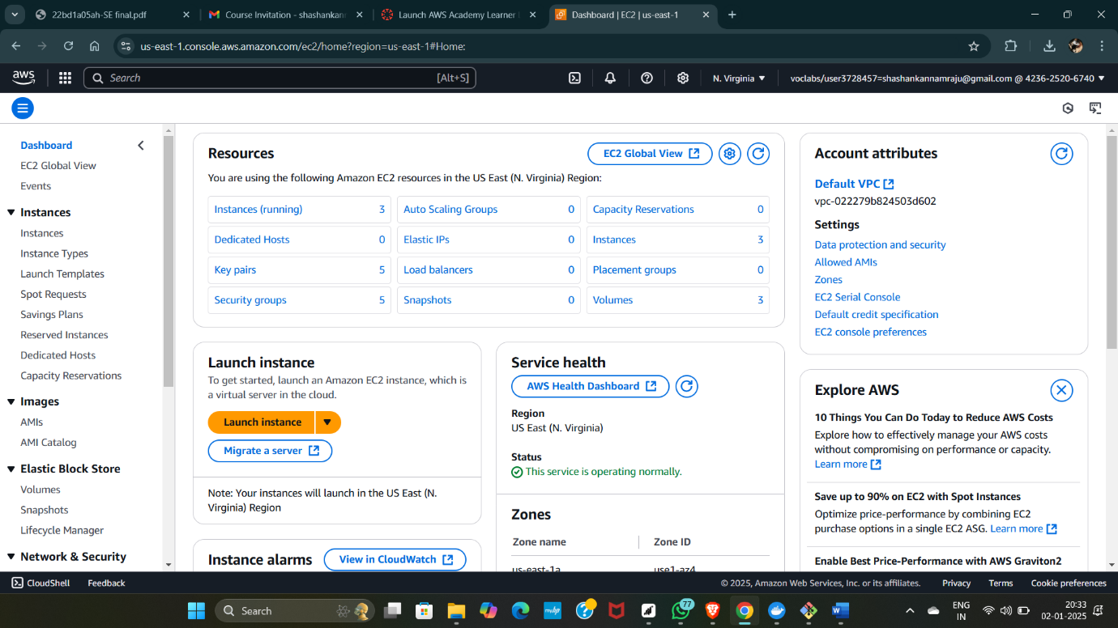

Give name and select ubuntu under application

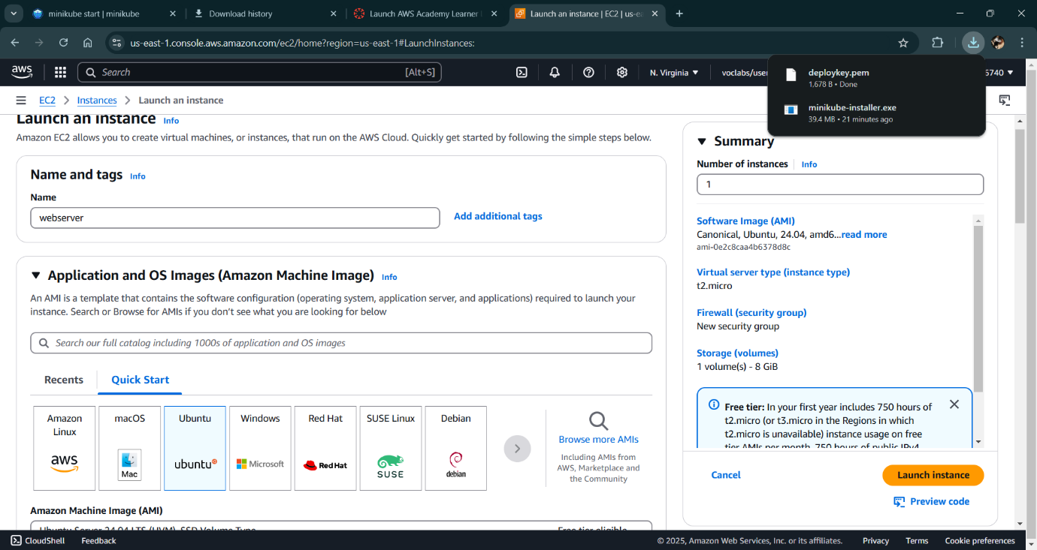

Make sure AMI and Architecture are there as shown

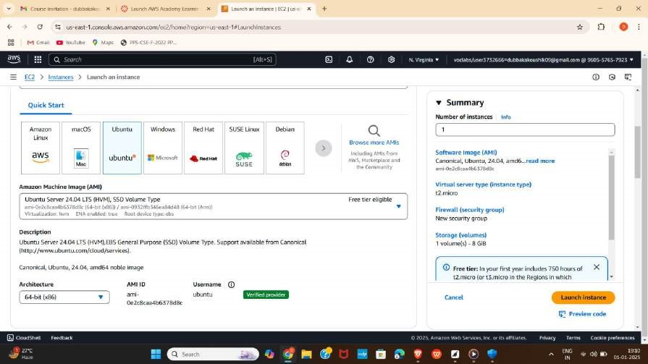

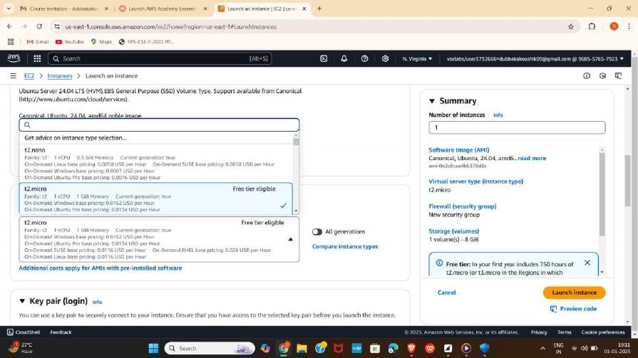

Click on create-new key pair

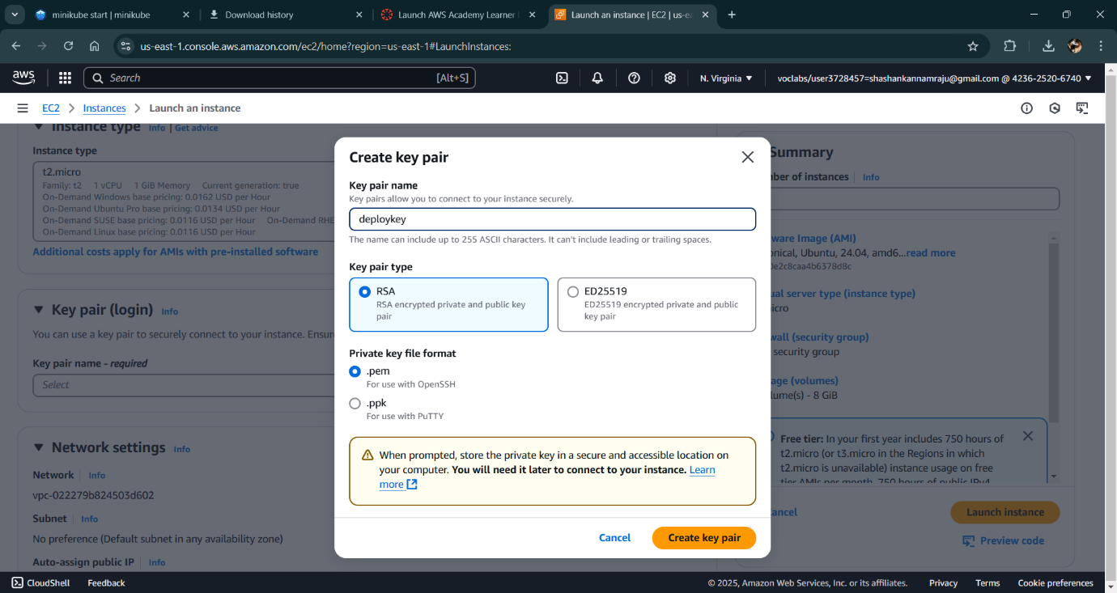

In network setting check all the checkboxes and click on launch instance which is at the bottom

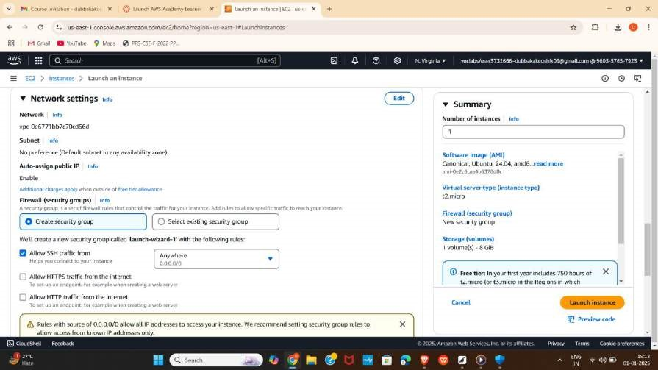

Wait for the Success message.

Now click on the instances

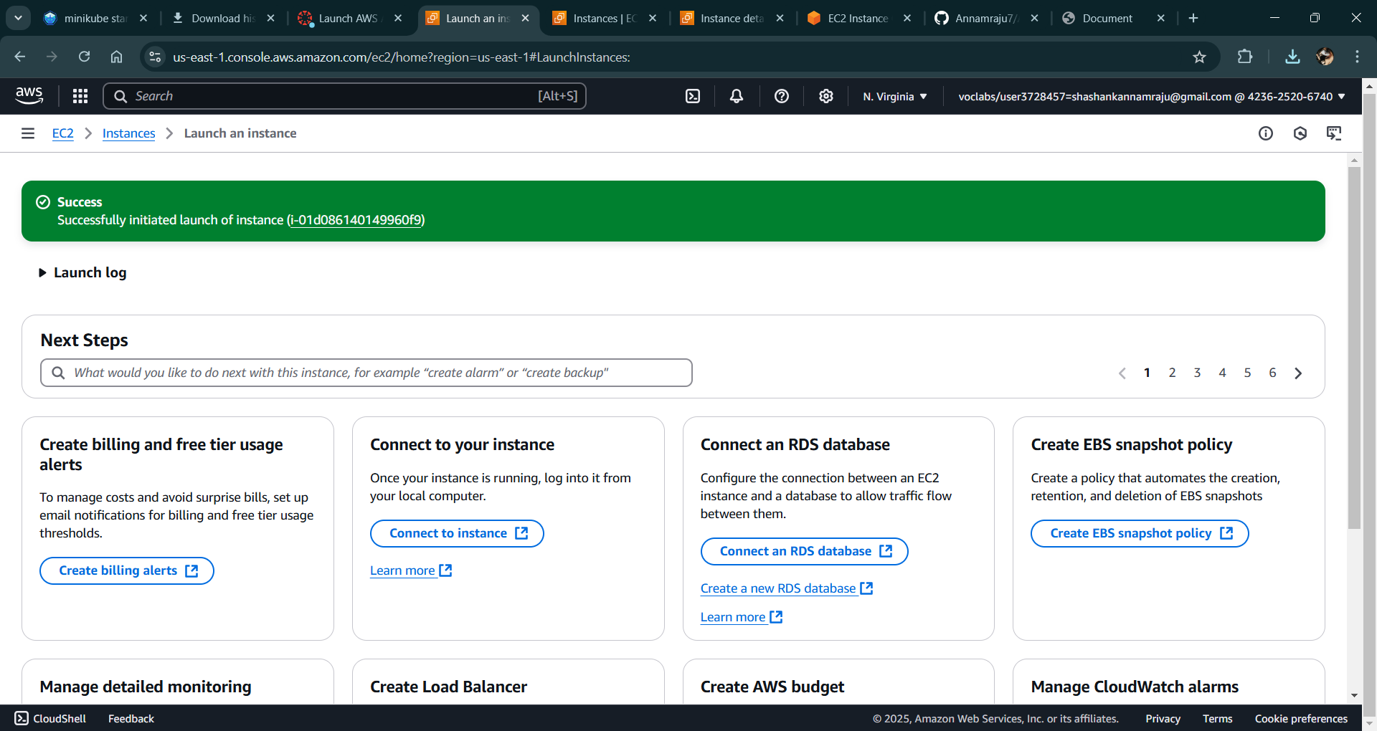

You can see MyExample is Running and wait for it to initialize

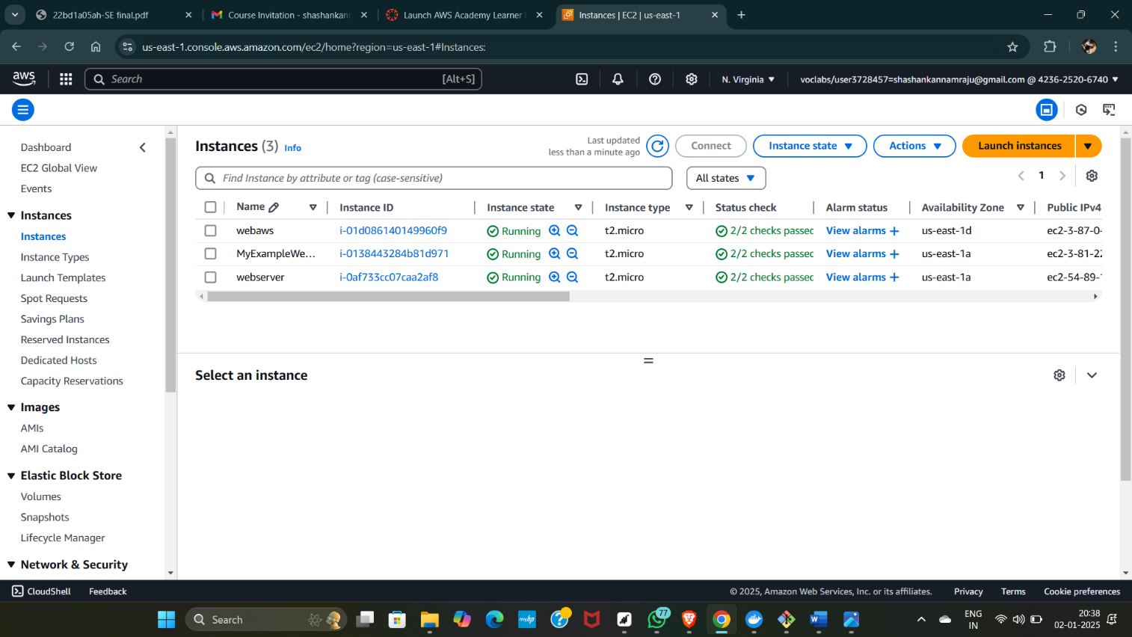

Open CMD and navigate to that path

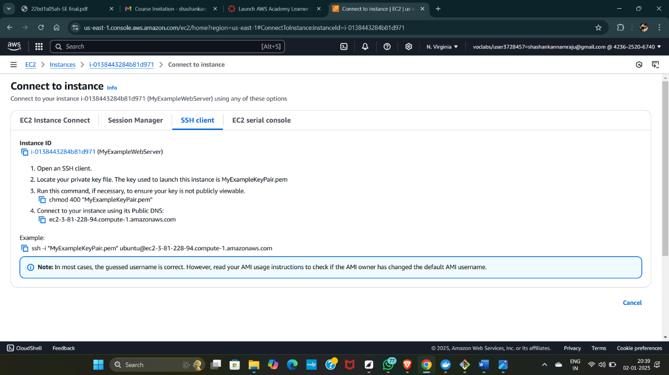

Go to SSh and copy the command which is present at the below

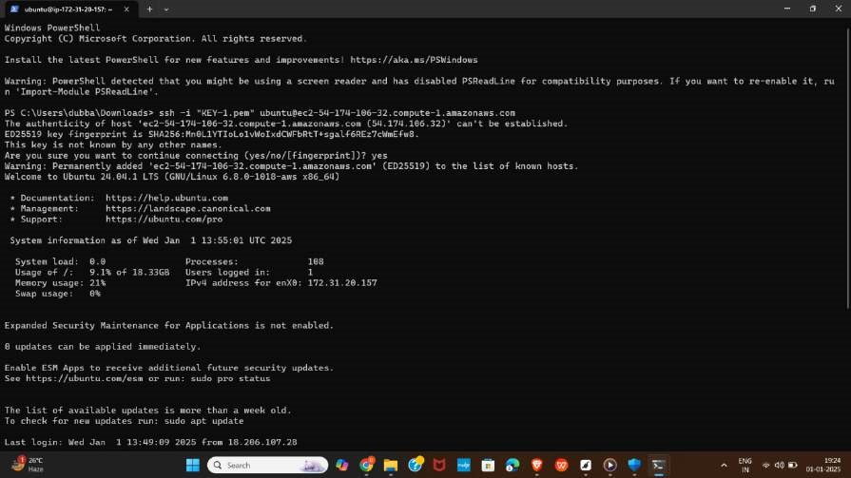

Run the following commands

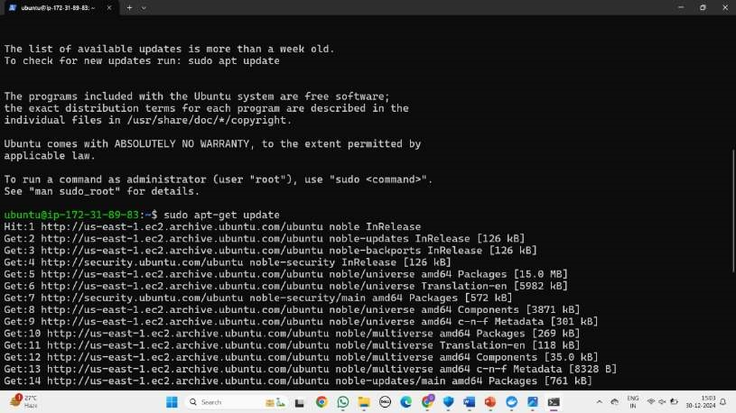

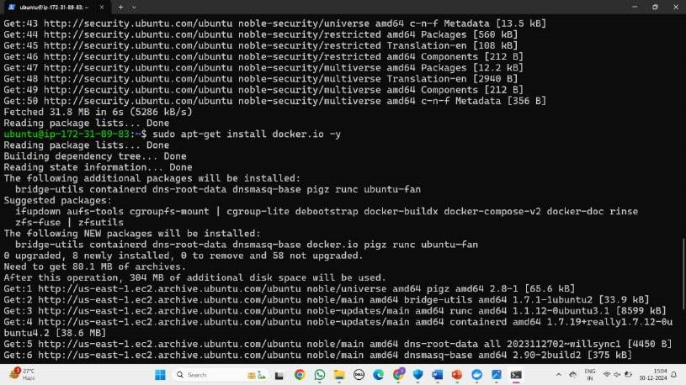

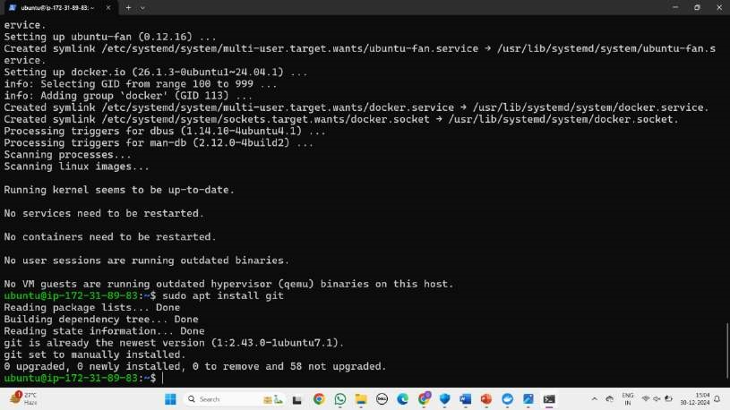

Create basic index.html file

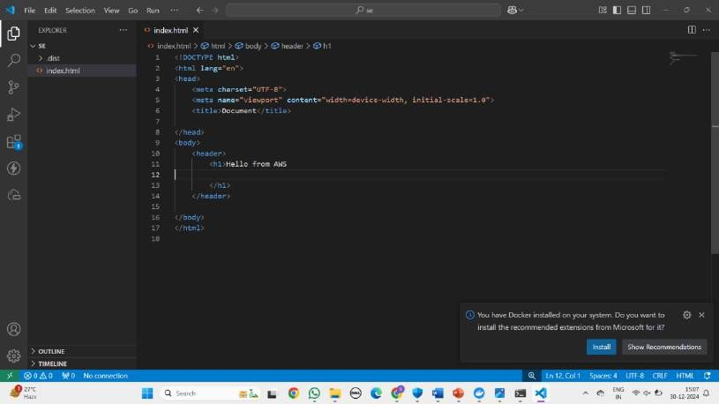

Go to github and copy ssh link of current working repository

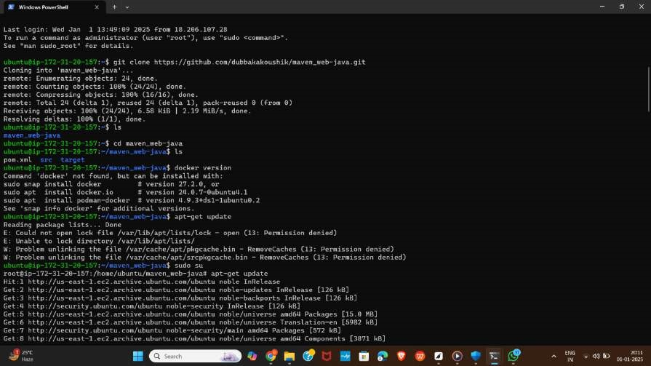

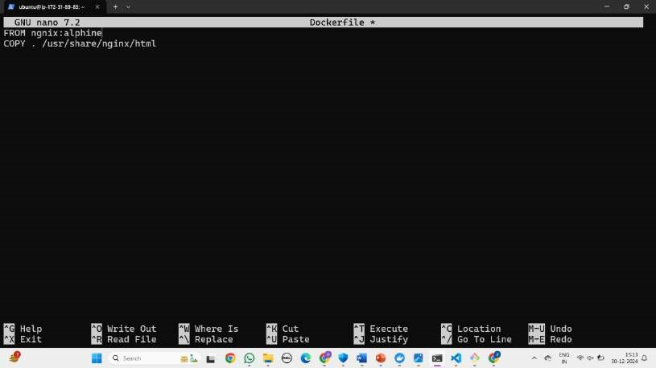

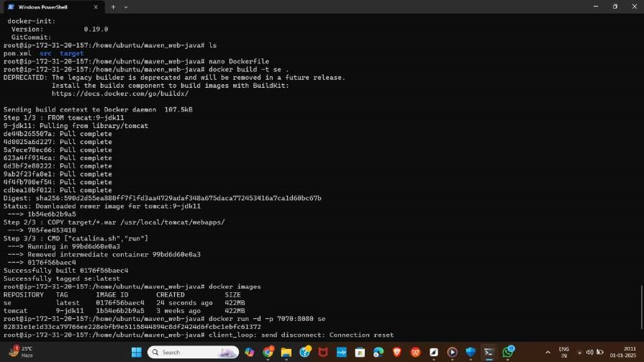

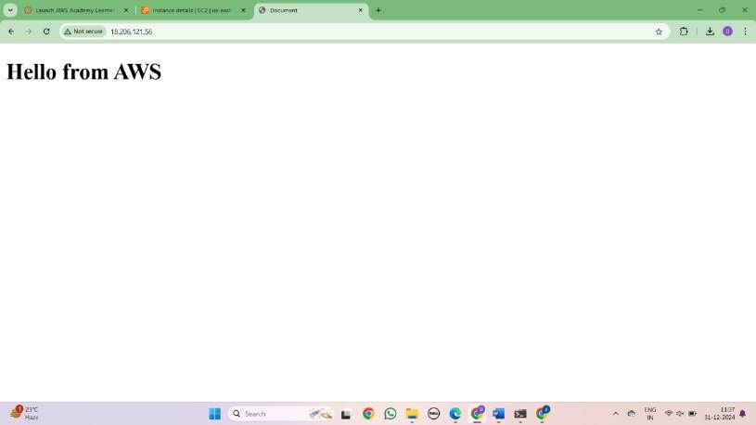

**C) MAVEN WEB PROJECT DEPLOYMENT IN THE AWS CLOUD USING EC2 INSTA**

## MAVEN WEB PROJECT DEPLOYMENT IN AWS

Click on EC2 and click on launch instance



Give a name

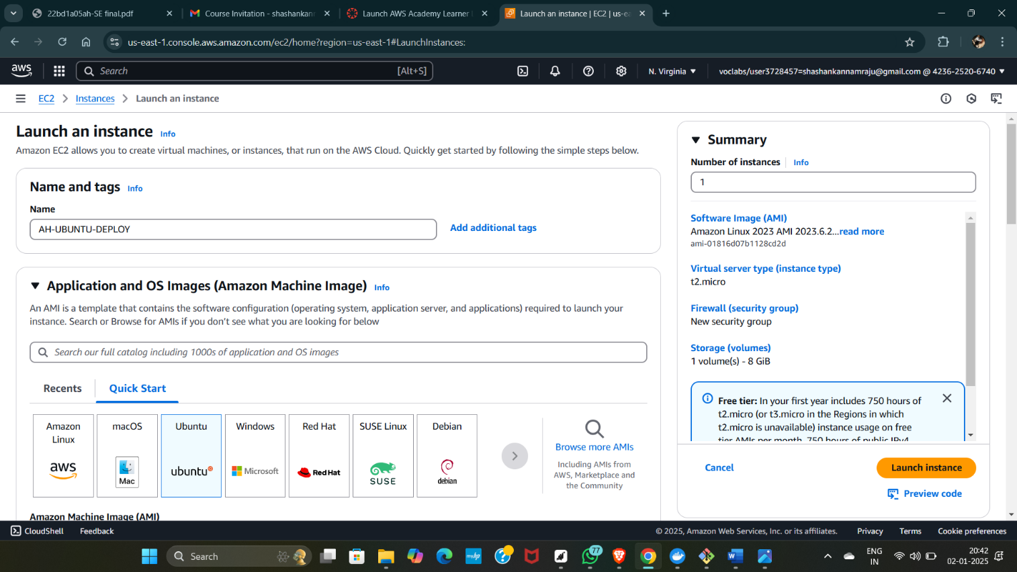

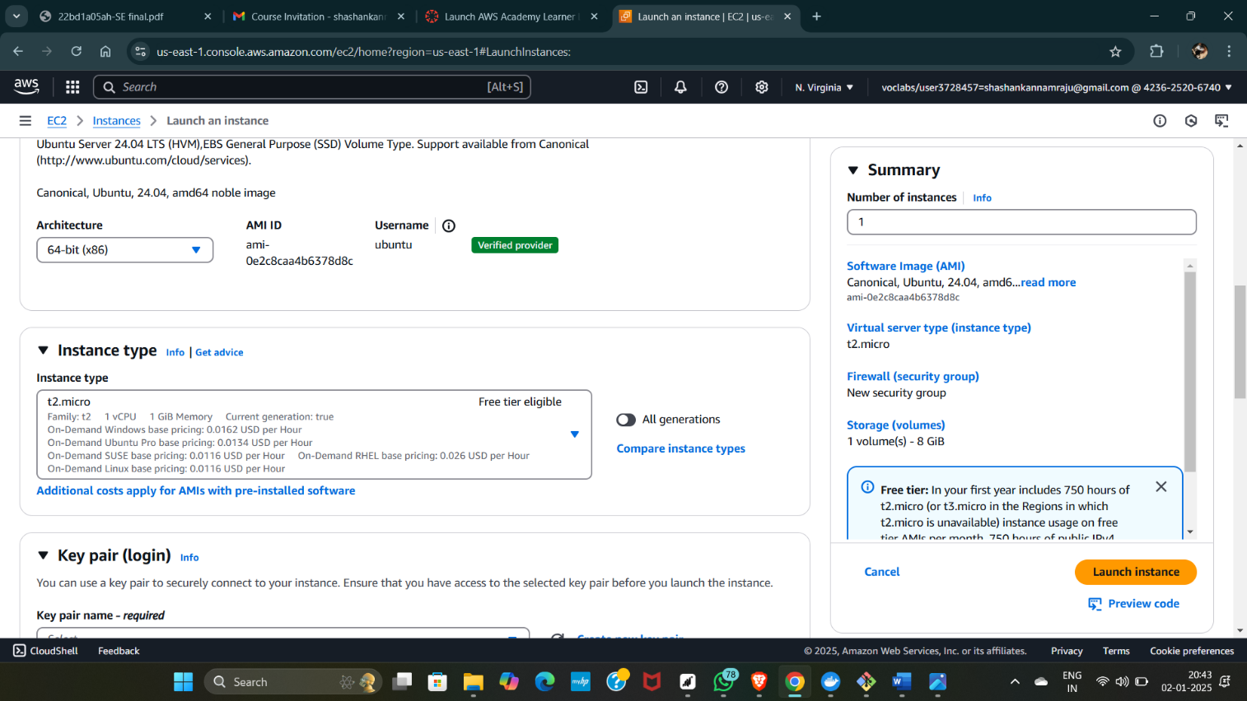

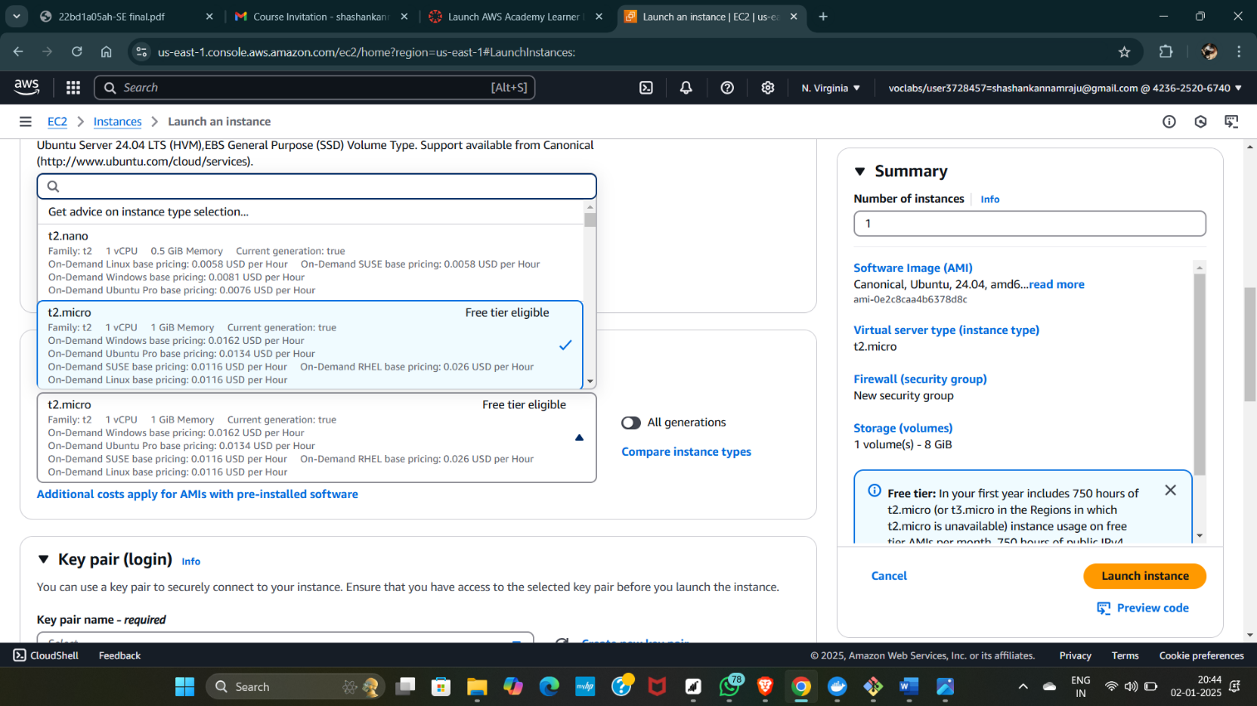

Create new key

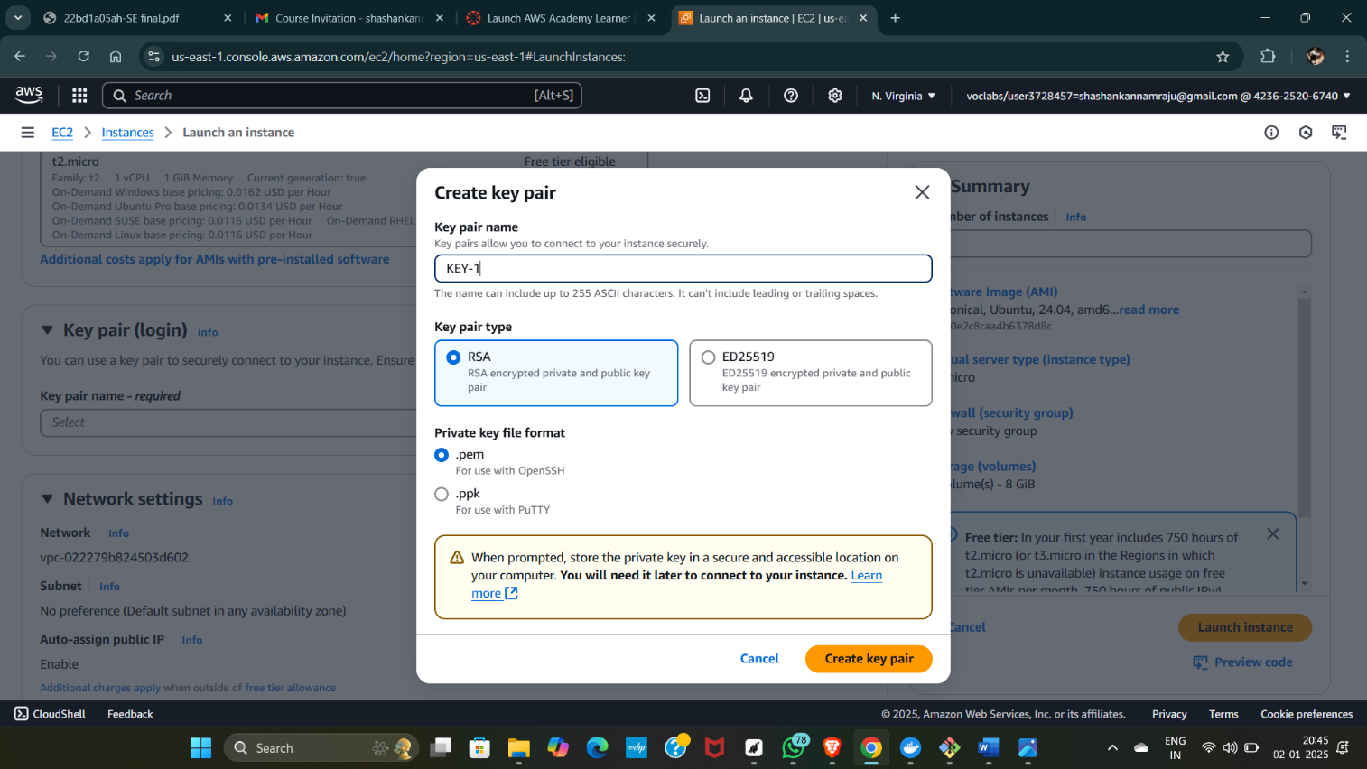

Check all the boxes under network and click on launch instance

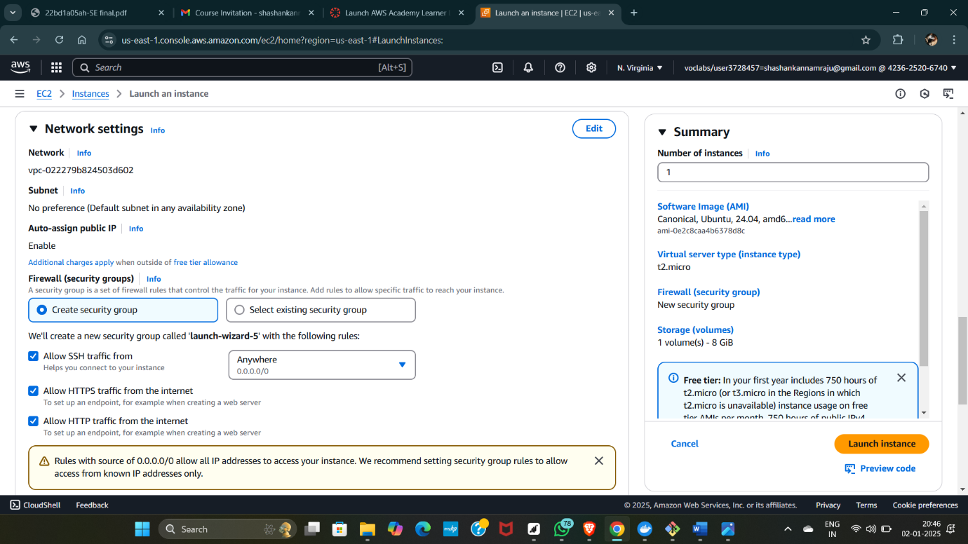

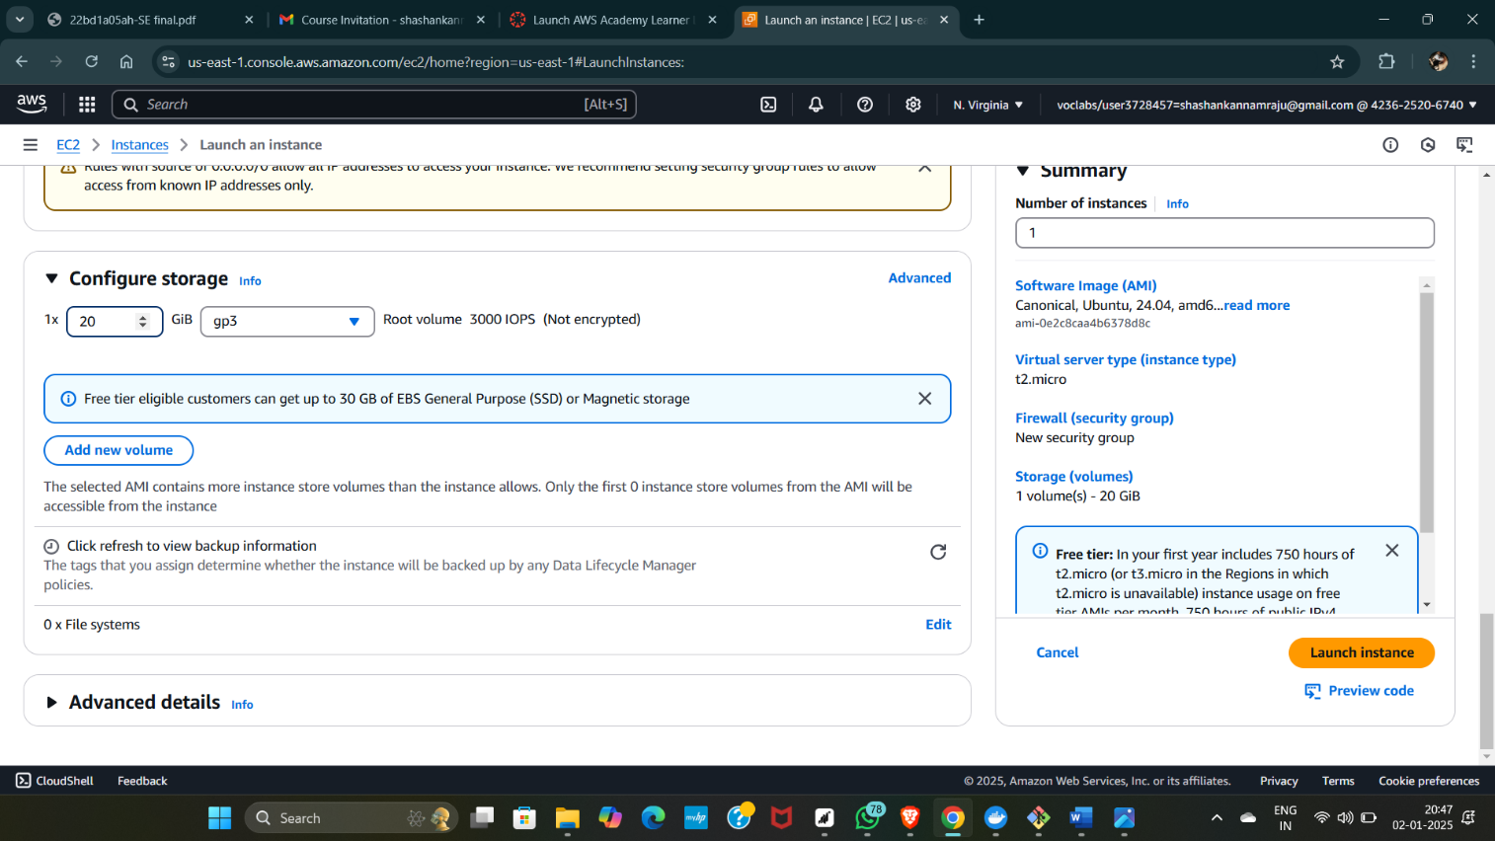

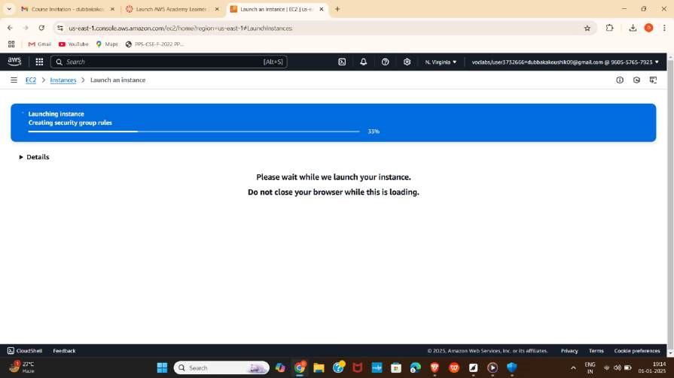

Wait for the Success message.

Now click on the instances





